ABC lectures for MAIN program:
a computational environment for solving 3-dimensional structures of proteins

Dr. Livija Tušar

Jožef Stefan Institute, Department of biochemistry and molecular and structural biology
Centre of Excellence for integrated approaches in chemistry and biology of proteins CIPKeBiP

February 2023

Table of Contents

Introduction 3
- Lesson: MAIN program installation 3
- Lesson: Presentation of the protein structure from the RCSB PDB
protein data bank 5
2.1. Short names of fourth windows opened during the running
of MAIN program 7
2.2. Using of mouse buttons in MAIN program 10
2.3. Calculation and visualization of the SURFACE of the protein 10
2.4. Generation of “png” file of a complex between enzyme and inhibitor 14
2.5. To start MAIN program by using “tk_main_config.pl” 20
2.6. Superimposed protein structures 21
2.7. Starting a new chain 24
2.8. Use of pairs 24
- Lesson: Model building or electron density interpretation and refinement 24
3.1. Data input 24
3.2. The replacement of the molecules 29
3.3. Start model building 31
- Lesson: Model validation 39
- Lesson: Generation of water molecules and S-S bonds 41
5.1. Generation of water molecules 41
5.2. Fine tuning 42
5.3. Water packing 42
5.4. Alphabetical order of segments 43
5.5. Changing of KICK step in REFINE 43
5.6. Refinement – step further 44
- Lesson: Conformations 47
- Lesson: Deposition of the protein structure inRCSB PDB protein data bank 51

Appendix
- Keyboard shortcuts which are case sensitive: magic of a keyboard touch 52
- Table A1. Table of colors codes for MAIN 53
- Procedure for model building: one-page of quick steps 54
- Macro for calculation of surfaces by using van der Waals radii
in MAIN program 55
- Installation of MAIN program in macOS Unix operating systems
by using brew 56
- GLOSSARY and ABBREVIATIONS 57

Introduction

MAIN is a program for macromolecular crystallography enables a display of macromolecular structures, to interactively build molecular models into electron density maps and, within the same interactive session, immediately refine the built models with crystallographic restraints and recalculates electron density maps for further inspection. The program is a tool for numerical and visual analysis and modification of molecular data. It can be used in model building and analyzing studies, in crystallographic refinement (including positional refinement, R-factor calculation, and placing solvent molecules at the final stages of refinement) and as an electron density maps editor (rotations, averaging, solvent flattening in real and reciprocal space, Fourier transformations, ...).

MAIN program is developed by Dušan Turk, “Jožef Stefan” Institut, Ljubljana, Slovenija (Turk, 2013). The generated figures of proteins by MAIN must be rendered with program RASTER 3D to get png graphic files (Merritt and Bacon, 1997).

Seven lessons have been prepared for a quick jump into using the MAIN program: MAIN program installation; Presentation of the protein structure from the RCSB PDB protein data bank; Model building or electron density interpretation and refinement; Model Validation; Generation of water molecules, S-S bonds and other final activities; Conformations; and Deposition of the protein structure into RCSB PDB protein data bank. Appendix contains keyboard shorts cuts to accelerate the procedure of protein structure development, the color codes system of MAIN program for developing of macros, one page of quick steps of protein structure developing, macro for calculation of surfaces by using of van der Waals radii, detailed installation procedure for MacOS Unix operating system by using brew, and finally Glossary and Abbreviations.

The purpose of this lessons was not to explain and to learn readers how to solve the protein structures, these lessons must be learned from other sources and books.

The lessons would never have been written if Prof. dr. Dušan Turk, head of Structural biology group in Department for Biochemistry and molecular and structural Biology B1 at “Jožef Stefan” Institute, would not try to teach me how to develop the protein structure from x-ray data. I thank him for his efforts. Matej Novak, young researcher in our group of Structural Biology, started to read my notes (which were very messy at the beginning) and compared it with his own, forced me to reorganize my notes in lessons. I would like to thank him for all his comments and discussions about this guidelines and MAIN program and on the structural biology in general.

I believe that this short guidelines about MAIN program are just first attempt which will be supplemented with new and more complex lessons.

References
- TURK, Dušan. MAIN software for density averaging, model building, structure refinement and validation, Acta Crystallographica Section D (August 2013) D69, Biological Crystallography ISSN 0907-4449.
- TURK, Dušan. Boxes of model building and visualization. V: WLODAWER, Alexander (ur.), DAUTER, Zbigniew (ur.), JASKOLSKI, Mariusz (ur.). Protein crystallography : methods and protocols. New York: Humana Press: Springer. 2017, str. 491-548. Methods in molecular biology, 1607, Springer protocols. ISBN 978-1-4939-6998-2, ISBN 1-4939-6998-6.
- Merritt, E. A. & Bacon, D. J. Raster3D: Photorealistic Molecular Graphics. Methods Enzymol. (1997) doi:10.1016/S0076-6879(97)77028-9.

1. Lesson: MAIN program installation

MAIN is developed for LINUX (based on gfortran-gcc) and macOS Unix operating system (based on g95). MAIN script is written in Fortran, Perl, C++ and Python therefore some programs and graphical libraries have to be properly installed or to be checked if they are not already installed before downloading the free available MAIN software: emacs, gcc, gcc-fortran, make, LINUX windowing system X11, package xorg-x11-server, perl-Tk 804.036.tar.gz, enhancement for Perl, that combines graphical library Tk with the language Perl. The installation depends on the software of the linux operating system: FEDORA 37, CENTOS, etc.

Then MAIN script can be downloaded from web page http://www-bmb.ijs.si as follows:

1st file: main_distribution.tar.gz

2nd file (the executive file is different for linux or OSX operating system): mainps_2021.exe_LINUX_GFORT_64

In order to install MAIN, create a directory where MAIN shall reside:
> mkdir MAIN
> cd MAIN

Copy / Move both files into that newly created directory.
Then, expand the downloaded
main_distribution.tar.gz by using tar command:
> tar -zxvf main_distribution.tar.gz

The following directories were created at the directory MAIN:
>cmds
>cmds_new
>config
>crke
>doc (files with the documentation, HELP text)
>prog
>symm
>top
>utils

Using command to unlock file:
> chmod 755 mainps_2016.exe_LINUX_GFORT_64
and the same in the case for OSX exe file.

To unlock the executable files in subdirectory >config use the following command:
> chmod +x *.pl

Make a back up by copying:

> cp .login_BASH login_BASH
Then, adapt the ".login_BASH" file using a text editor like Emacs to your BASH shell. The MAIN environments need to be properly assigned. For example use /usr/local/progs/ for scientific software depository.

The content of file ".login_BASH"
MASTER_LOCAL=/usr/local/progs/
export MASTER_LOCAL
MAIN=$MASTER_LOCAL
export MAIN
CE_SUPERIMPOSE=$MASTER_LOCAL/CE_superimpose/jfatcat/
export CE_SUPERIMPOSE
alias mainps=$MAIN"mainps_2016.exe_LINUX_GFORT_64"

Integrate the "login_BASH" file into your working environment. BASH user insert appropriate line
source /disk/username/main/login_BASH

into your local startup file. For personal installations this would be in ".bashrc" file, wheres for a larger user community the system manager will normally provide other solutions.

Mac and path: /Users/Fani/
File called “.bashrc”

The content of the file: “cat .bashrc”
echo "I am BASH shell"
source /Users/Fani/Desktop/MAIN/login_BASH
alias python=/usr/local/bin/python3.8
if command -v pyenv 1>/dev/null 2>&1; then
eval "$(pyenv init -)"
fi

In this case we have to start in BASH:

>bash

The installation of MAIN for Apples’s Mac computers is described in Appendix as well as installation of the program Raster3D for rendering figures.

2. Lesson: Presentation of the protein structure from the RCSB PDB protein data bank

To present protein structure in MAIN program from PDB database https://www.rcsb.org, first select one, for example, the structure with code “1huc” and download the file in “PDB format” as “1huc.pdb” (Figure 1). The MAIN program is always started in the bash level as it was presented in the first lesson. Then you must prepare the input files with the selected structure “1huc.pdb” for the MAIN program by using code written in Perl named "create_auto_start.pl".

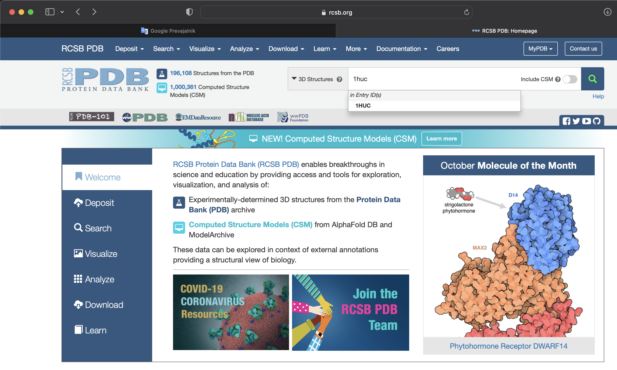
Figure 1. Downloading the selected protein structure from PDB protein data base internet address https://www.rcsb.org with PDB code “1huc”.

Program code named “create_auto_start.pl” has many options:
-h --help prints this message with available options and current status
-c --command define macro with MY COMMANDS [?MAIN_UTILS:my_commands.com]
-i --input set file name of the data input macro [read.com]
-g --groups define NCS groups by [NONE/CHAINS/SEGMENTS] [SEGMENTS]
-o --output set file name of the created macro [.main]
-p --pdb extract information from a PDB file
-f --file extract information from cif file
-x --crystal PDB CRYSTAL record use [USE/IGNORE] [USE]
-d --depp depp pages [NEW/OLD] menu [NEW]
-s --display display position and sizes [0 0 1280 1024] menu
followed by “--doit”.

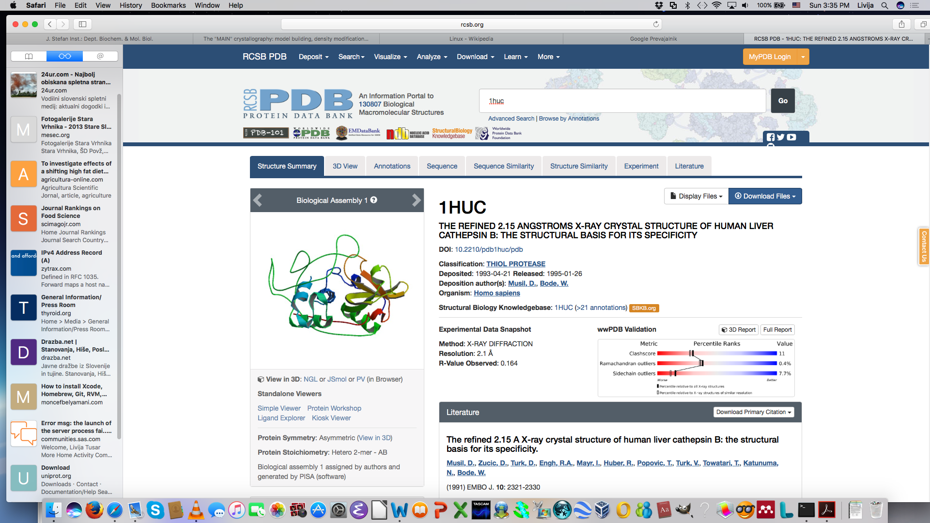
Figure 2: PDB format file “1huc.pdb”, with the information of protein structure for cathepsin B, was downloaded by using button DOWNLOAD FILES.

To start bash level and move to directory where PDB protein structure file was saved:
fani ~ % bash

To present the protein structure with PDB format use the combinations of the following options or commands:
bash-3.2$ create_auto_start.pl -p 1huc.pdb --doit

The output in terminal window where we could check the implementation of MAIN program and which information about protein structure was copied directly into MAIN program arrays or special files from where MAIN program reads data:

bash-3.2$ create_auto_start.pl -p 1huc.pdb --doit
creating ".main"
topo loop: ALL_H
reading PDB file "SAVE_FILE.PDB"
UNIT CELL: 86.230 | 34.160 | 85.560 | 90.00 | 102.90 | 90.00
SPACE GROUP: p1_21_1
.../MAIN/top/top_99_csd.main
.../MAIN/top/top_prot_adds.main
.../MAIN/top/top_sme.main
.../MAIN/top/top_ion.main
reading TOPOLOGY file ".../MAIN/top/top_99_csd.main"
reading TOPOLOGY file ".../MAIN/top/top_prot_adds.main"
reading TOPOLOGY file ".../MAIN/top/top_sme.main"
reading TOPOLOGY file ".../MAIN/top/top_ion.main"
AUTO_START> 0segm list: A
0 segm group A
nn: 0 groups: 1 0
creating "cell.dat"
creating "read.com"
topo loop: ALL_H
crystal: 1
format:MAIN
file:reflect.dat
data:BRAGG
fraction{0.3}
creating "re_image.cmds"
bash-3.2$ ls -la
total 35264

In this case, MAIN program writes the data to the following text files: “SAVE_FILE.PDB”, “cell.dat”, “main_config.data”, “main_config.data.old” (prepared for back up of “main_config.data” file as well as main_config.data.old2), "read.com", “re_image.cmds“ (text file is created to display and visualized the selected protein structure and it is written in MAIN macro language), “.main” (call some MAIN programs needed for presenting PDB format) which include the data of the protein structure with PDB format as data input for MAIN program. File “input.cop” contains all implemented MAIN programs or commands in the terminal window.

The output of the execution of the MAIN program could be written in the file called MyOuput as follows:
bash-3.2$ create_auto_start.pl -p 1huc.pdb --doit >MyOutput

To display the prepared data for “1huc” write "mainps" in the bash and windows presented in Figure 3 will open:
bash-3.2$ mainps

2.1. Short names of fourth windows opened during the running of MAIN program

The MAIN program execution windows are presented in Figure 3:
1. The largest window called “only a MAIN user can be cool” presents the protein structure or structures. In the right upper corner the status of figure is displayed and it will be explained when the status will be changed or important. The short name of this window is my_image.
2. “DEPP pages” window is a list of available commands which will be explained when some command will be used for the first time. The short name of this window is my_depp.
"Depp pages" stand for "moron pages". "Depp" in German is an equivalent to "moron". The name is an original contribution from prof. dr. Robert Huber (Nobel prize winner from Max-Planck Institute), who in the early days of program development has said that he would use the program, if it had menus for a "depp" like himself.
3. The window where the outputs and executed code during the MAIN program running is displayed, in this case as “1huc – mainps_2021.exe_OSX_GFORT-INTEL – 131x11”(the name means the PDB code of the selected protein structure, the executable file of MAIN program and the size of my_image window), is called my_term. To get in my_term you have to select PROMPT command in my_depp, then appeared in the left corner MAIN> as could be seen in Figure 4. This is actually the command line in MAIN program where some commands or macro files could be executed directly by the user. For example, if you write there “show size” the information on default size of arrays in MAIN program will appear. MAIN uses dynamical memory allocation. As default it is allocated memory for 300000 atoms. If some arrays are too small for selected protein structure, you have to enlarged them by using start command “mainps” or command line in my_term. With command “mainps” the following options are regular:

bash-3.2$ mainps --help
--atoms nn
--residues nn
--nodisplay
(Appropriate for using MAIN program for selected calculations without displaying protein structure)
--nostartup
--geometry x y width height

You can start MAIN with modified (enlarged) sizes of ATOM and RESIDUE arrays
bash-3.2$ mainps --atoms 10000000 --residues 50000 --nostartup

Output of the version of MAIN program:

bash-3.2$ mainps -nostartup
>>>> unknown command line word -nostartup
MAIN environment {>} is set to {/Users/Fani/Desktop/MAIN/}

<<< MAIN for ACADEMIC and NON-PROFIT organizations >>>
<<< and individuals only >>>
<<< compilation date May 9 2022 >>>

MAIN>quit

In my_term we could use also the following commands:
MAIN>image line 3.0 (to define the weight of lines in the protein structure)
MAIN>image di 0.33 (to define the size of the my_image window to 80x17, the default value is 133x11)

MAIN>show residues (the output in my_term is “TOTAL NUMBER OF RESIDUES 787”. In the case of 1huc the total number of residues is equal to 787.)
MAIN>write bond (the output in my_term for 1huc is
MAIN>write bond
COVALENT BONDS FOR SYSTEM:
1 N LEU A 1 - 2 CA LEU A 1 1.4737
2 CA LEU A 1 - 5 CB LEU A 1 1.5586
2 CA LEU A 1 - 3 C LEU A 1 1.5161
3 C LEU A 1 - 4 O LEU A 1 1.2210
3 C LEU A 1 - 9 N PRO A 2 1.3558
5 CB LEU A 1 - 6 CG LEU A 1 1.5465
6 CG LEU A 1 - 7 CD1 LEU A 1 1.5477
6 CG LEU A 1 - 8 CD2 LEU A 1 1.5380
9 N PRO A 2 - 10 CA PRO A 2 1.4536
9 N PRO A 2 - 15 CD PRO A 2 1.4791
…

MAIN>write resi or write residues for 1huc:
MAIN>write resi
* RESIDUE SEQUENCE
SEGMENT: A
LEU PRO ALA SER PHE ASP ALA ARG GLU GLN TRP PRO GLN CYS PRO
THR ILE LYS GLU ILE ARG ASP GLN GLY SER CYS GLY SER CYS TRP
ALA PHE GLY ALA VAL GLU ALA ILE SER ASP ARG ILE CYS ILE HIS
THR ASN VAL SER VAL GLU VAL SER ALA GLU ASP LEU LEU THR CYS
…

MAIN>show segm or show segment for 1huc:
MAIN>show seg
SEGMENT 1 <A > ATOMS: 4159 4159 RESIDUES: 787 787

MAIN>show chain for 1huc
MAIN>show chain
CHAIN 1 {A|A } ATOMS: 364 RESIDUES: 47
CHAIN 2 {B|A } ATOMS: 1574 RESIDUES: 205
CHAIN 3 {C|A } ATOMS: 364 RESIDUES: 47
CHAIN 4 {D|A } ATOMS: 1574 RESIDUES: 205
CHAIN 5 {A|A } ATOMS: 32 RESIDUES: 32
CHAIN 6 {B|A } ATOMS: 121 RESIDUES: 121
CHAIN 7 {C|A } ATOMS: 27 RESIDUES: 27
CHAIN 8 {D|A } ATOMS: 103 RESIDUES: 103
TOTAL 8 ATOMS: 4159 RESIDUES: 787 SEGMENTS:

MAIN>im di
or
MAIN>im dia
“im di” or “im dia” present the shortest version of the two words command “image dialogue”. This command is used when you want to return in my_depp and my_image windows to manipulate with the protein structure within list or menus of commands of MAIN program.

To exit the MAIN program but not “quit” it type “CTRL Z”. To return back into MAIN program from bash level type “fg” and ENTER.

To run the macro program in the command line type its name as follows “<xxx.com” (Appendix: example of one macro code).

4. “dials” window is called my_dials describing the functionality of the dial box and mouse.

Each action undertaken by the user that changes the molecular model data is stored in a file named input.cop, allowing easy restoration after a computer or program crash or a user's mistake.

Figure 5 shows a case when MAIN does not display the bonds in the protein structure but only the positions of amino acid residues. Figure 5 shows the case where the connectivity table was not calculated. It contains the information on amino acid residues and its bond connections to other amino acid residues has to be calculated again. For calculation of bonds we have to select UTILS in my_depp and in its submenu “CALC_BON” followed by pressing BACK. Then in my_depp select RE_IMAGE and in my_image the protein structure 1huc will appeared properly.

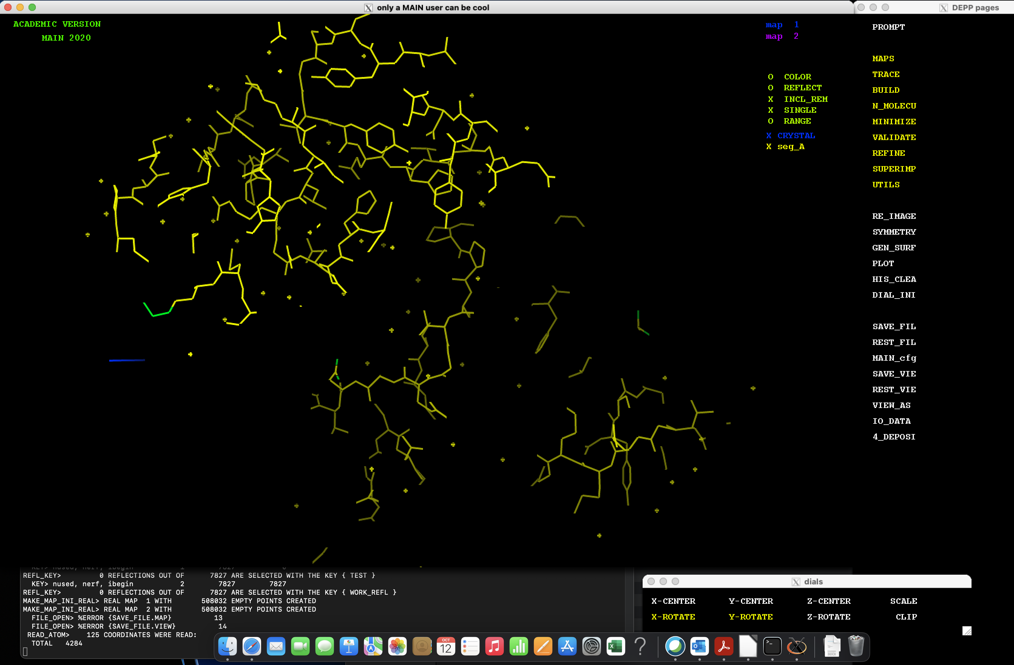
Figure 3. Display of protein structure with PDB code 1huc. Windows of MAIN program are called my_image, my_depp, my_term, and my_dials.
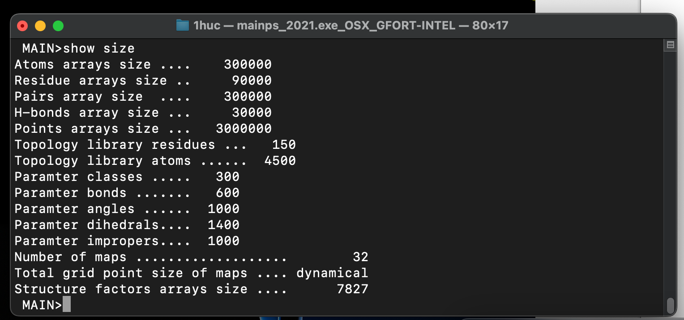
Figure 4. My_term window with command line where we input the command “show size”.

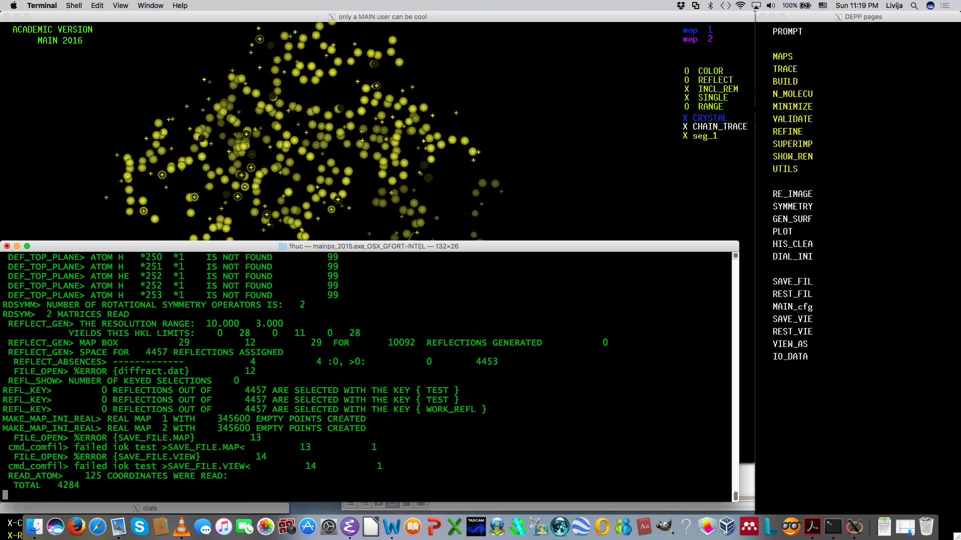
Figure 5. Image present the protein structure 1huc in the case when MAIN did not display bonds but only amino acid residues as small balls.

2.2. Using of mouse buttons in MAIN program

All three buttons of mouse are used for the manipulation of MAIN program. Figure 6 shows the short names of buttons which will be used for the description of opening windows or running some commands.

Mouse wheel = Wmouse

Right mouse button=Rmouse
Left mouse button= Lmouse

Figure 6. Short names of mouse buttons which will be used for the description of certain activities in MAIN program, for0 example, opening of windows with options.

Right mouse button or shortly Rmouse opens the windows of the commands in my_depp written with white color: RE_IMAGE … 4_DEPOSI.

Left mouse button or shortly Lmouse opens the sub menus of yellow written commands in my_depp: MAPS … UTILS. It is used also to run or to implement the newly selected parameters for white colored commands in my_depp: RE_IMAGE … 4_DEPOSI. For example, Rmouse opens the RE_IMAGE window where we can change some parameters and in my_depp we must click again on RE_IMAGE with Lmouse to implement these new parameters.

2.3. Calculation and visualization of the SURFACE of the protein

The solvent occupied areas inside the crystal have no rigid structure, so they can be “flattened” (all grid points in the solvent region obtain a single density value - usually zero). Solvent flattening, when successfully applied, defines clear boundaries between solvent and protein regions and improves interpretability of an electron density map. To generate surface the button GEN_SURF in my_depp have to be pressed by Rmouse and first the subwindow titled “Tk: create_image_gen_surface.pl” is opened (Figure 7). Then the button “Write-It” without changing anything followed by “Quit” have to be clicked and then clicked again the button GEN_SURF in my_depp by Lmouse (Figure 8). The command “Write-It” actually prepare the macro program code called “image_gen_surface.cmds” which is implemented by clicking Lmouse on GEN_SURF in my_depp. In my_term the output of the calculation of the protein surface is written. The calculation is finished when it is written “hello 504 52985” for 1huc in my_term (Figure 8).

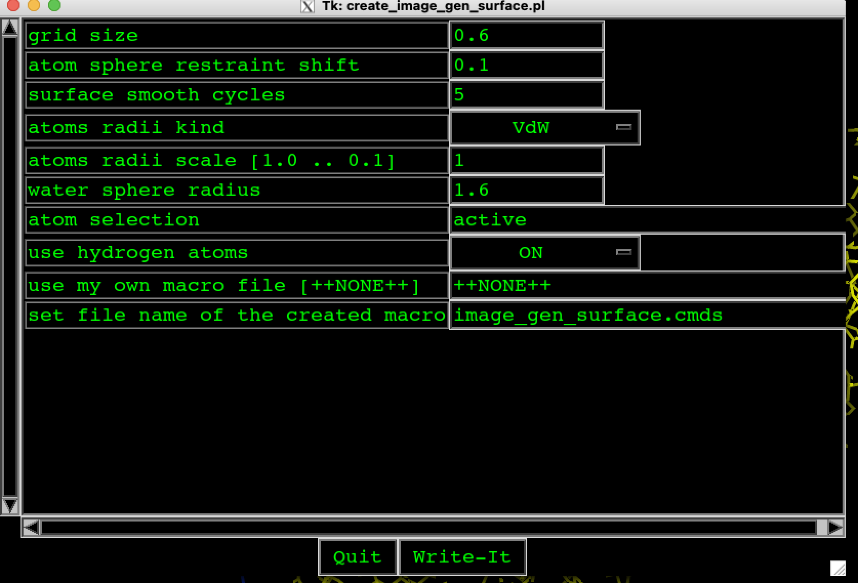
Figure 7. Generation of surface of the protein. We simply click on button “Write-It” with Lmouse without changing anything followed by clicking “Quit”.
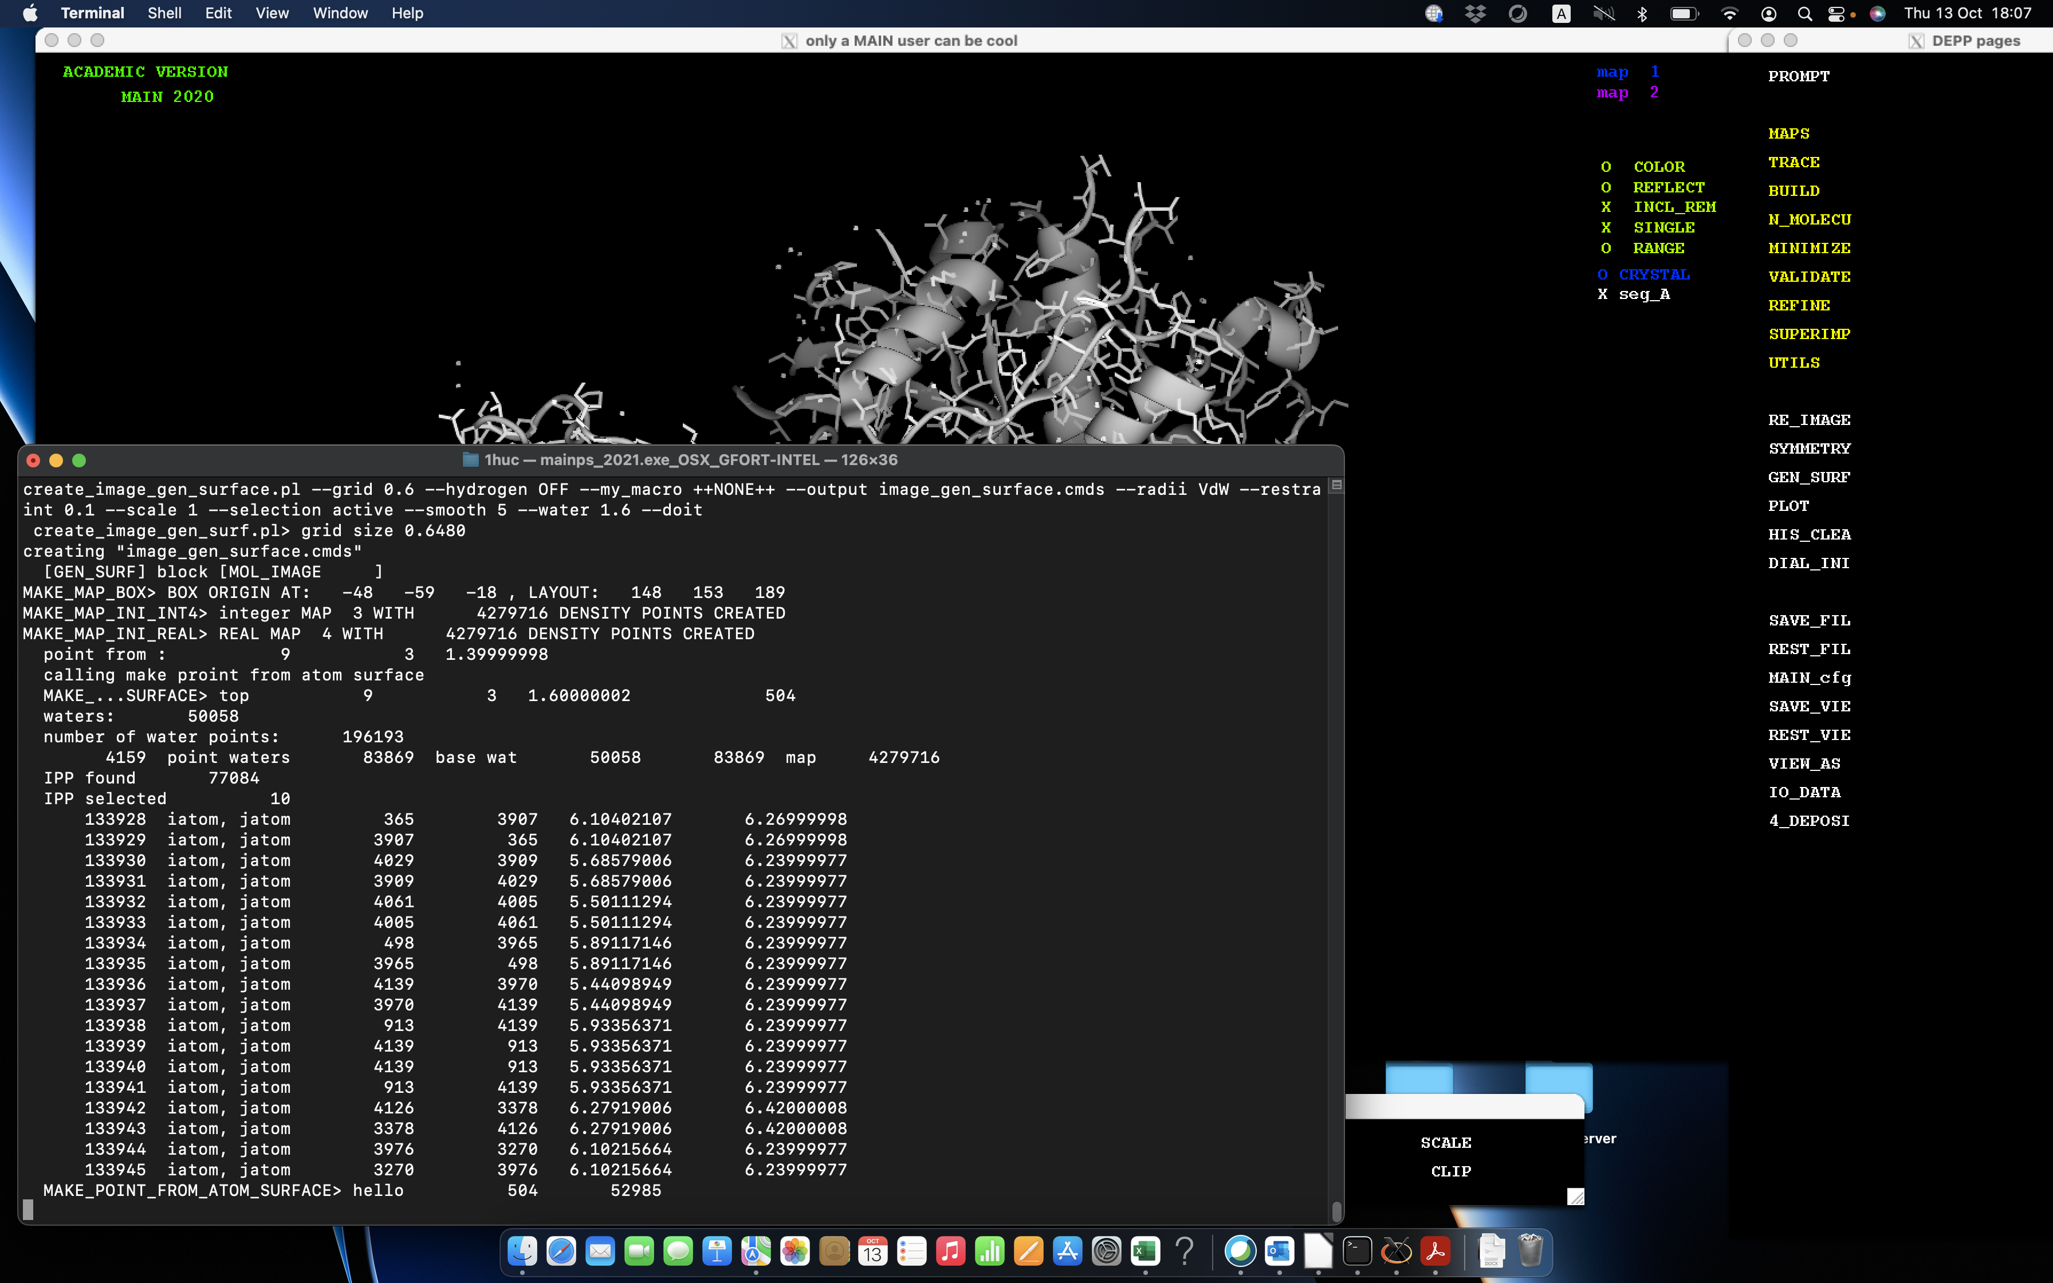

Figure 8. In my_term the output of the calculation of the protein surface is written. The calculation is finished when it is written “hello 504 52985” for 1huc.

In my_depp the button RE_IMAGE have to be clicked by Rmouse that the subwindow Tk: re_image.cmds appeared. In this subwindow for the “seg_A” at the column “SURFACE” the button “COLOR” have to be selected and the color of the surface – in this the color of the surface will be “WHITE” (Figure 9). To confirm the selection and close the subwindow click the button “Write-It” and then “Quit” by Lmouse. By clicking on “Write-It” the macro program code called “re_image.cmds” is prepared and by clicking again with Lmouse the button RE_IMAGE in my_depp this program code is implemented. Therefore for the preparation of more complex figures of proteins the code “re_image.cmds” presents basic macro program or code which could be adequately changed and later it will be presented how this code have to be changed.
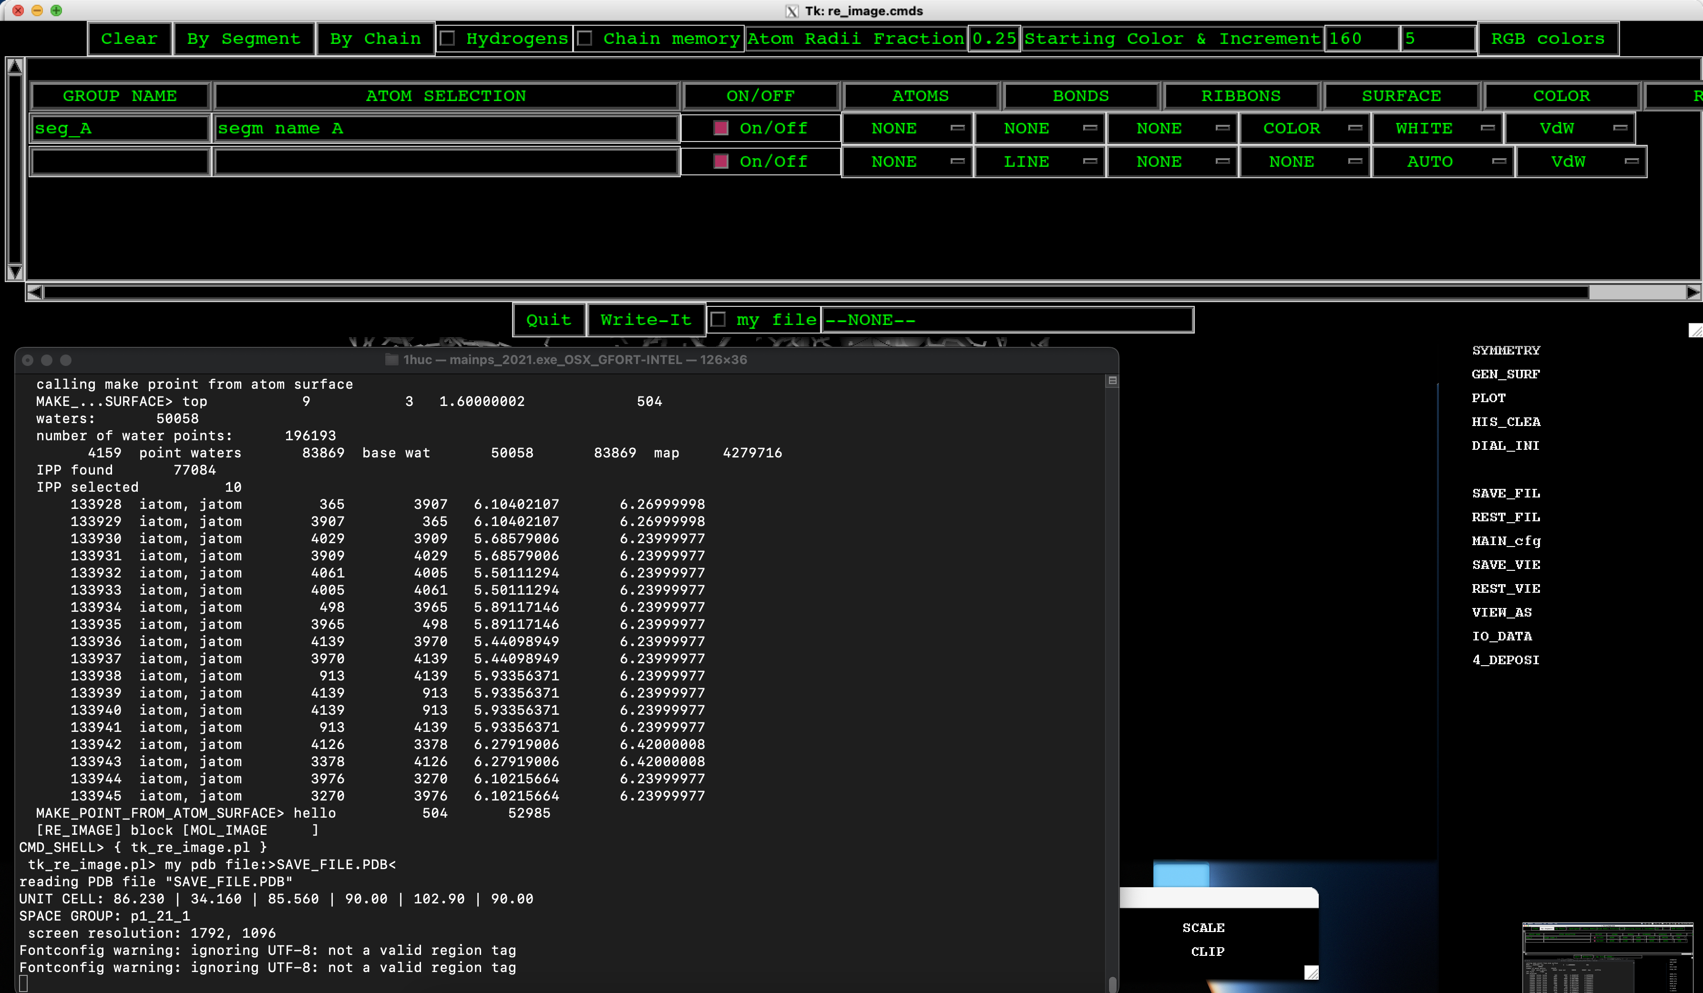

Figure 9. In my_depp the button RE_IMAGE have to be clicked by Rmouse that the subwindow Tk: re_image.cmds appeared. In this subwindow for the “seg_A” at the column “SURFACE” the button “COLOR” have to be selected and the color of the surface – in this the color of the surface will be “WHITE”. To generate code click on the button “Write-It” with Lmouse and close the subwindow by click on “Quit” with Lmouse again.

To run the prepared code called “re_image.cmds” and to draw the protein surface click the button RE_IMAGE in the my_depp (Figure 10) with Lmouse.
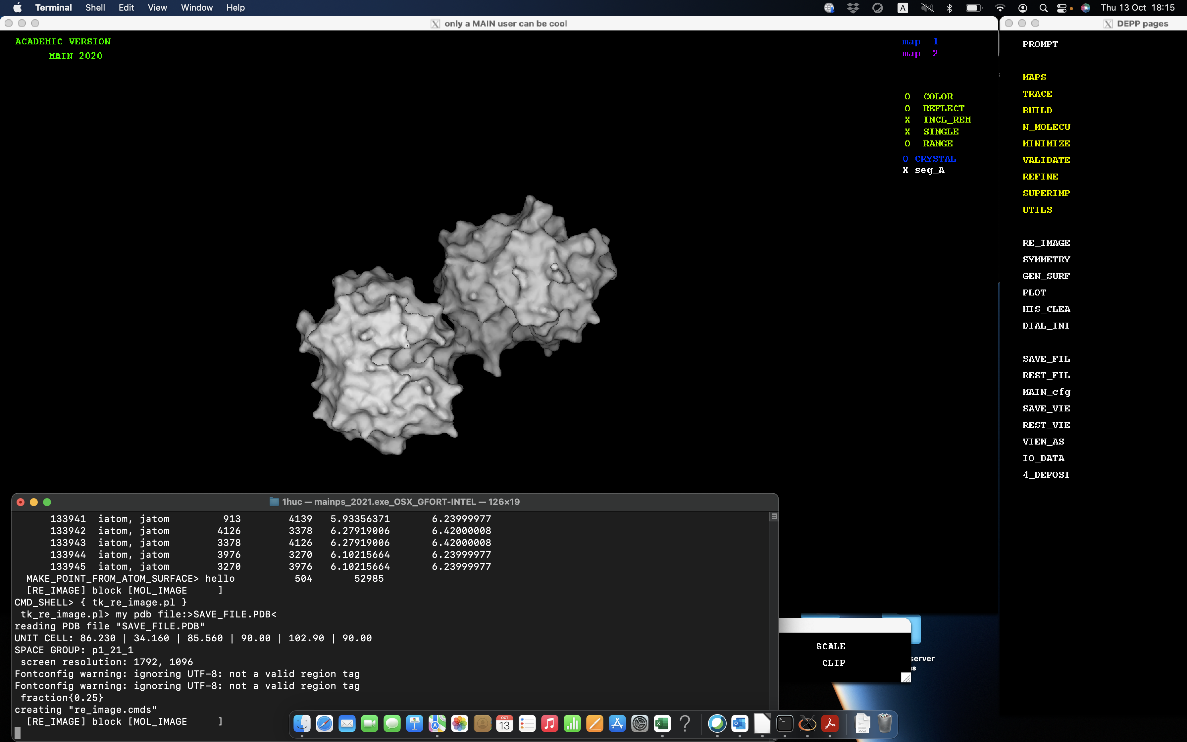

Figure 10. Generated surface of the protein 1huc.

To color selected amino acid residue with different colors select RE_IMAGE in my_depp by clicking Rmouse to open subwindow (Figure 11). In the second row write amino acid residue “glu”, sequential number of this residue “seq 194”, color “red” and then click “Write-It” and then “Quit” with Lmouse. The new red surface of residue at seq 194 could be seen in Figure 12.
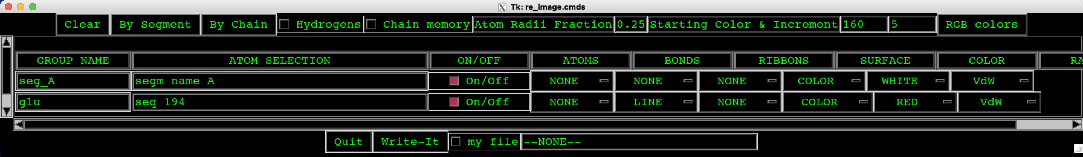
Figure 11. Selection of GLU 194 for coloring in red. To confirm the selection press ‘Write-It” and then “Quit” with Lmouse.
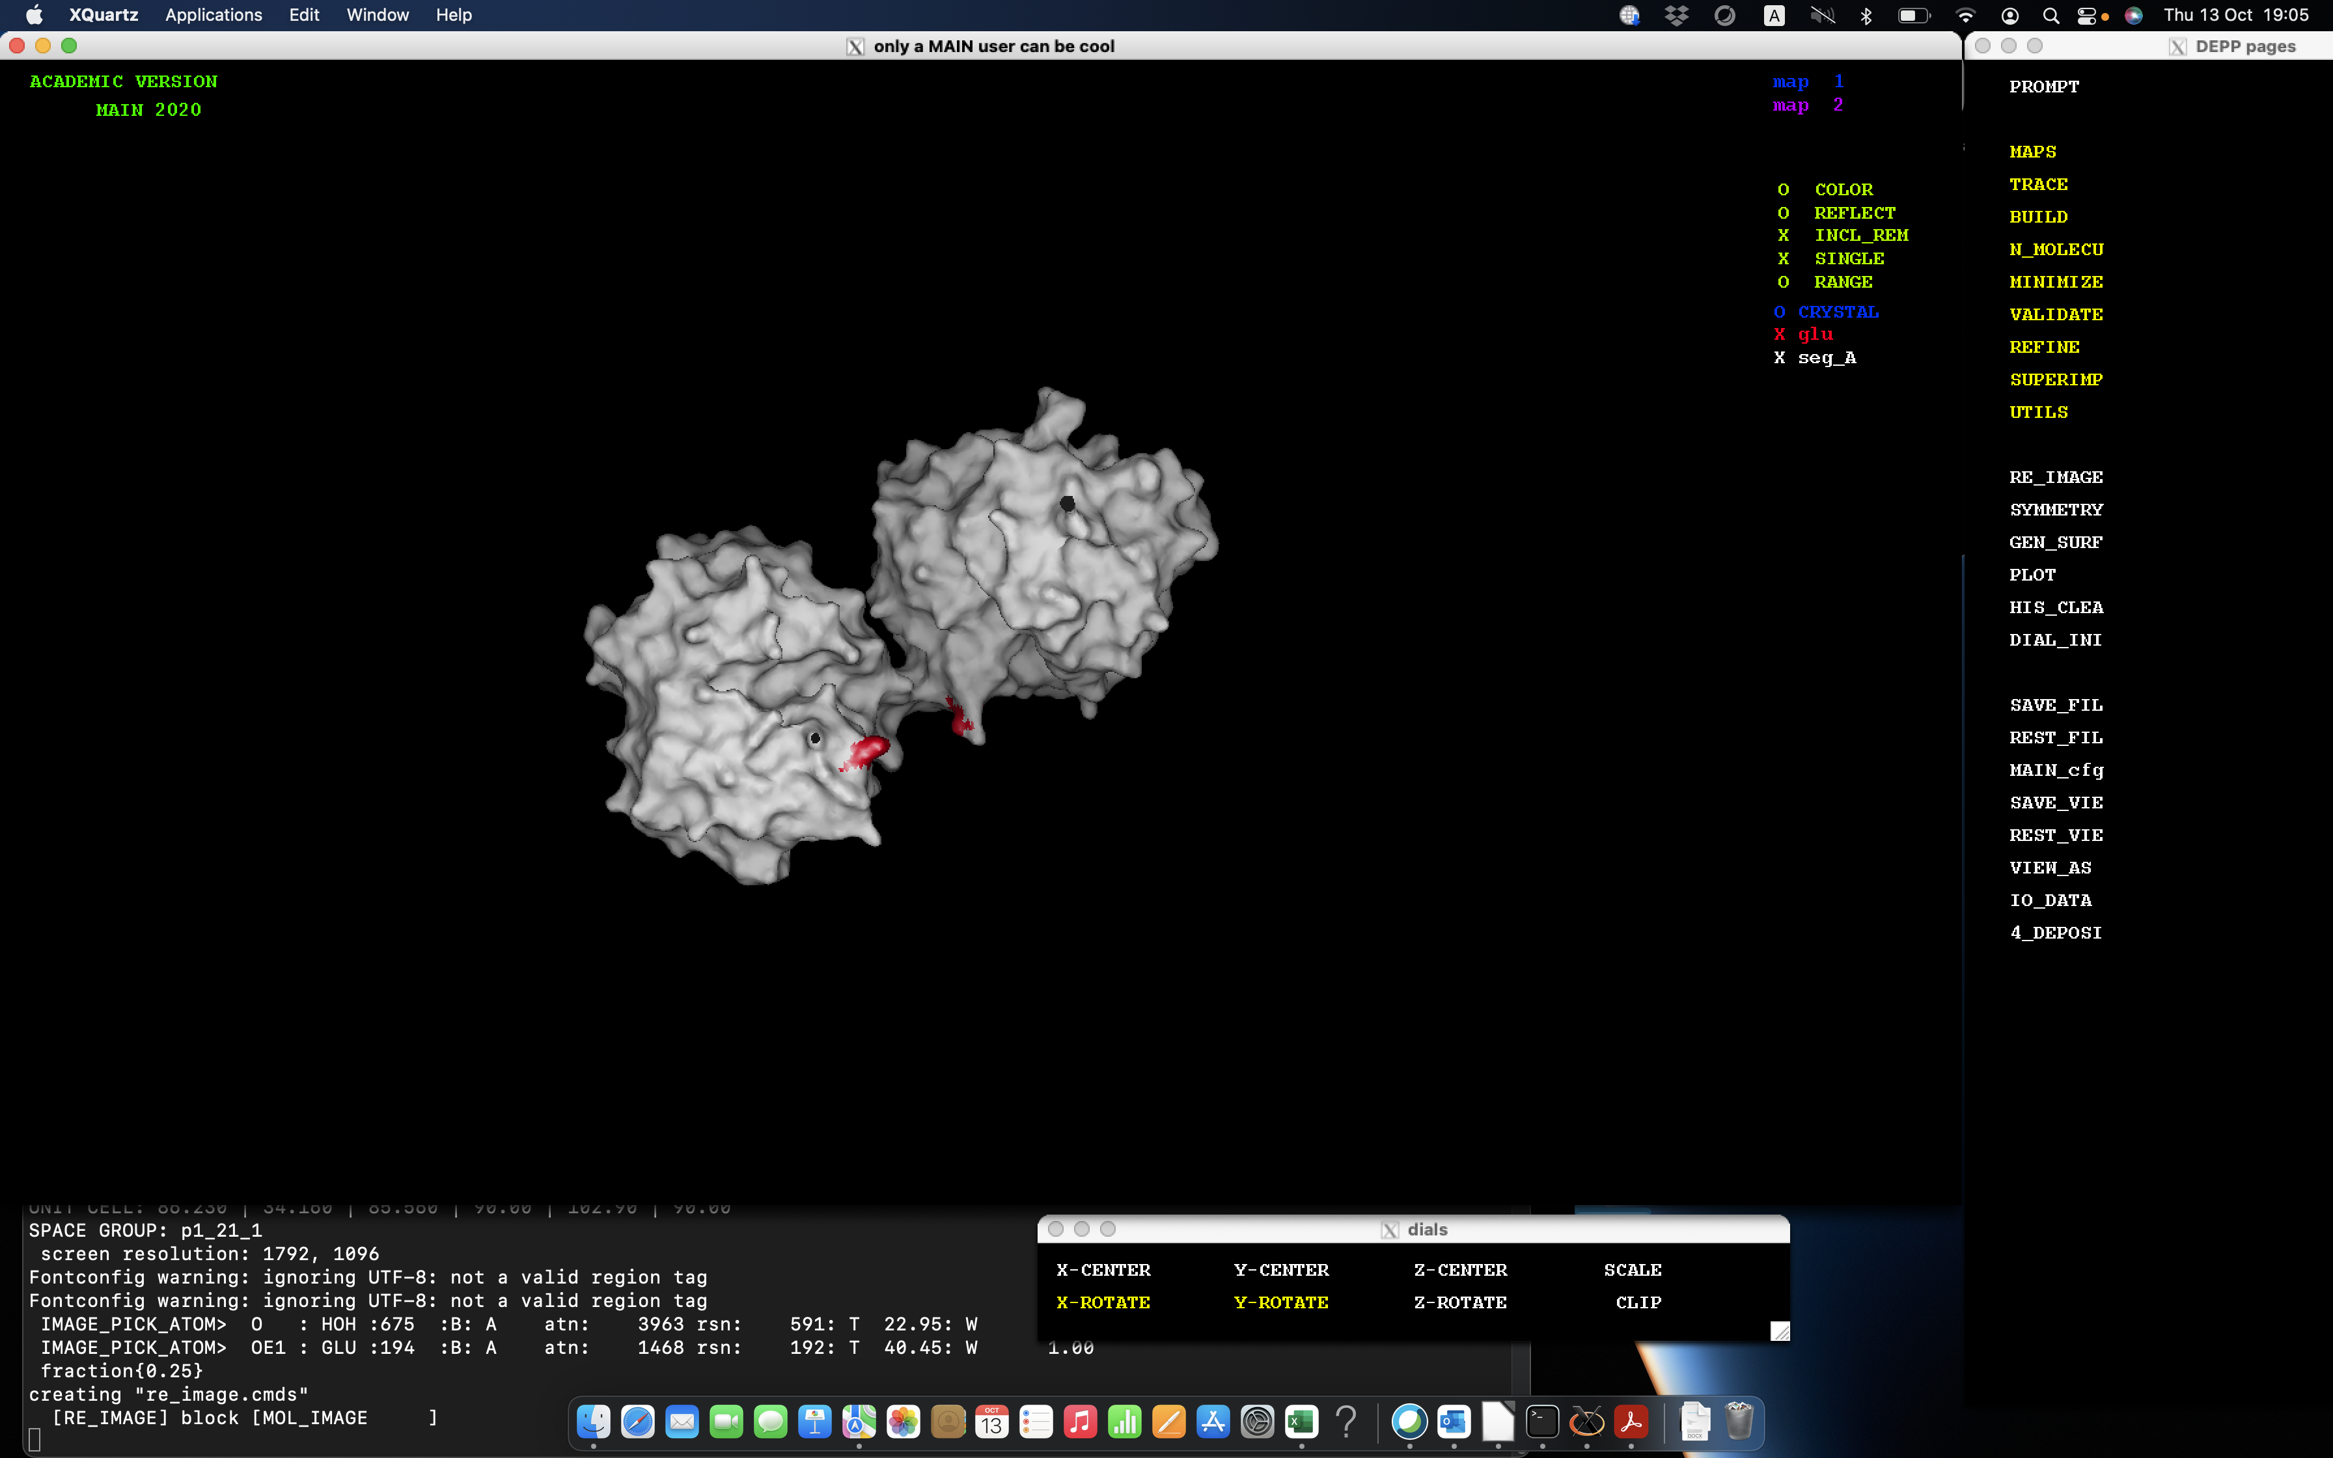
Figure 12. The amino acid residue with sequential number 194 was colored red.

To generate the png figure the button PLOT in my_depp have to be clicked by Rmouse button to open subwindow presented in Figure 13. To make png of at least 300 dpi, the dimension of the rendered image have to be at least 1500x1500 (in this case we input 1800x1800). The png protein structure could have white or black background. In Figure 13 the background will be white because in the second row “background of the rendered image” is written WHITE. In the row “molecular model image” have to be selected “RE_IMAGE” to keep in the png file red amino acid residue. Rendering program is RASTER3D and the name of file will be “image_save.r3d”. Then click “Write-It” and “Quit” than in my_depp again PLOT. In my_term we could see that the program RASTER3D is running and the png file created.

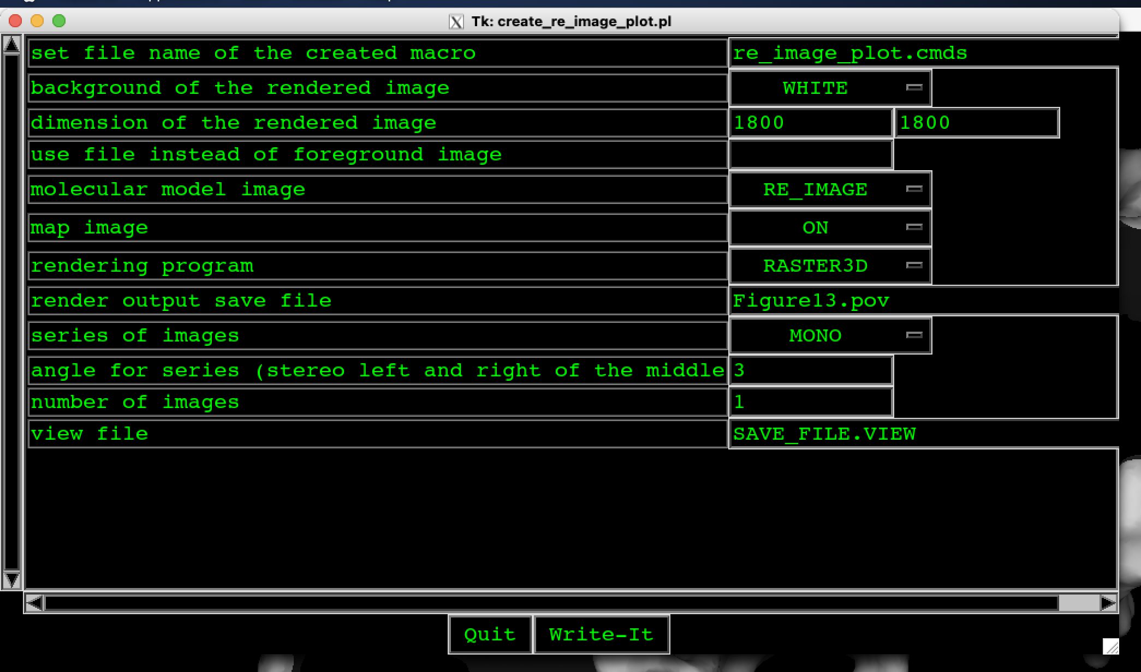
Figure 13. The subwindow of the button PLOT of my_depp when right mouse button was clicked. To make png of at least 300 dpi, the dimension of the rendered image have to be at least 1500x1500 (in this case we input 1800x1800). The png protein structure will have white background because in the second row “background of the rendered image” is written WHITE. We could select also BLACK background. In the row “molecular model image” have to be selected “RE_IMAGE” to keep in the png file red amino acid residue. Rendering program is RASTER3D and the name of file will be “image_save.r3d”.

Then click “Write-It”. To exit the MAIN program first select PROMPT in my_depp to get in my_term and then write “quit”:
MAIN>quit

2.4. Generation of png file of a complex between enzyme and inhibitor

The development of the structure of complex between mouse cathepsin B and DARPin 4m3 (enzyme and inhibitor) is explained in the continuation but in this chapter we would like to present the image development of this complex. To make the Figure 14 you have to prepare image by using GEN_SURF and RE_IMAGE buttons in my_depp and macro program called xx1.com which is the adequately changed macro code of MAIN program called “re_image.cmds”. The file “re_image.cmds” was changed after the GEN_SURF and RE_IMAGE was implemented. When xx1.com is prepared, the RE_IMAGE procedure have to be implemented again. Finally, by using PLOT button the png file is prepared.

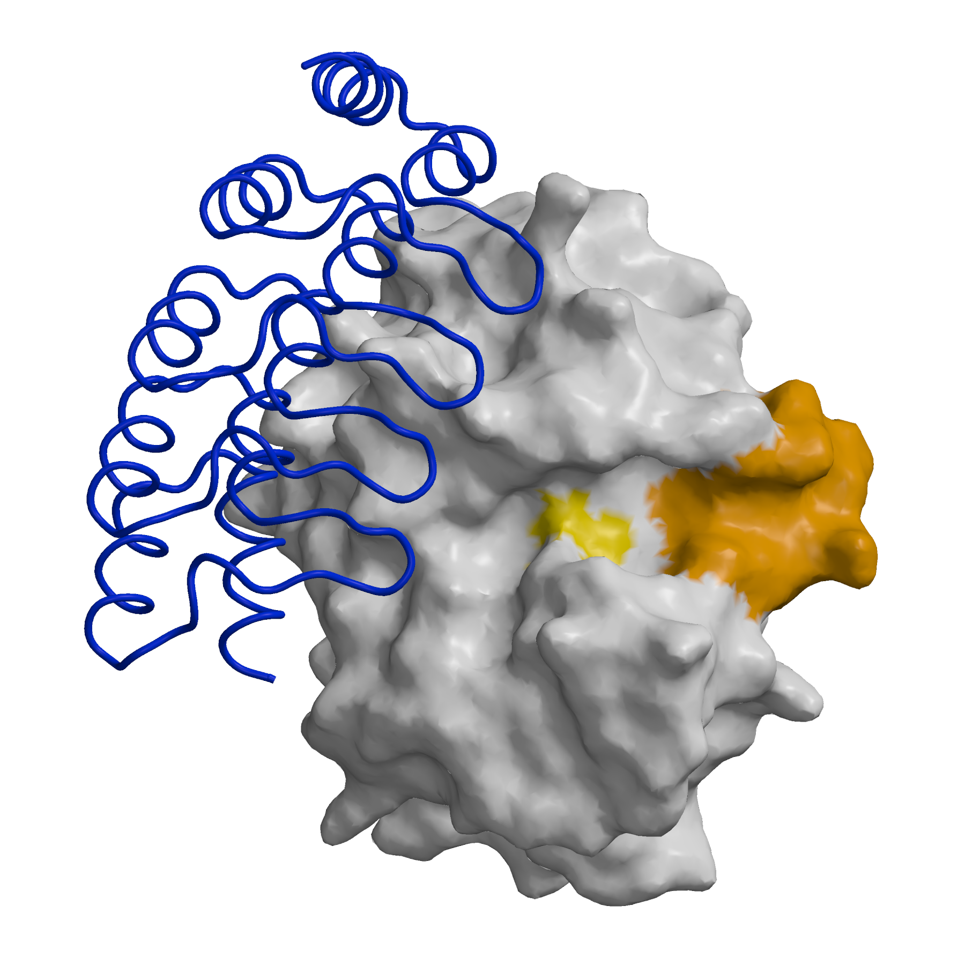
Figure 14. Complex of mouse cathepsin B and DARPin 4m3. Mouse cathepsin B is presented with white surface and DARPin 4m3 with blue ribbon. The yellow spots are Cys29 and His199. The orange area is occlusion loop of residues from 108 to 119.

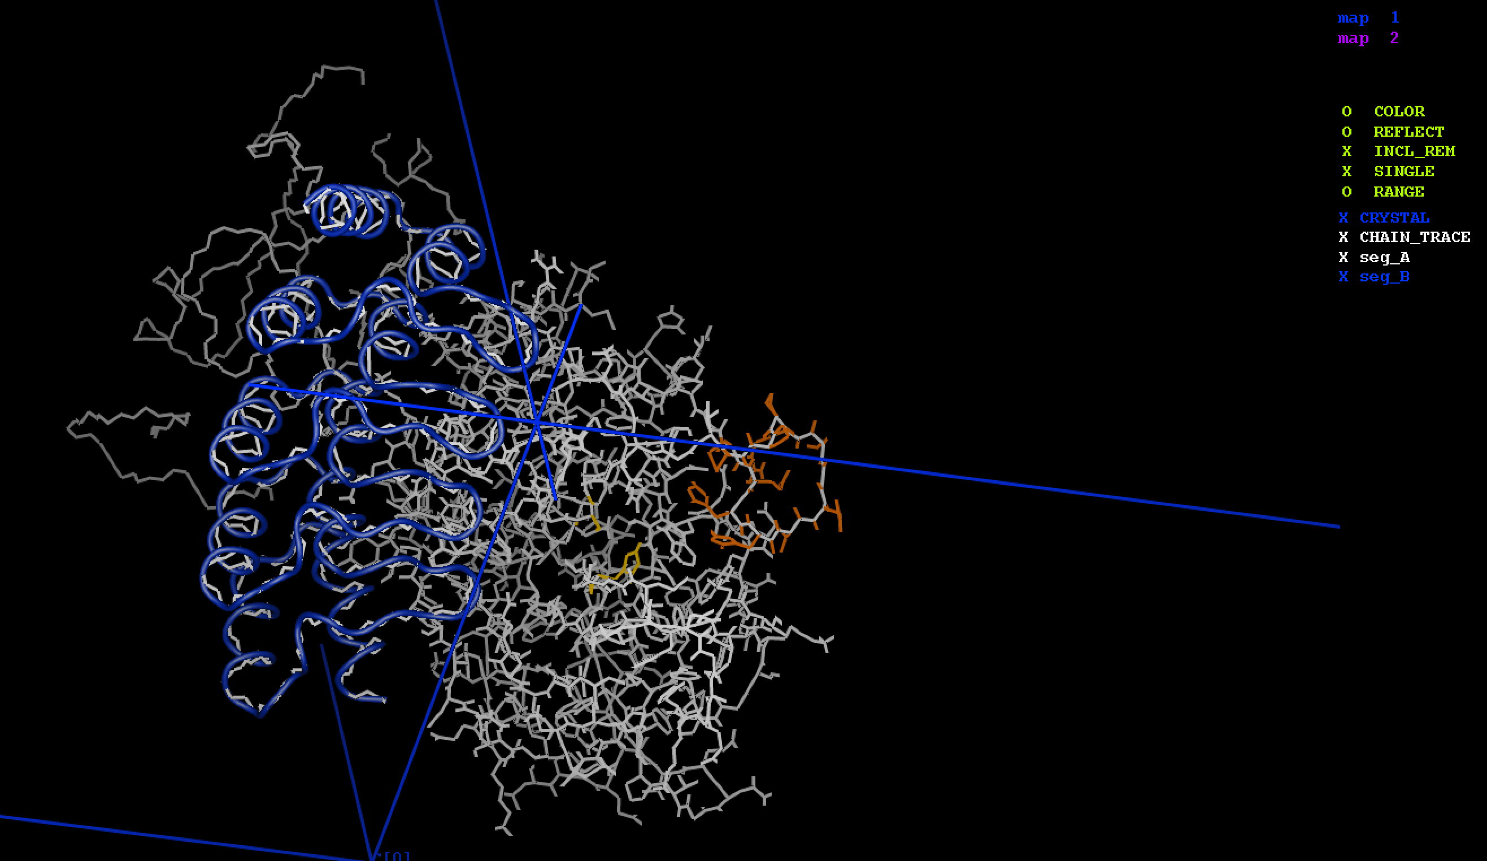
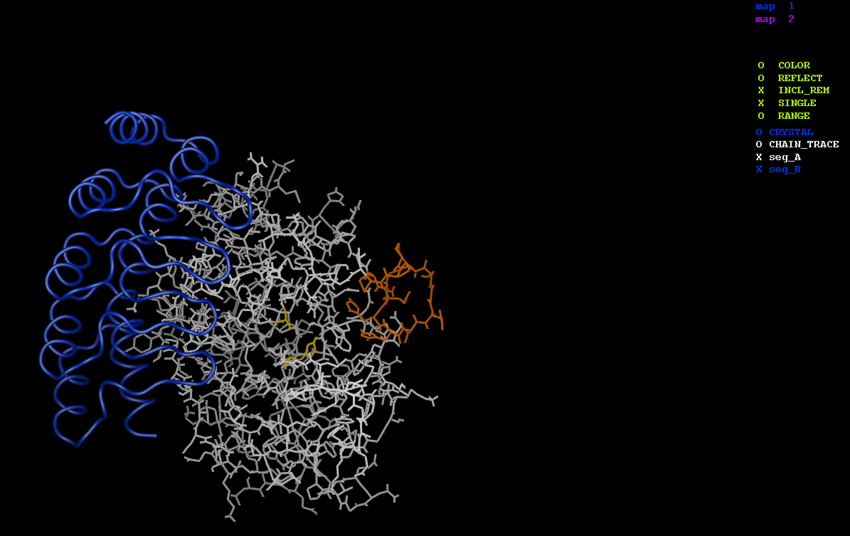
a) b)
Figure 15. The switch off of some visualization effects in my_image. a) The crystal displaying the selected crystal symmetry with blue lines (X CRYSTAL) and chain trace with grey lines (X CHAIN_TRACE) are switched on. b) The crystal displaying the selected crystal symmetry with blue lines (O CRYSTAL) and chain trace with grey lines (O CHAIN_TRACE) are switched off by clicking with mouse on X or X.

We generate the surface by opening the subwindow presented in Figure 16 by pressing GEN_SURF in my_depp (right mouse button( where some parameters have to be changed. Important is that at the “atom selection” only “segm name A” is specified. To have more correct surface of protein the “use of hydrogen atoms” is switched to OFF. Then close the subwindow by selecting “Write-It” and “Quit”. In my_depp press again GEN_SURF (left mouse button).

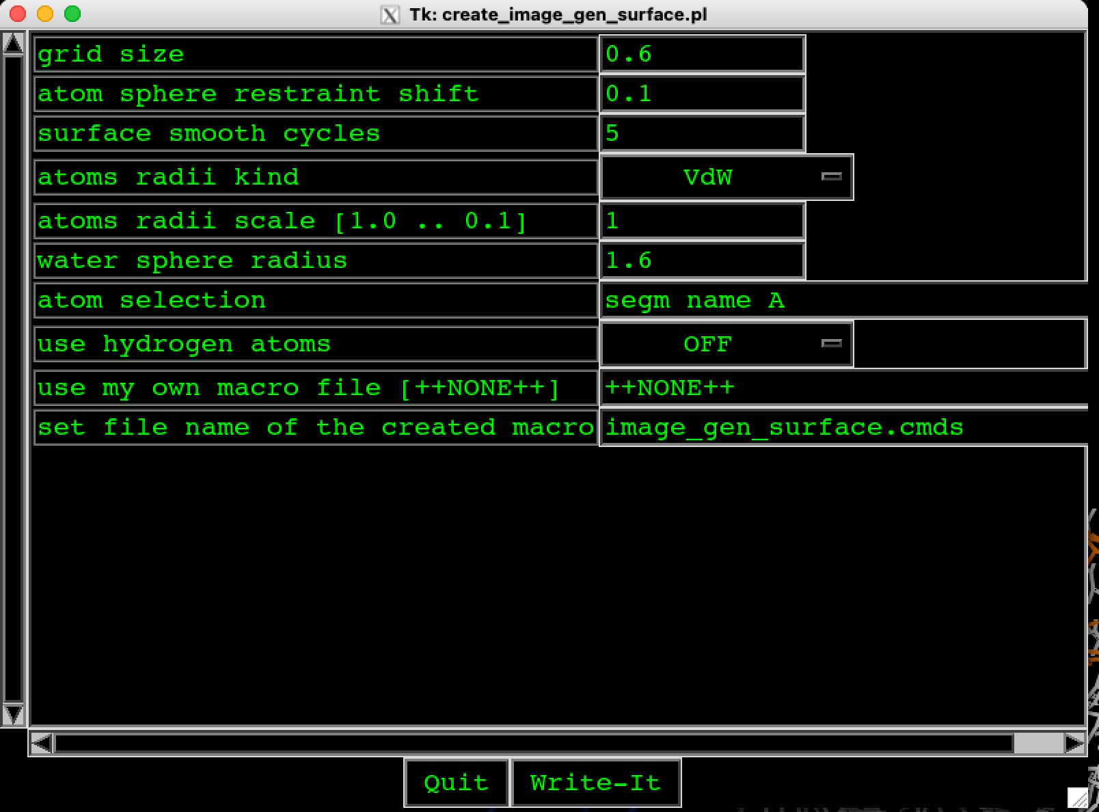

Figure 16. Parameters for calculation of the surface of only mouse cathepsin B therefore at the “atom selection” only “segm name A” is specified. To have more correct surface of protein the “use of hydrogen atoms” is switched to OFF.
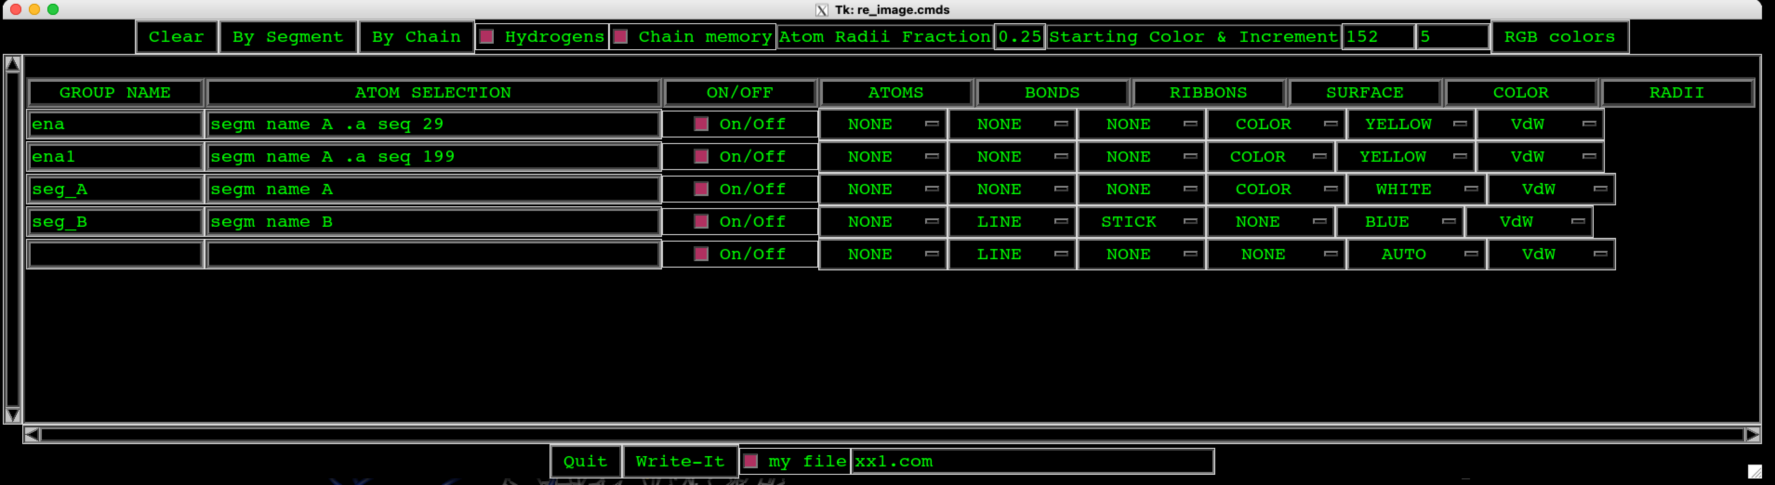
Figure 17. Parameters for calculation of new image of the selected complex taking into account the new macro code named xx1.com. The code is simply written into empty box and by clicking with the left button of the mouse on small box before “my file” this box became red. This mean that the xx1.com will be implemented during the procedure of the RE_IMAGE.

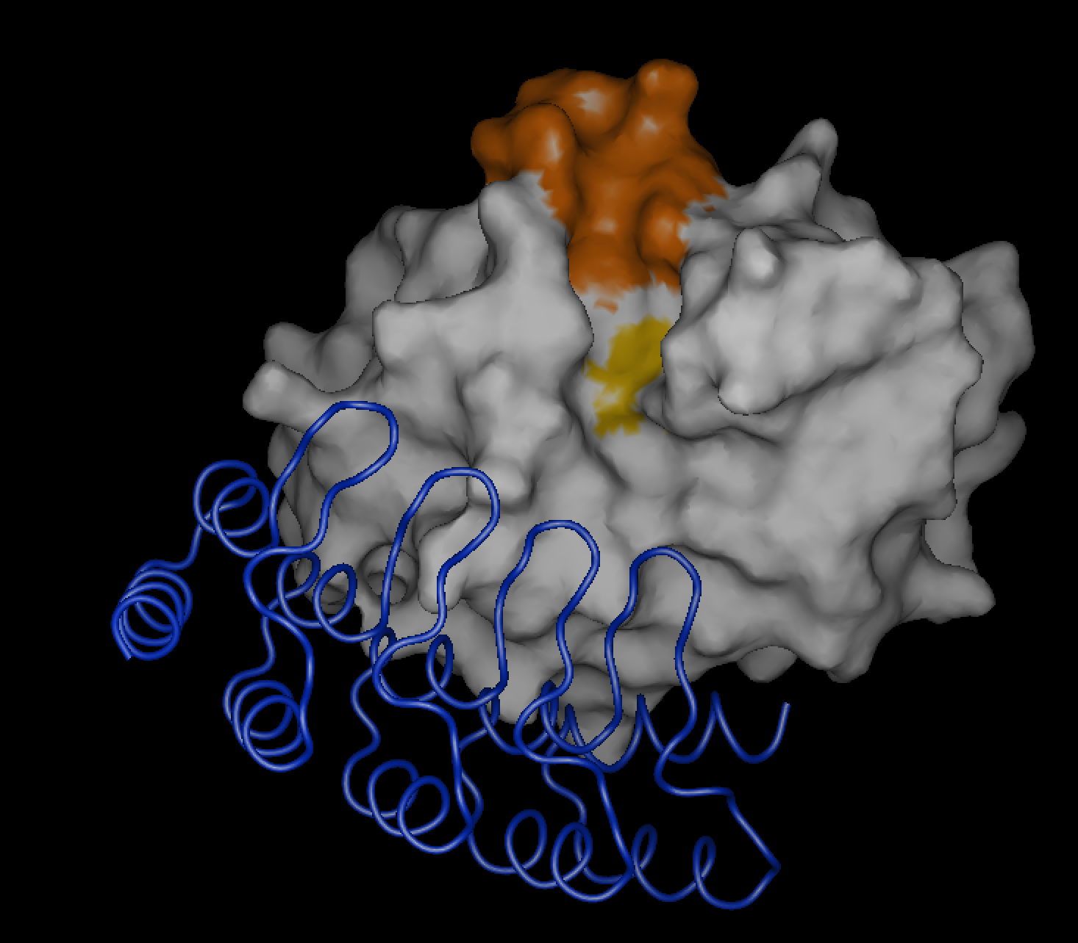

Figure 18. Figure of complex mouse cathepsin B and DARPin 4m3.

The content of the file “xx1.com” is as follows which is a modification of the macro of MAIN named re_image.cmds which was generated by clicking the “Write_It” as it presented in Figure 17. As could be seen in Figure 17, the newly generated code was named xx1.com and it was written directly into the empty box only before “my file” the small box have to become red by clicking with right mouse button. The xx1.com could be executed within the procedure RE_IMAGE.

We will explain shortly xx1.com macro code. The additional sentences in macro code are marked with dark green letters and original code with light green letters. The original code which was dropped out because it was not necessary, it is not marked. The comments are written in magenta after exclamation point ! which is mark for comment. But anyway, the user have to check macro codes carefully and only with the correct codes the images will be drawn properly.

“xx1.com”
subroutine char SEGMENTS

delete atom sele segm name #* end
key image sele .not all end

image from IMAGE_BASE

if ( MIN_TETHER .eq. "ON" ) then
key my_tether sele active end
end_if

image erase
vlt
color 33 red 1.00 green 1.00 blue 1.00 ! white
color 34 red 0.00 green 1.00 blue 1.00
color 35 red 1.00 green 0.00 blue 1.00
color 36 red 1.00 green 1.00 blue 0.00
color 37 red 1.00 green 0.50 blue 0.80
color 38 red 0.50 green 1.00 blue 0.80
exit

if ( MIN_TETHER .ne. "ON" ) then
image from CRYSTAL
image erase CHAIN_TRACE
image group name CHAIN_TRACE
image sele atom name CA C N .a segm name WORK_SEGM end col 1 bond
ima from CHAIN_TRACE
image erase

end_if

set level 0
image group name seg_A ! segm name A is mouse cathepsin B drawn with the white surface
key display select segm name A end
!key display select display .a .not atom name H* end

if ( MIN_TETHER .eq. ON ) then
key display sele display .and. .not. my_tether end
end_if

set color
sele display end col 32 ! white surface
sele seq 29 199 end col 156 ! yellow CYS29 and HIS199
sele seq 108 : 119 end col 148 ! orange occlusion loop
exit

key xx_active sele active end
key active sele display end
<?MAIN_CMDS:image_color_set.cmds
image select display end poin 3angle ( point rgb )
key image sele image .o ( display ) end
key active sele xx_active end
key xx_active drop

set rad sele display end VdW
scal 0.25 sele display end rad
image sele display end set bond line
image sele display .a .n by bond display end set atom cros
image sele display .a .n by bond all .a .n atom name O* end set atom ball

image group name seg_B ! segm name B is DARPin
key display select segm name B end

if ( MIN_TETHER .eq. ON ) then
key display sele display .and. .not. my_tether end
end_if

set color
sele display end col 244 ! blue ribbon
exit

dele point sele display end ribbon
make poin from atom sele display .a atom name CA end ribb both ! heli ! strand ! both
set rib rad 0.3 \
dens 16 \
step 8 \
refine 1

image set
image sele display end poin ribb ( stick helix 1.5 0.3 strand 0.8 0.3 )
key image sele image .o ( display .a atom name CA ) end

key display drop
return

To make a “png” file with the complex presented in Figure 18, click on PLOT with Rmouse button to open sub-window and repeat the procedure presented in Figure 13 up to this page.

To get the same view for more figures just adapt SAVE_FILE.VIEW or even change the name to, for example, SAVE_FILE1.VIEW (Figure 21).

To plot all bonds as it showed in Figure 19, first do the same as it is showed in Figure 20 and then in Figure 21.

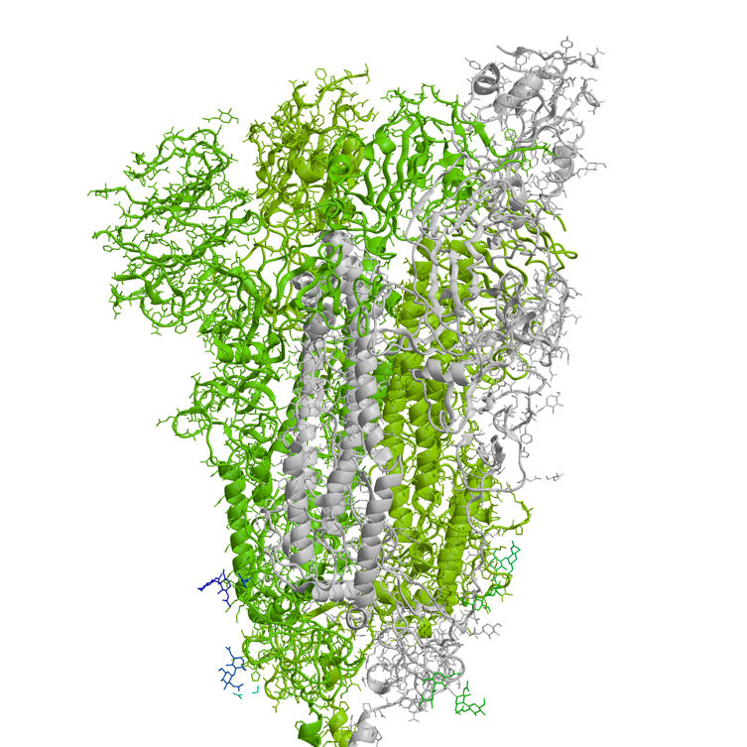
Figure 19. Protein structure is presented with all bonds.

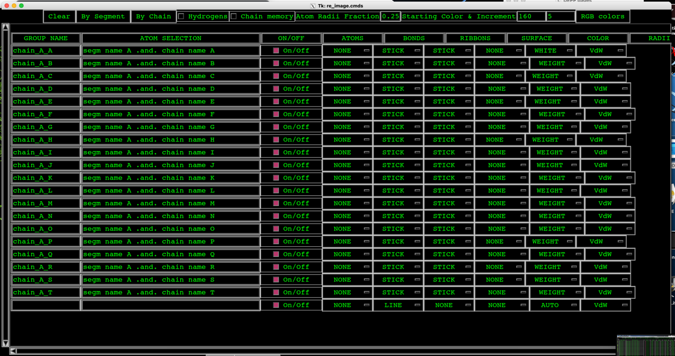
Figure 20. To get the protein structure presented in Figure 19, BONDS and RIBBONS must have status “STICK”.

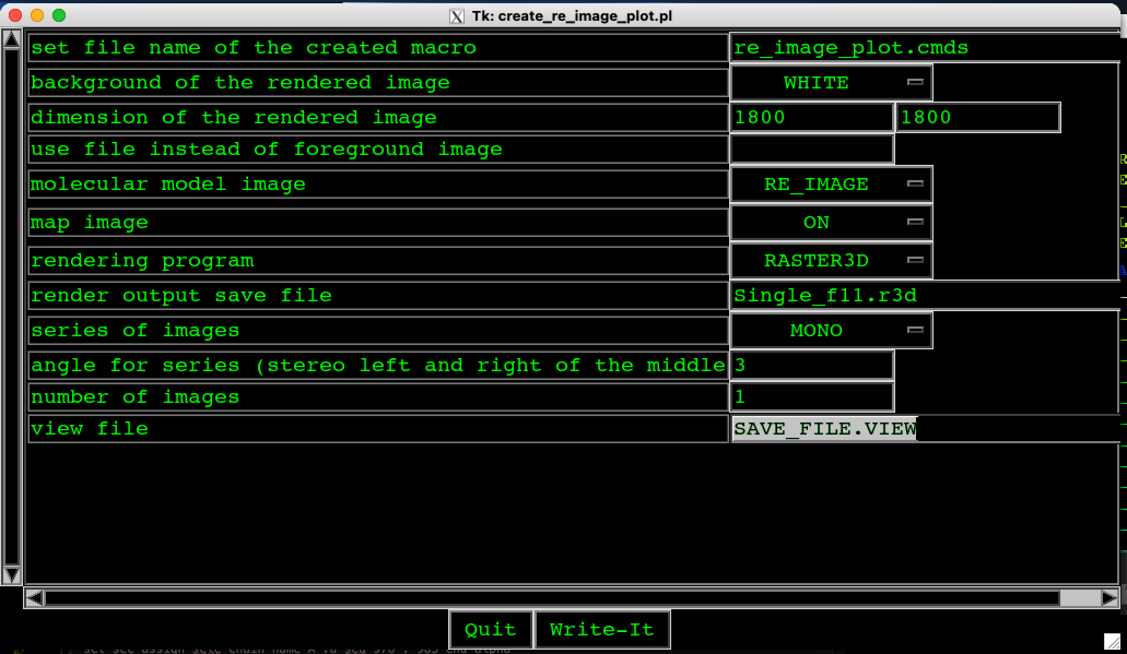
Figure 21. The dimensions of the figure are saved in text file “SAVE_FILE.VIEW” and the same profile of the protein structure is ensured.

2.5. To start MAIN program by using “tk_main_config.pl”

Program code tk_main_config.pl is a GUI (Graphical User Interface) to prepare your session by creating the library READ.COM:

>tk_main_config.pl

The selected protein could originated from PDB protein database or could have other origin but it must be written in PDB format. If we open PDB file, for example, 1huc.pdb, the other data are not needed. Then, you must click on “write-it” to write files of input data for MAIN followed by “Quit”.

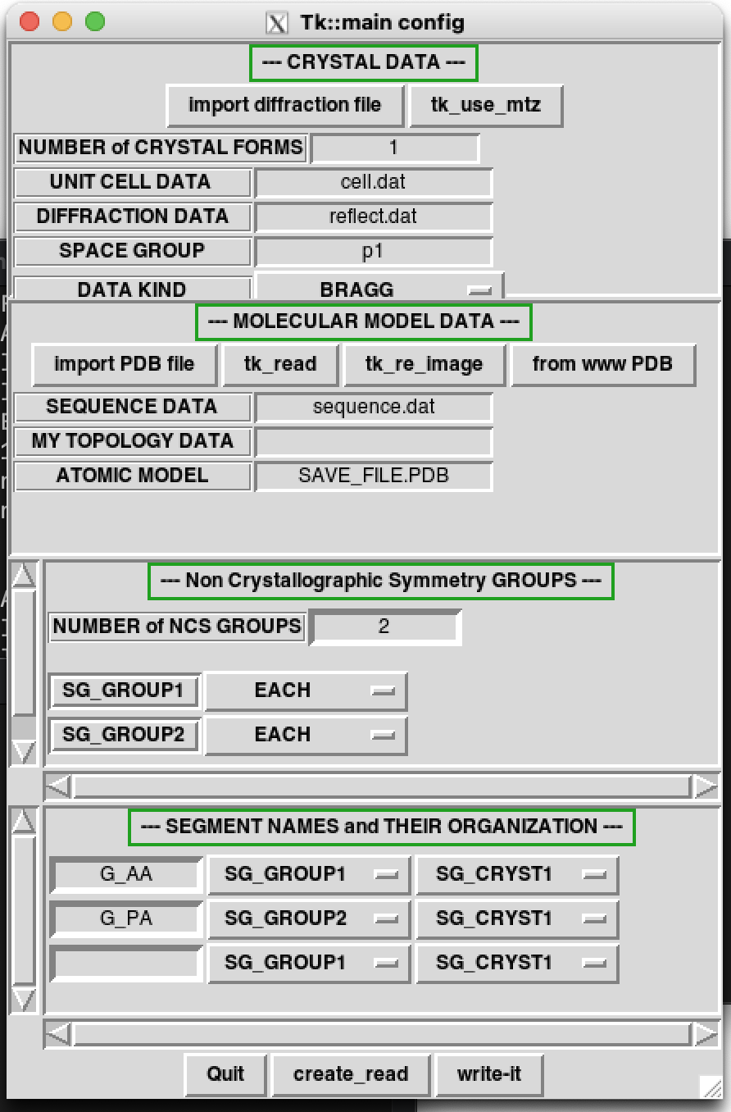

Figure 22. The form for input of data appeared when tk_main_config.pl is executed. If you select 1huc.pdb, the other data are not needed. Then, you must click on “write-it” to write files of input data for MAIN followed by “Quit”.

MAIN has the same files in LINUX and MAC OSX systems but to work with them you must create »mainps« in working system:

>create_auto_start.pl --doit

The file .main is created and we start the MAIN by using »mainps«.

2.6. Superimposed protein structures

Superimposition of the complex cathepsin V and peptide with residues GLY ALA LYS SER ALA ALA (“catV_subs_complex.pdb”; parts of proteins with UniProt codes Q8NC51, P1=52) and a short peptide from the human MST3 kinase with PDB code 3a7f with residues SER PHE GLY GLU VAL PHE (from 34 to 39) (parts from proteins with UniProt codes Q9P289, P1=36; Q9Y6E0, P1=48 for cathepsin V).

bash-3.2$ create_auto_start.pl -p catV_subs_complex.pdb –doit
bash-3.2$ mainps

In my_depp, we will open IO_DATA (Lmouse button) to add protein with PDB code 3a7f (Figure 20) which was already downloaded from PDB protein database.

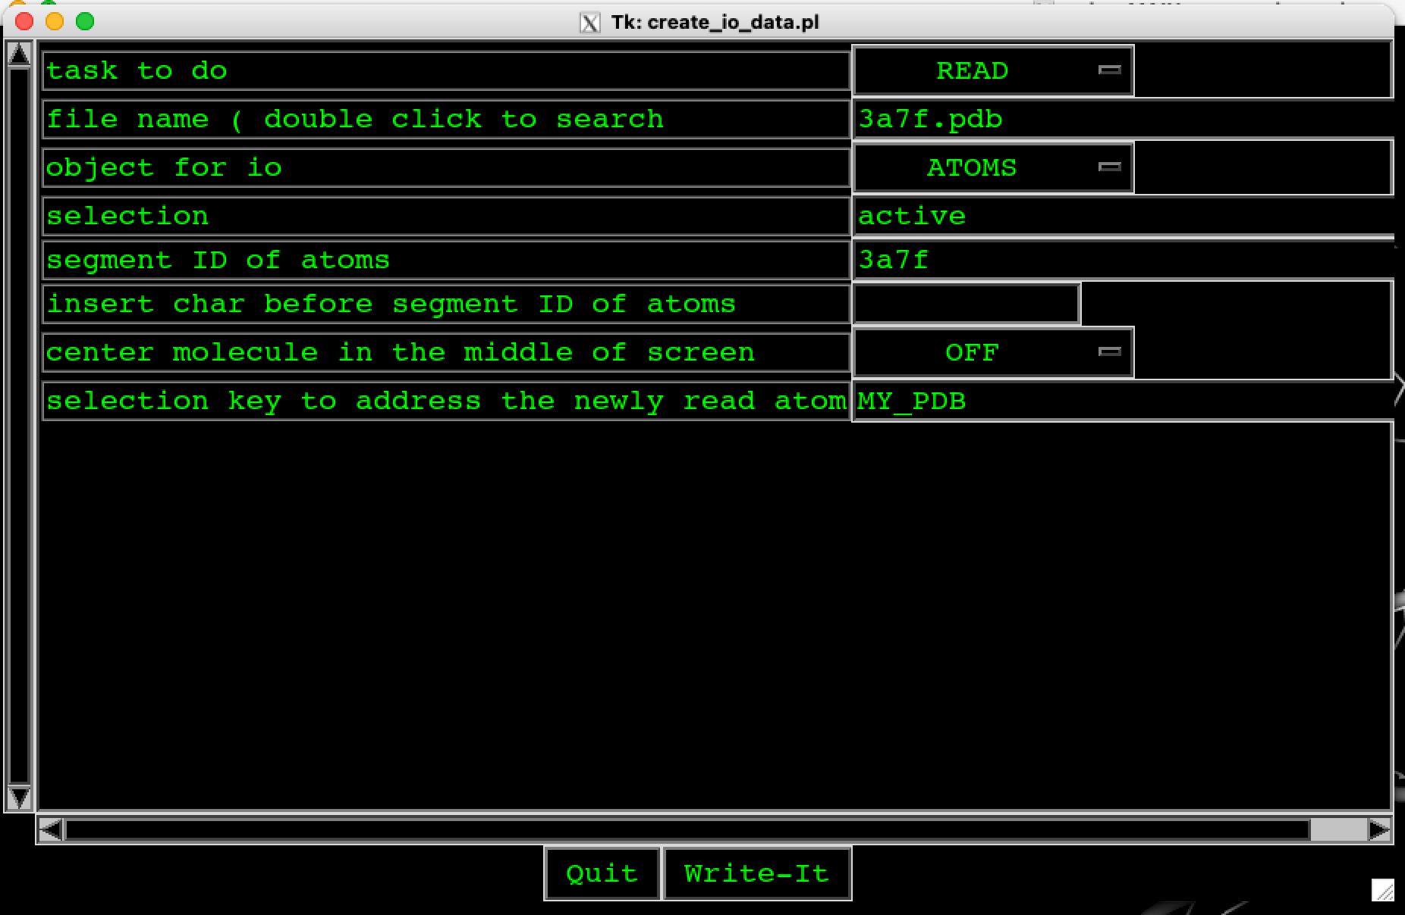

Figure 23. To add protein 3a7f to complex cathepsin V and peptide with residues GLY ALA LYS SER ALA ALA open IO-DATA of my_depp and input the following parameters: the file name with protein in this case 3a7f.pdb and the name of segment ID of atoms which can be up to 4 signs long. The proteins are by default in the center of the screen (ON) but in this case we select not to be in the center (OFF) because we will superimpose one short part of the 3a7f protein.

The name of “segment ID of atoms” can be composed up to 4 signs only, in this case the name was 3a7f. The proteins are by default in the center of the screen (ON) but in this case we select not to be in the center (OFF) because we will superimpose one short part of the 3a7f protein and not the whole proteins. Finally, press Write-It and in my_depp again IO_DATA.

Segm name B was first selected by clicking the SER 34 and then PHE 39 (names of residues were written in Figure 23). We opened UTILS in my_depp, select ACT_2RES (the square in front must be filled up) and press REN_SEGM which moves the cursor in window my_term where we have to input the name of segment: B (in our case) and press ENTER. The name of segment can be up to 4 characters long. ACT_2RES selects all atoms between the last two picked atoms.

Then open RE_IMAGE in my_depp and as can be seen in Figure 24 input new segm name 3a7f and B. For new segments, you could select colors i.e. CYAN and RIBBON STICK. Then close RE_IMAGE by Write-It and again RE_IMAGE in my_depp by right mouse button.

To superimpose new peptide SER PHE GLY GLU VAL PHE from 3a7f on another GLY ALA LYS SER ALA ALA, open SUPERIMP (click on right mouse button) in my_depp and again SUPERIMP (click on left mouse button) to open subwindow and input the parameters as could be seen in Figure 25.

The superimposed peptide SER PHE GLY GLU VAL PHE of 3a7f to GLY ALA LYS SER ALA ALA of the complex V is presented in Figure 26.
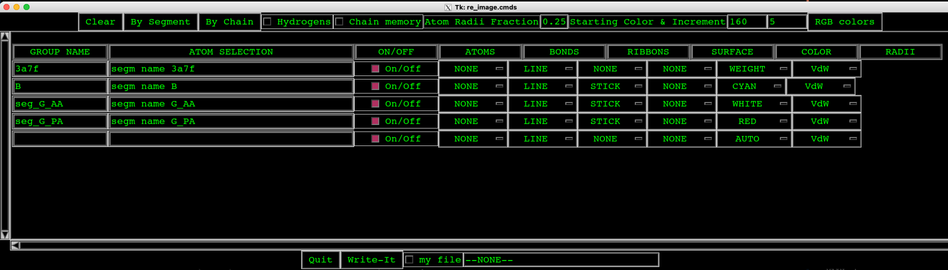
Figure 24. Input of new segments in RE_IMAGE of my_depp: segm name 3a7f which has been already defined in IO_DATA and segm name B which represents new peptide SER PHE GLY GLU VAL PHE of protein 3a7f and it was defined in UTILS (my_depp) with RE_SEGM.

set file name of the created macro | superimpose.cmds
source | SELECTION
way of superimposition | PAIR
from /source/ selection | segm name 3a7f .a resi string SER PHE GLY GLU VAL PHE
atom names | CA
applied to selection/when empty equals to from/ | segm name 3a7f
to /target/ selection | segm name G_PA
task | FIT
rotation matrix file | superimpose.com
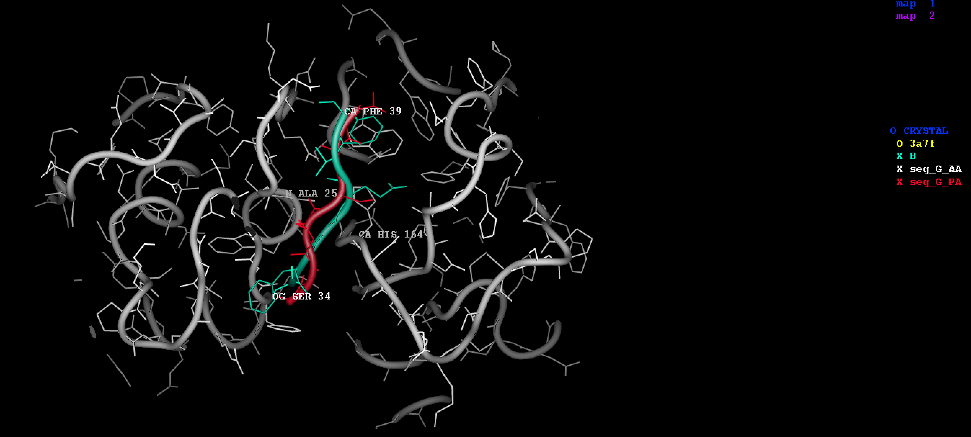
Figure 25. To superimpose peptide SER PHE GLY GLU VAL PHE of 3a7f to GLY ALA LYS SER ALA ALA the parameters written in table have to be input.
Figure 26. Complex of white - cathepsin V (C25A) with red peptide GLY ALA LYS SER ALA ALA superimposed with cyan peptide B from protein “3a7f.pdb”: SER PHE GLY GLU VAL PHE. The rest of the structure 3a7f is not presented because as you could see in front of 3a7f “O” instead of “X”.

2.7. Starting a new chain

We want to build alanine chain 10 residues long followed by a tryptophan and 3 cysteines. The chain starts to grow from the image center, so it should be set properly by dials or mouse. The BUILD menu should be in START mode, a SEGMENT name and SEQUENCE root are supposed to be defined. Afterwards picking item "RESID ??" activates a chain generation.
The "RESID ??" prompt should be answered with desired residue sequence "10 ALA". The desired sequence appears as an extended chain growing from the middle of the image screen.

2.8. Use of pairs

PAIR constraints require previously defined pair list. Two atoms in a pair are pulled together or pushed apart to a specified distance with a force (stored in the variable "force_pair") acting as a harmonic oscillator (analytically identical to the BOND energy term).

In my_term when we select the complex of protein structures, for example, mouse cathepsin B and DARPin 4m3, we input the following code:

calc pair select segm name A and segm name B end rad 3.0
image pair sticks
show pair

calc pair ( segm name A and segm name B end rad 3.0 )

3. Lesson: Model building or density interpretation and refinement

3.1. Data input

The input data are:
- MTZ file
- PDB file
- Sequence file

1.MTZ file
The MTZ file format is special format used for storage of reflection data. It is not ASCII file therefore it could not be red by usual editor programs.
File for “A” case is “output_file_name.mtz”. MAIN program reads these file format.

2.PDB file
PDB format or Protein Data Bank format is standard ASCII file containing coordinates of atoms.
First 5 lines of file “model_0.pdb” for A case are as follows:

ATOM 1 N VAL H 2 29.515 -5.303 9.147 1.00 39.90 H N
ATOM 2 CA VAL H 2 28.879 -6.547 8.596 1.00 38.19 H C
ATOM 3 C VAL H 2 28.244 -6.265 7.235 1.00 37.57 H C
ATOM 4 O VAL H 2 27.278 -5.515 7.135 1.00 39.53 H O
ATOM 5 CB VAL H 2 27.821 -7.143 9.564 1.00 39.52 H C
….

3.Sequence file
Sequence file contains amino acid residues of the protein and MAIN has its own format: 50 residues per line in blocks of 10 residues with one space between as could be seen in example for A case and file »sequence.dat« for one molecule (antibody H, L):

molecule H
1 DVHLQESGPG LVKPSQSLSL TCSVTGYSIT SGYYWNWIRQ FPGNKLEWMG 50
51 YIGYDGSNNS NPSLKNRISI SRDSSKNQFF LKLNSVTSED TATYYCARRG 100
101 GAFDYWGQGT TLTVSSAKTT PPSVYPLAPG SAAQTNSMVT LGCLVKGYFP 150
151 EPVTVTWNSG SLSSGVHTFP AVLQSDLYTL SSSVTVPSST WPSETVTCNV 200
201 AHPASSTKVD KKIVPRDCGK HHHHHH 226

molecule L
1 DIVLTQTPLS LPVSLGDQAS ISCRSSRSIL HSNGNTYLEW YLQKPGQSPK 50
51 LLIYKISNRF SGVPDRFSGS GSGTDFTLKI SRVEAEDLGV YYCFQGSHVP 100
101 WTFGGGTKLE IKRADAAPTV SIFPPSSEQL TSGGASVVCF LNNFYPKDIN 150
151 VKWKIDGSER QNGVLNSWTD QDSKDSTYSM SSTLTLTKDE YERHNSYTCE 200
201 ATHKTSTSPI VKSFNRNEC 219

end

Bellow is an example of »sequence.dat« for two different molecules B case (enzyme A, A2 and its inhibitor B, B2):

molecule A
1 LPETFDAREQ WSNCPTIGQI RDQGSCGSCW AFGAVEAISD RTCIHTNGRV 50
51 NVEVSAEDLL TCCGIQCGDG CNGGYPSGAW SFWTKKGLVS GGVYNSHVGC 100
101 LPYTIPPCEH HVNGSRPPCT GEGDTPRCNK SCEAGYSPSY KEDKHFGYTS 150
151 YSVSNSVKEI MAEIYKNGPV EGAFTVFSDF LTYKSGVYKH EAGDMMGGHA 200
201 IRILGWGVEN GVPYWLAANS WNLDWGDNGF FKILRGENHC GIESEIVAGI 250
251 PRTD 254

molecule B
1 MDLGKKLLDA ASAGQDDEVR ILMANGADVN ASDAHGRTPL HAAAWSGHLE 50
51 IVDVLLAHGA DVNASDKYGY TPLHLAASYG HLEIVDVLLA NGADVNASSK 100
101 YGNTPLHVAA TSGHLEIV/DV LLAHGADVNA NTAAGKTPFD LAIDNGNEDI 150
151 AEVLQKAAAA ALEVLFQGPL EHHHHHH 177

molecule B2
1 MDLGKKLLDA ASAGQDDEVR ILMANGADVN ASDAHGRTPL HAAAWSGHLE 50
51 IVDVLLAHGA DVNASDKYGY TPLHLAASYG HLEIVDVLLA NGADVNASSK 100
101 YGNTPLHVAA TSGHLEIVDV LLAHGADVNA NTAAGKTPFD LAIDNGNEDI 150
151 AEVLQKAAAA ALEVLFQGPL EHHHHHH 177

molecule A2
1 LPETFDAREQ WSNCPTIGQI RDQGSCGSCW AFGAVEAISD RTCIHTNGRV 50
51 NVEVSAEDLL TCCGIQCGDG CNGGYPSGAW SFWTKKGLVS GGVYNSHVGC 100
101 LPYTIPPCEH HVNGSRPPCT GEGDTPRCNK SCEAGYSPSY KEDKHFGYTS 150
151 YSVSNSVKEI MAEIYKNGPV EGAFTVFSDF LTYKSGVYKH EAGDMMGGHA 200
201 IRILGWGVEN GVPYWLAANS WNLDWGDNGF FKILRGENHC GIESEIVAGI 250
251 PRTD 254

end

The file name »sequence.dat« is default name for MAIN program and it is red automatically. If we select another name, we have to define this name in MAIN program during the procedure of reading data (Figure 22).

In the case of input of three files of data into MAIN program, the MAIN is started (Figure 22):
bash-3.2$ tk_main_config.pl

and the form presented in Figure 27 appeared. We input data in four areas:

1. CRYSTAL DATA. The MTZ format file name have to be input. The resolution is taken from the MTZ file. The default resolution of a data in MAIN program is 3.0A. When we start building a model, we usually select lower resolution, for example, the experimental one is 1.6 but we started with 2.5.

2. MOLECULAR MODEL DATA. The PDB format file name and sequence data have to be input.

3. Non Crystallographic Symmetry GROUPS. The number of groups is 2 and 4 for the case A and B, respectively. We can input this data also later within the MAIN program.

4. SEGMENT NAMES and THEIR ORGANIZATION. The groups have to be input in the same order as they are written in file “sequence.dat”. For example, we must input for the A case first H and then L and for the B case A, B, B2, and A2. We can input this data also later in MAIN program.

The file “sequence.dat” was red automatically together with reading PDB file when we click the button “write-it” and then “Quit”. When the button “write-it” is clicked the following structure parameters are written in my_term window:

IMPORT diffraction file my.mtz
use_mtz.pl --mtz output_file_name.mtz --doit
reading mtz file "output_file_name.mtz" 0 >>>my.mtz<<<
CELL 42.7860 94.5190 57.7980 90.0000 94.7490 90.0000
CELL_DATA: 42.7860 94.5190 57.7980 90.0000 94.7490 90.0000
FILE_CELL: cell.dat
FILE_MTZ: output_file_name.mtz
FILE_MTZ_NATIVE: USE_FILE
FILE_REFL: reflect.dat
INIT_MAP: NONE
MTZ_FOBS: FP
MTZ_HLA:
MTZ_HLB:
MTZ_HLC:
MTZ_HLD:
MTZ_IOBS: IMEAN
MTZ_ISIGMA: SIGIMEAN
MTZ_PHASE:
MTZ_SIGMA: SIGIMEAN
MTZ_TEST:
MTZ_TEST_WAY: CCP4
MTZ_WEIGHT:
REFL_TEST_FRACT: 20
RESOLUTION: 47.259 1.852
SPACE_GROUP: p1_21_1
UNUSED MTZ FILE COLUMNS:
q:SIGIMEANSIGFP
Q: SIGFP
creating "cell.dat"
creating "p1_21_1.symm"
all_crystals> n_crystals 1
file sequence: sequence.dat model: sequence.dat
create_auto_start.pl --pdb model_0.pdb --groups SEGMENTS --crystal USE --doit
creating ".main"
topo loop: POLAR_H
topo loop: RCSB_NUC
reading PDB file "SAVE_FILE.PDB"
/Users/Fani/Desktop/MAIN/top/top_99_csd.main
/Users/Fani/Desktop/MAIN/top/top_prot_adds.main
/Users/Fani/Desktop/MAIN/top/top_sme.main
/Users/Fani/Desktop/MAIN/top/top_ion.main
my topo files: /Users/Fani/Desktop/MAIN/top/top_dna_rna.main
reading TOPOLOGY file "/Users/Fani/Desktop/MAIN/top/top_99_csd.main"
reading TOPOLOGY file "/Users/Fani/Desktop/MAIN/top/top_prot_adds.main"
reading TOPOLOGY file "/Users/Fani/Desktop/MAIN/top/top_sme.main"
reading TOPOLOGY file "/Users/Fani/Desktop/MAIN/top/top_ion.main"
reading TOPOLOGY file "/Users/Fani/Desktop/MAIN/top/top_dna_rna.main"
AUTO_START> 1segm list: H L
0 segm group H
0 segm group L
nn: 0 groups: 2 1
creating "read.com"
topo loop: POLAR_H
topo loop: RCSB_NUC
my topologies
cryst data >0<
crystal: 1
format:MAIN
file:reflect.dat
data:BRAGG
cryst new NONE 0 >BRAGG< : >BRAGG<
fraction{0.3}
creating "re_image.cmds"

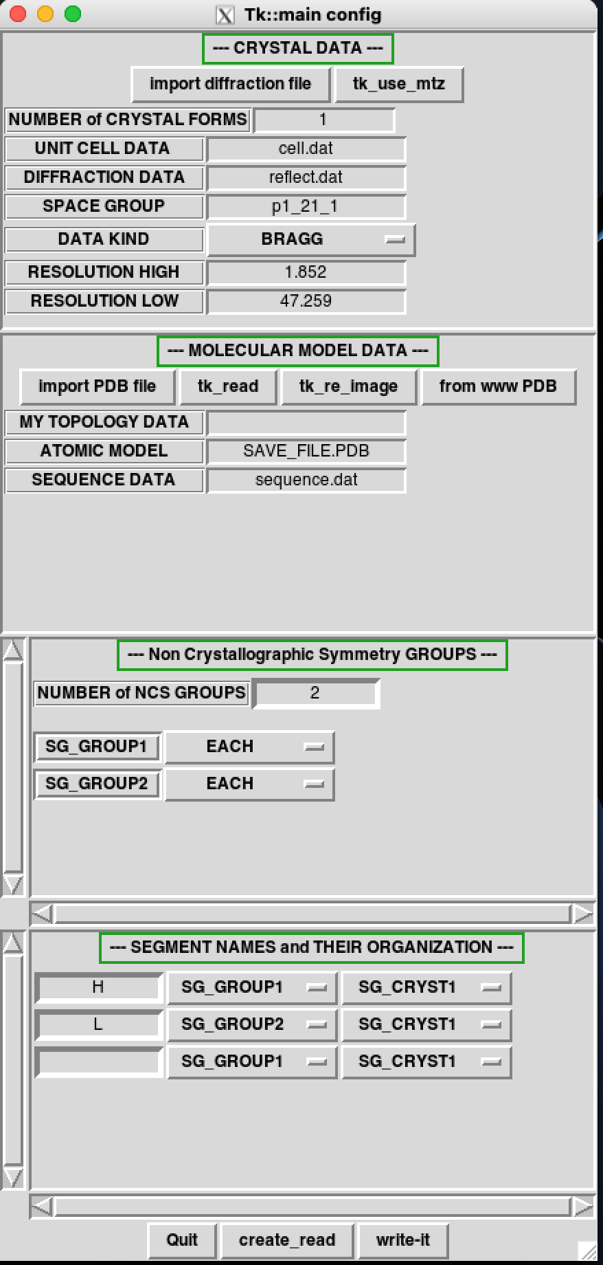
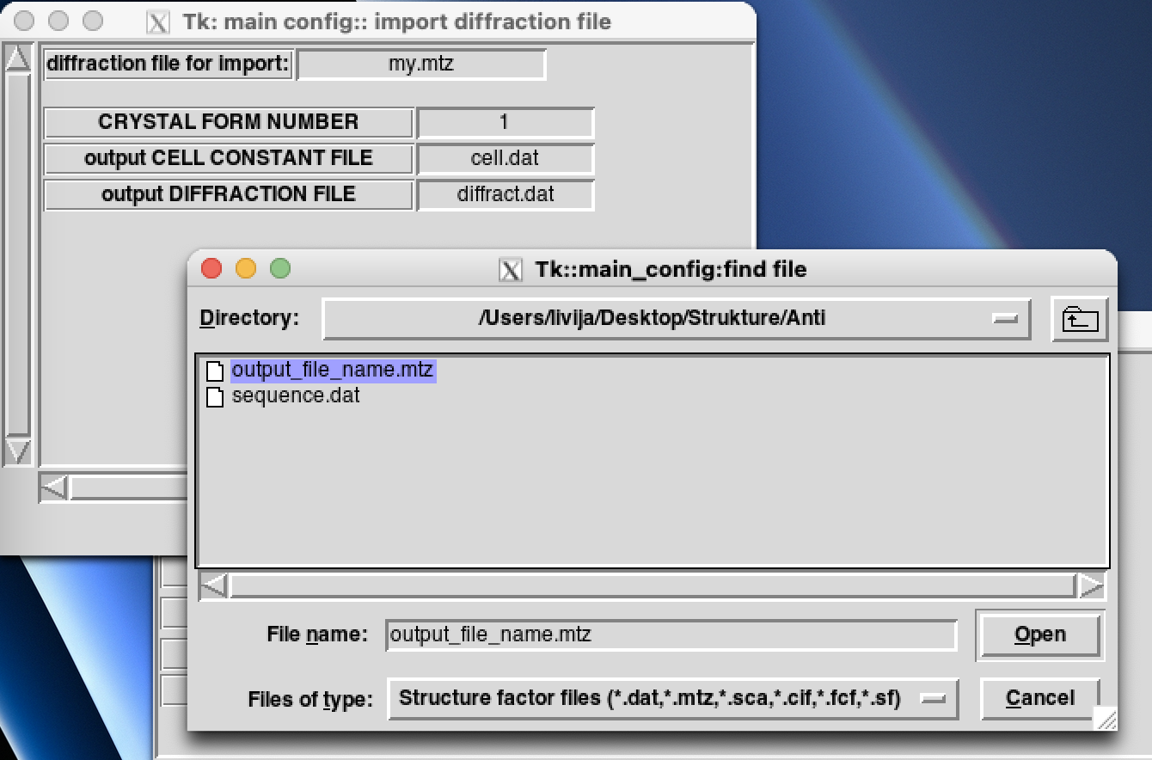
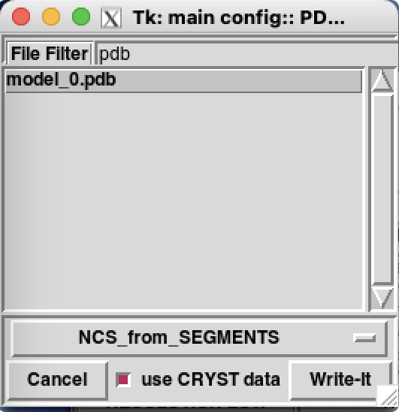

Figure 27. The form for the input of data for the case A which is divided into four sections: crystal data as MTZ format file, smaller figure shows the opened sub-window for the input of the MTZ file format; the resolution could be changed – the default value is in the range from 2.5 to 100; molecular model data as PDB file format (presented in smaller window) and amino acid residues of the protein as “sequence.dat”; there are two non crystallographic symmetry groups and two segment names H and L.

In the case of some improper reading of the protein structure parameters, the errors are written also in my_term window and therefore this window should be constantly checked.

Then we start building and developing the protein structure by running MAIN program on the basis of the input data from described files:
bash-3.2$ mainps

The MAIN program opens four windows which have been already described: my_image with the selected structure of the protein, my_depp, my_dials and my_term (Figure 28). The following output is written in my_term:

READ_SYMM> NUMBER OF ROTATIONAL SYMMETRY OPERATORS IS: 2
RDSYM> 2 MATRICES READ
cmd_read_reflect> resol: 47.2589989 1.85200000
refl_set_crystal> set crystal data set 1
reflect_gen> top: refl_current_set 1
reflect_gen> resol max 1.85200000
REFLECT_GEN> THE RESOLUTION RANGE: 47.259 1.852
YIELDS THIS HKL LIMITS: -23 23 0 51 0 31
resol_max 1.85200000 30.0000000 78208
REFLECT_GEN> MAP BOX -23 23 0 51 0 31 FOR 78208 REFLECTIONS GENERATED 0
upper count of refl: nn 39880
case 1: nn 39880
after - refl_data> resol: 1.85200000 box size 39880
REFLECT_GEN> SPACE FOR 39880 SUCCESSFULLY REFLECTIONS GENERATED 0
REFLECT_GEN> space for 39880 reflections assigned 39880 hkl box
REFLECT_ABSENCES> ------------- 25 25 :0, >0: 0 39855
READ_REFLECT> OUT OF 39880 AVAILABLE IN RESOLUTION RANGE: 47.26- 1.85
38271 REFLECTIONS PROCESSED AND
0 OUT OF RESOLUTION SPHERE
2 OUT OF HKL-LIMITS
38269 WITH HKL FROM THE FILE
0 SYSTEMATIC ABSENCES PRESENT
38269 MULTIPLY DEFINED - SO MERGED and DIVIDED by 2
38269 TOTAL UNIQUE ONES READ 0 as FRIEDEL PAIRS
crtyst_data kind 1 1
read_reflect> reflect_set_resolution 47.2589989 1.85200000
REFLECT_SET_RESOLUTION> initial 47.2589989 1.85200000 new: 38.8672142 1.85202825
sel_refl> 0 selected from crystal: 1 39880 39880 0
KEY> nused, nerf, ibegin 1 39880 0
REFL_KEY> 0 REFLECTIONS OUT OF 39880 ARE SELECTED WITH THE KEY { TEST }
sel_refl> 38269 selected from crystal: 1 39880 39880 0
KEY> nused, nerf, ibegin 2 39880 39880
REFL_KEY> 38269 REFLECTIONS OUT OF 39880 ARE SELECTED WITH THE KEY { WORK_REFL }
MAKE_MAP_INI_REAL> REAL MAP 1 WITH 1075200 EMPTY POINTS CREATED
MAKE_MAP_INI_REAL> REAL MAP 2 WITH 1075200 EMPTY POINTS CREATED
FILE_OPEN> %ERROR {SAVE_FILE.MAP} 13
FILE_OPEN> %ERROR {SAVE_FILE.VIEW} 14
READ_ATOM> 125 COORDINATES WERE READ:
TOTAL 3270
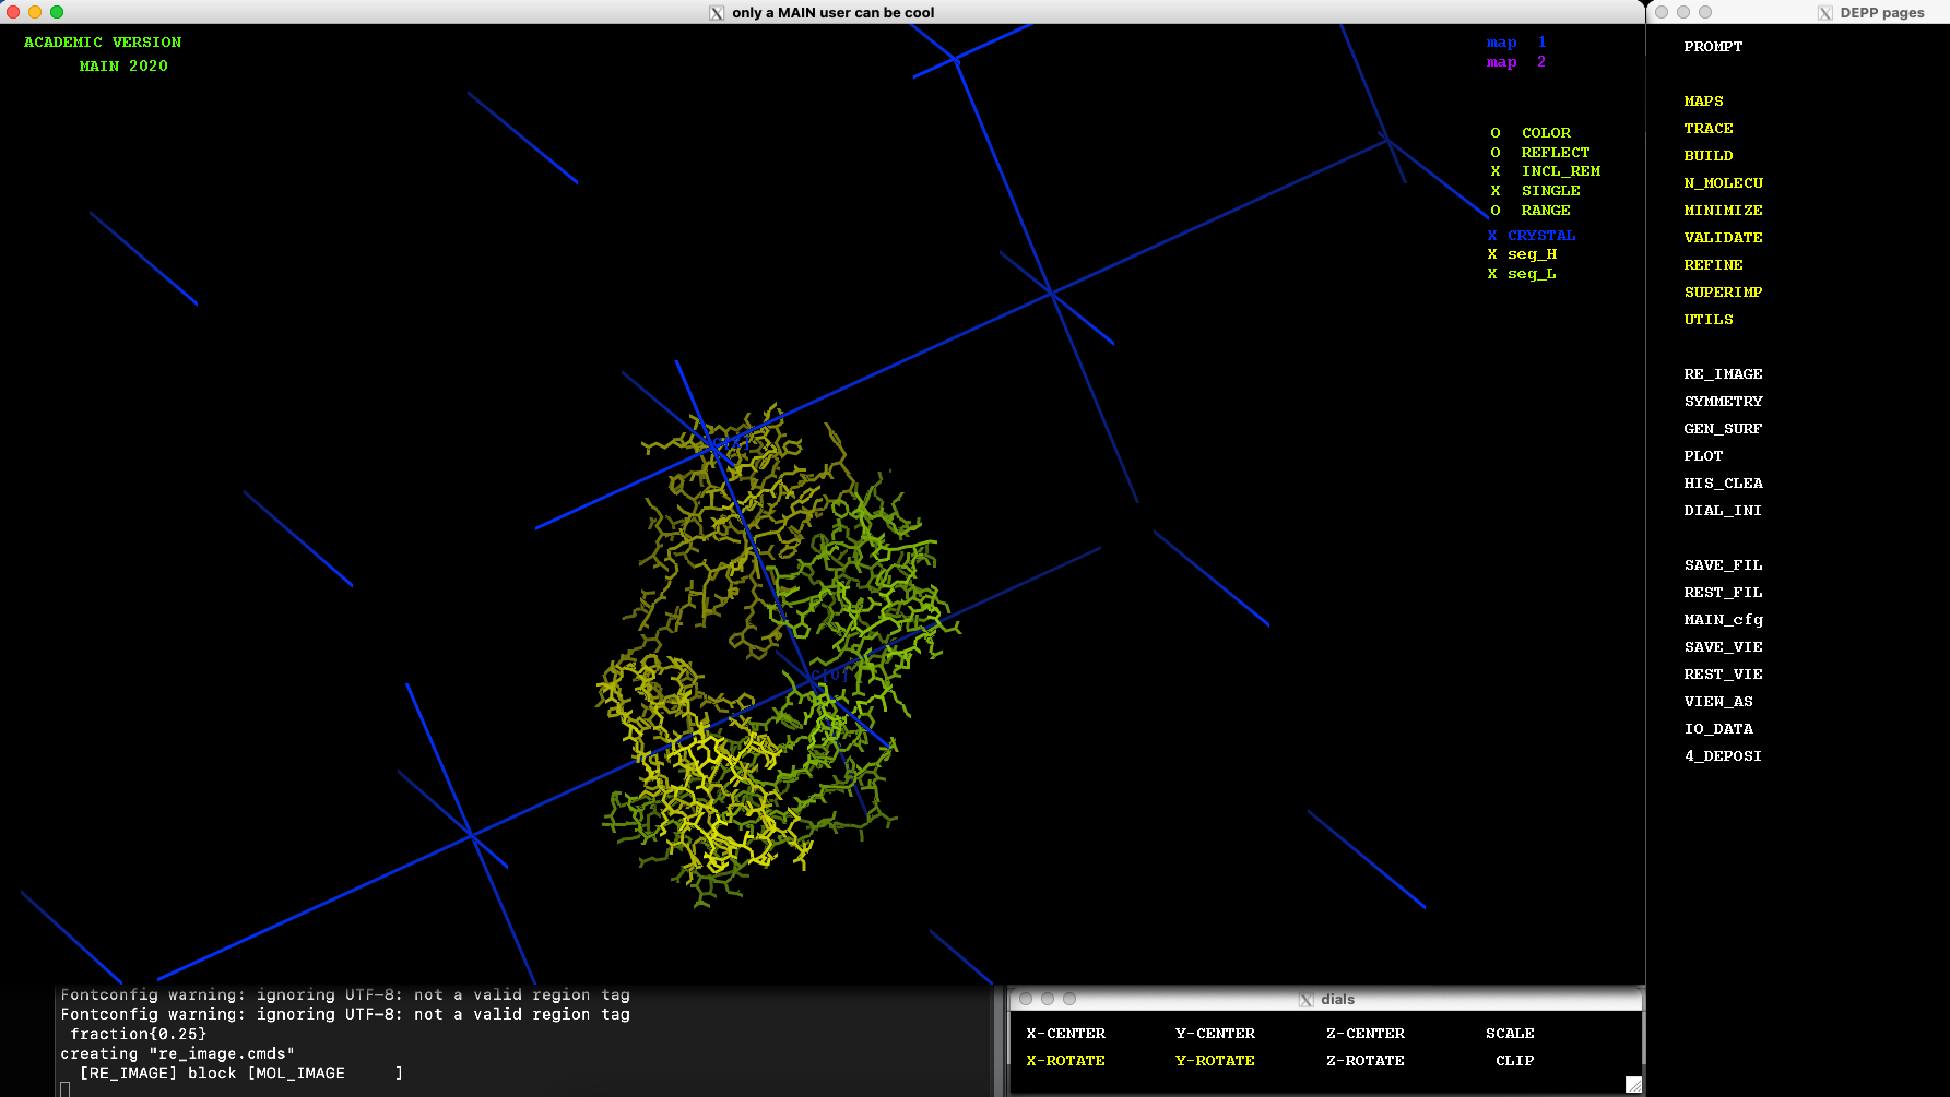
Figure 28. The MAIN program opens four windows: my_image with the selected structure of the protein – case A, my_depp, my_dials and my_term.

The MAIN program reads the data also with the following command:

tk_config.pl -m create_auto_start.pl

To get the menu: create_map_calc.pl within MAIN: mouse right button and then we can click DOIT and select the default selection (map of 2FOFC+FOFC, 2FOFC, FOFC, PHASE_COMB, FOBS, FCALC, sFO2FC, REFINE; target function: UN, SIGMA, ML, FREE-KICK).

There are two common types of electron density maps, the 2Fo-Fc map and Fo-Fc map. The 2Fo-Fc map will include the Fo-Fc map and electron density around the model. Fo-Fc map (difference or omit map) is used to show what has been overfit or not accounted for by the model.

3.2. The replacement of the molecules

Figure 29 shows two mouse cathepsins B and two DARPins. One mouse cathepsin B had two DARPins (marked with two side arrow) but the other no one. We must move molecules so that every mouse cathepsin B (enzyme) will have one DARPin (its inhibitor). There is more ways how to do this replacement. One way is to introduce symmetry. In my_depp click Rmouse on “SYMMETRY” (12 row) to open the window presented in Figure 30.

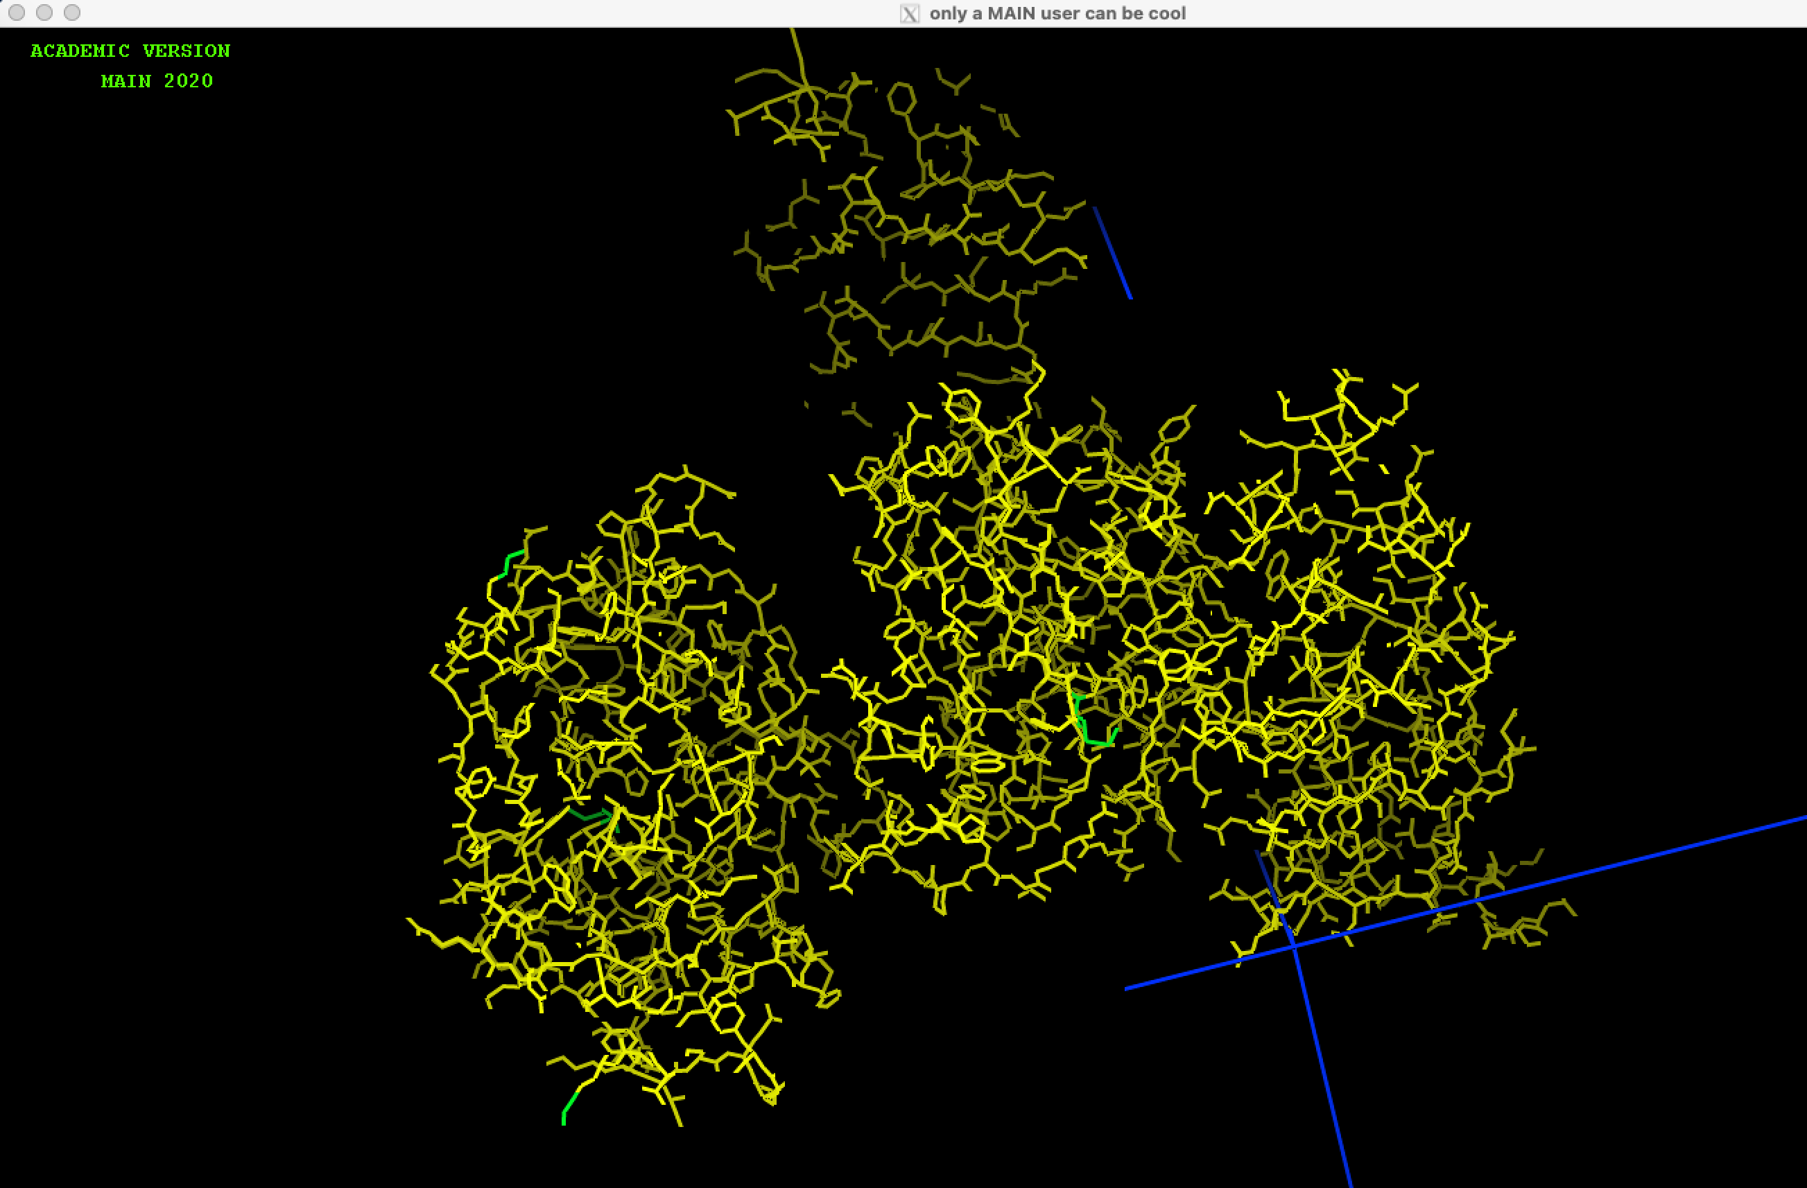
DARPin
Cat B
Cat B
DARPin
Figure 30. In this case, the presented four molecules of two groups (mouse cathepsin B as group I and DARPin as group II) are not placed properly. One cathepsin B had two DARPins and the other zero. We must move molecules so that every mouse cathepsin B (enzyme) will have one DARPin (inhibitor).

Figure 31 shows what we must input in window Tk: create_symmetry.pl. We have to select option (SPHERE) and input value (100).

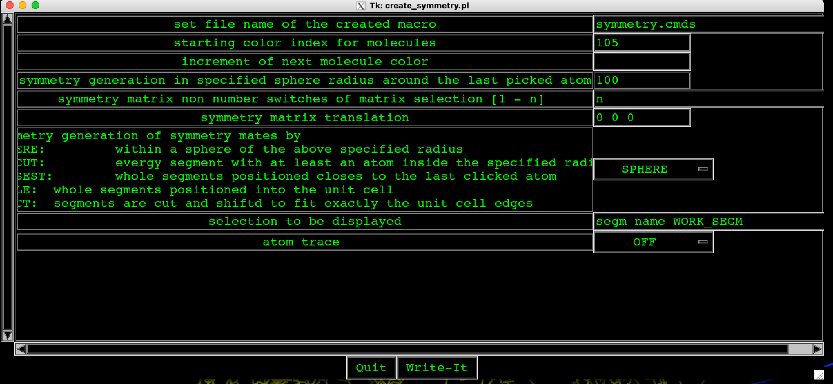
Figure 31. The “symmetry” window and the presented parameters which enable the presentation in my_image of the Figure 32. Important is that the sphere radius is put to 100 (4th row), then with mouse click Write-It. In my_depp click with mouse again SYMMETRY.

In my_image, we select mouse cathepsin B within orange lines with sign “mouse cathepsin B” by clicking its several residues. A common rule is to klick atom(s) (residue(s)) first and afterwards activate a function. The advantage of this logic is double: it enables you to correct the picked atoms list without a need to start all over again and the function needs no approval.

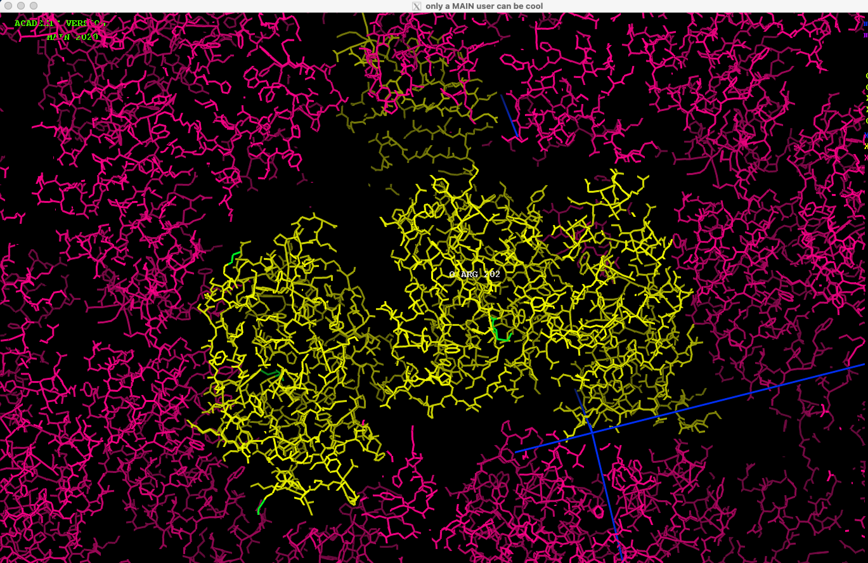
mouse cathepsin B
Figure 31. The image of two mouse cathepsins and two DARPins are written in yellow. To get pair of one mouse cathepsin B and DARPin, we will select mouse cathepsin B with the sign “mouse cathepsin B” which is inside of orange frame.

In my_term, by input
MAIN>show segm
we check if the whole molecule is selected (if not – try again until the whole structure is selected). When the new segment is selected you must renamed it. Select in my_depp UTILS by Lmouse, fulfill the square before ACT_SEGM and with Lmouse click on REN_SEGM. In my_term will be written the following

CHARACTER VARIABLE 16 GLOBAL {Str_arg } = "D3" 2
NEW SEGMENT NAME:: A2

and you have to input A2 and press ENTER. In my_depp, click on RE_IMAGE with Rmouse and all four molecules must be written.

When you select the whole new segment, you must copy coordinates to this new segment. To do this in my_term input the following:

MAIN>copy coor sele active end sele segm name A2 end

If it is no way to select the whole new segment then it is possible to select it in parts. First, rename the first part into A2 as it is described above. Then select the missing part to A2 by using ADD_MODE. In my_depp select UTILS, then ACT_SEGM and ADD_MODE, click on residues in both parts and then rename the selected parts under new name by using REN_SEGM into A2. At the end, you must copy also coordinates.

Figure 32 shows the implemented replacement of molecules which have to be done (see Figure 29) where molecules are not properly placed).

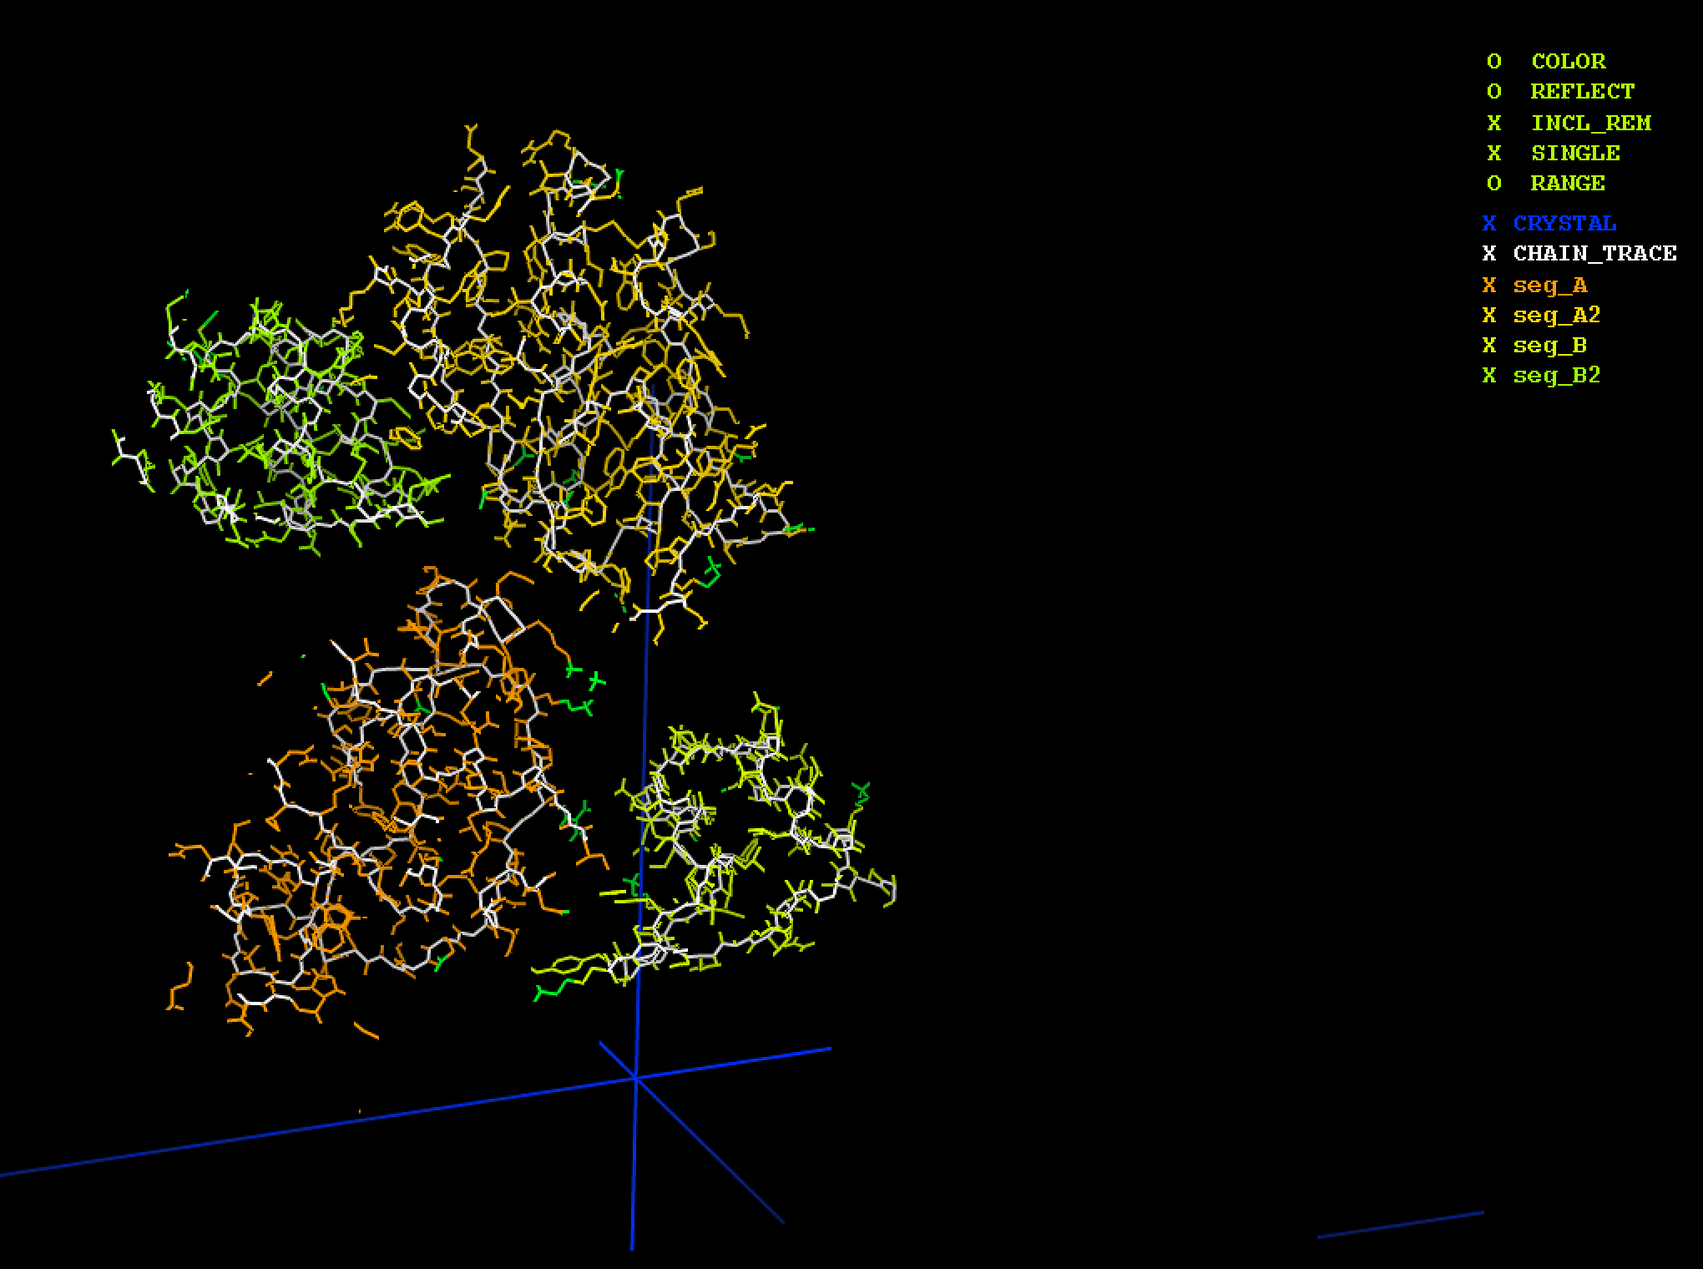
Figure 32. The correct placement of molecules in comparison to Figure 29 with improper one.

3.3. Start model building

The presented development of protein structure, actually a complex between mouse cathepsin B + DARPin 4m3 (resolution 1.7) based on the most similar protein structure model building based on human cathepsin B + DARPin 8h6. In this case it is expected that some residues and their conformations have to be changed as well as to add hydrogen bonds, disulphide bridges, water molecules, different conformations...

It is suggested to generate the missing atoms, in this case hydrogens, by using “FILL_ATOM” in UTILS of my_depp. Then go back to my_depp and click Lmouse on SAFE_FILE.PDB.

Be careful with this step, since the non-matched atoms of a matched residue name will disappear (for example C-terminals might be affected). Missing atoms (for example missing hydrogens) inserted, according to their internal coordinates representation. First the Z-table is created from atom bonding connectivity. The internal coordinates are afterwards calculated according to their connectivity from atom coordinates. Missing atoms are inserted inside the BUILD module and their Cartesian coordinates calculated from internal afterwards. Since new atoms have probably not been inserted with optimal geometry, it makes sense to optimize their geometry by a quick energy minimization. First all energy terms have to be defined: Note that atom class of Sulphur atoms included in disulfide bonds has to be modified after their assignment from topology residues. The same is true for C- and N-terminals. Usually it suffices to call the standard procedure (the file name variable DEFINE).

Then we calculate electron-density maps by clicking with Lmouse on MAPS in my-depp. We started by clicking Rmouse of “MAP_IO”, not change the default options (Figure 33) and going back and click Lmouse on “MAP_IO”.

Then we select the following commands in MAPS with the default values of options by clicking with Lmouse in presented sequential order of commands:
- RMS_FIT
- MAK_MASK
- MAP_CALC (floating resolution - for decreasing the resolution)
- DM_PREP (MAP 1 copy in MAP 2)
- DM_NEXT (repeat the command at least 2 or -times)

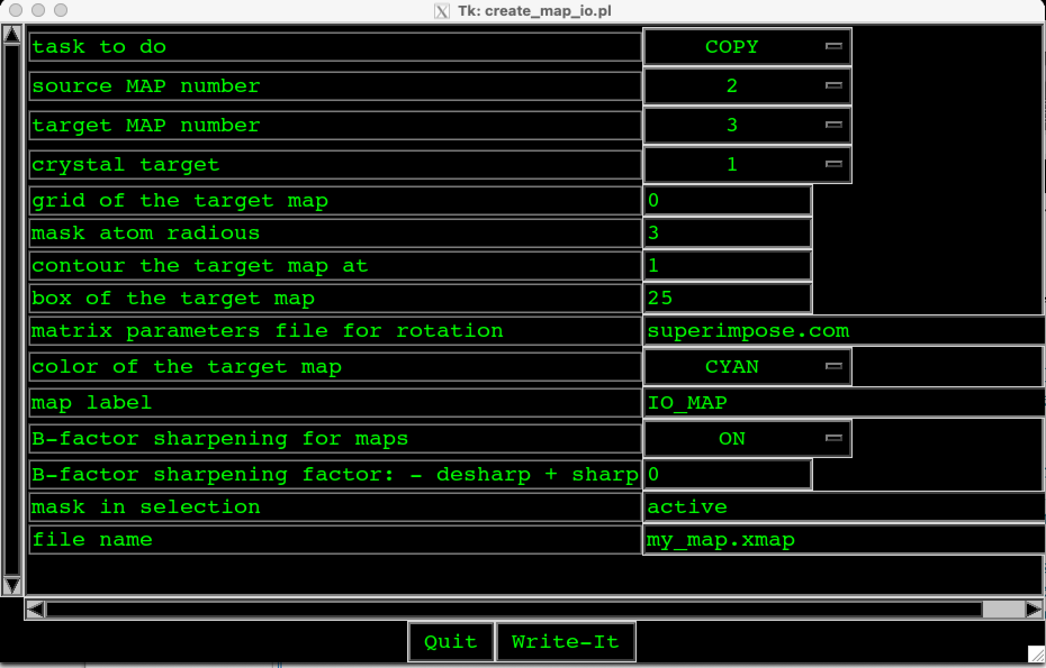
Figure 33. The default values of “MAP_IO” options.

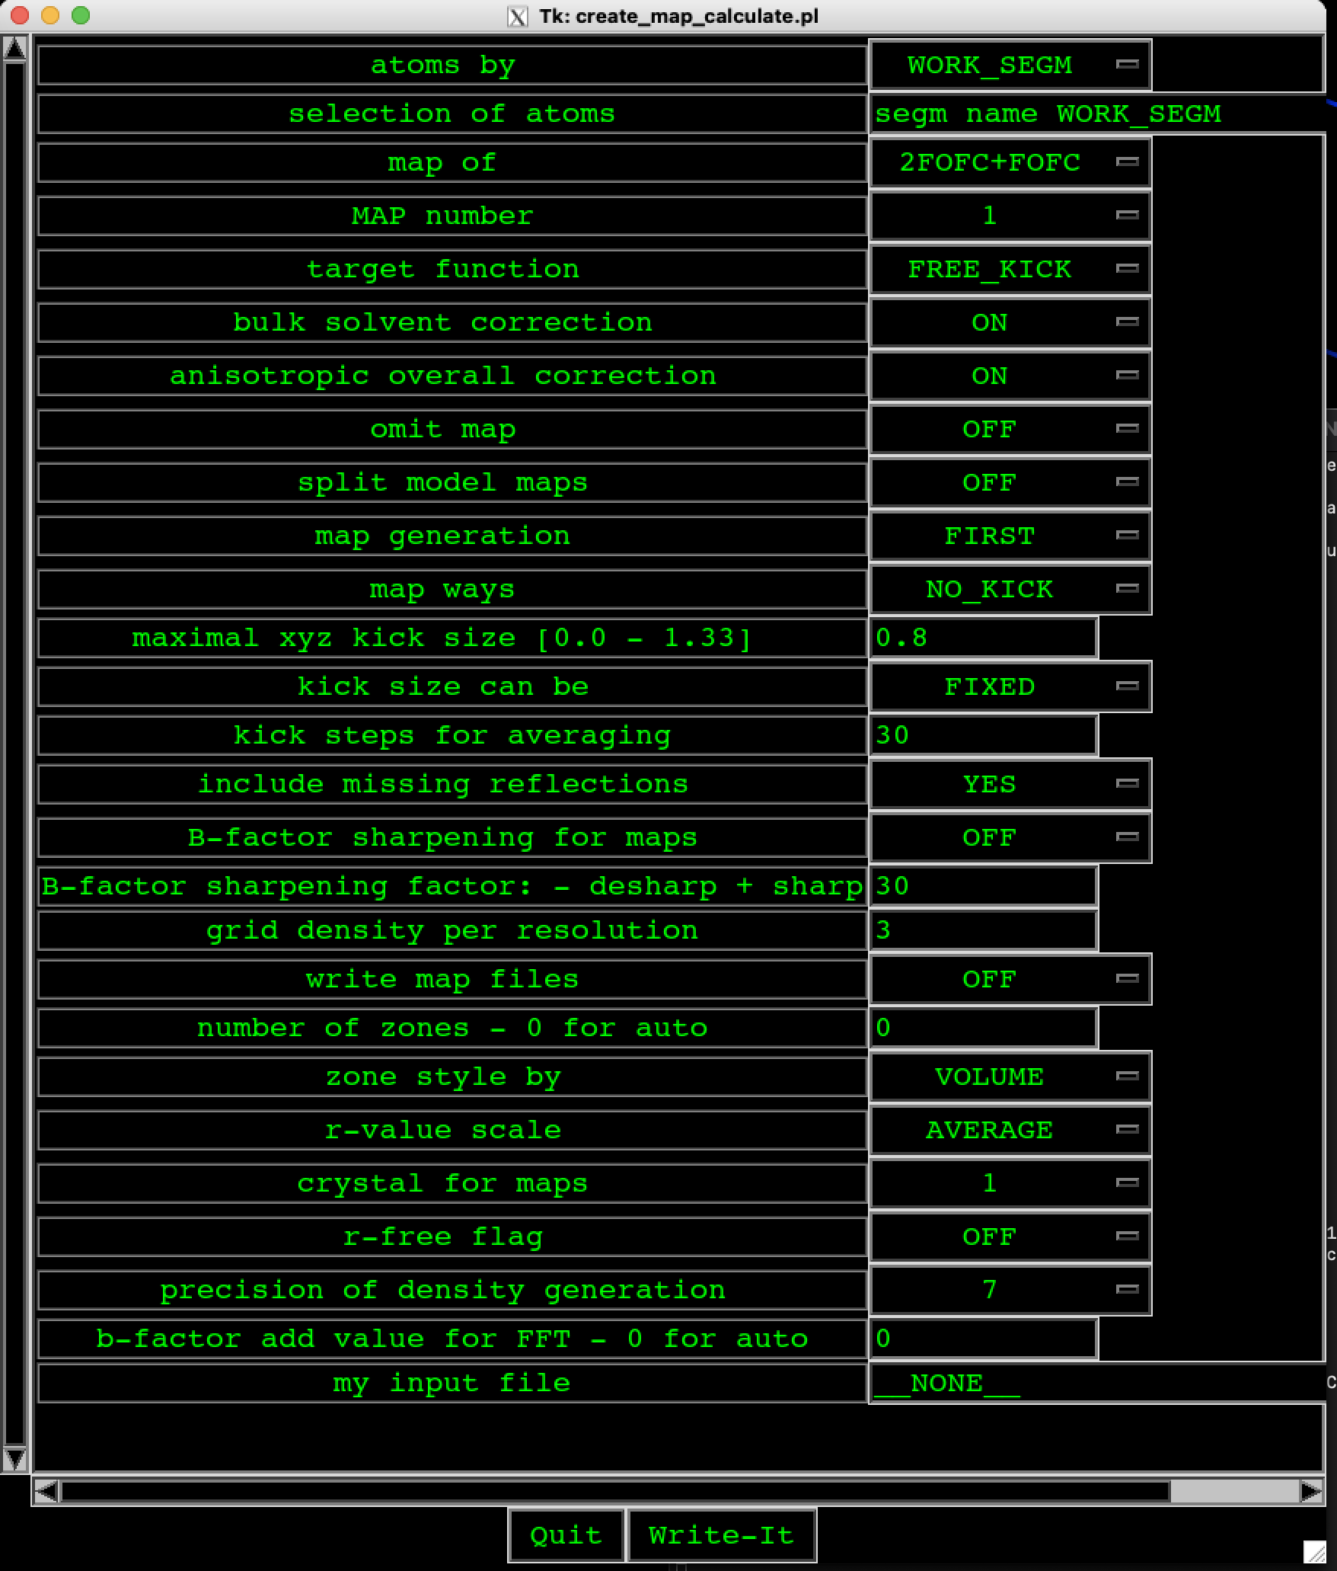
Figure 34. The default values of “MAP_CALC” options.

We go back to my_depp and select by Lmouse command “REFINE” and then 6. “REF-ALL” three times (NCS must be on, NCS is off in final stages), the calculated electron-density map is calculated and presented in Figure 35.

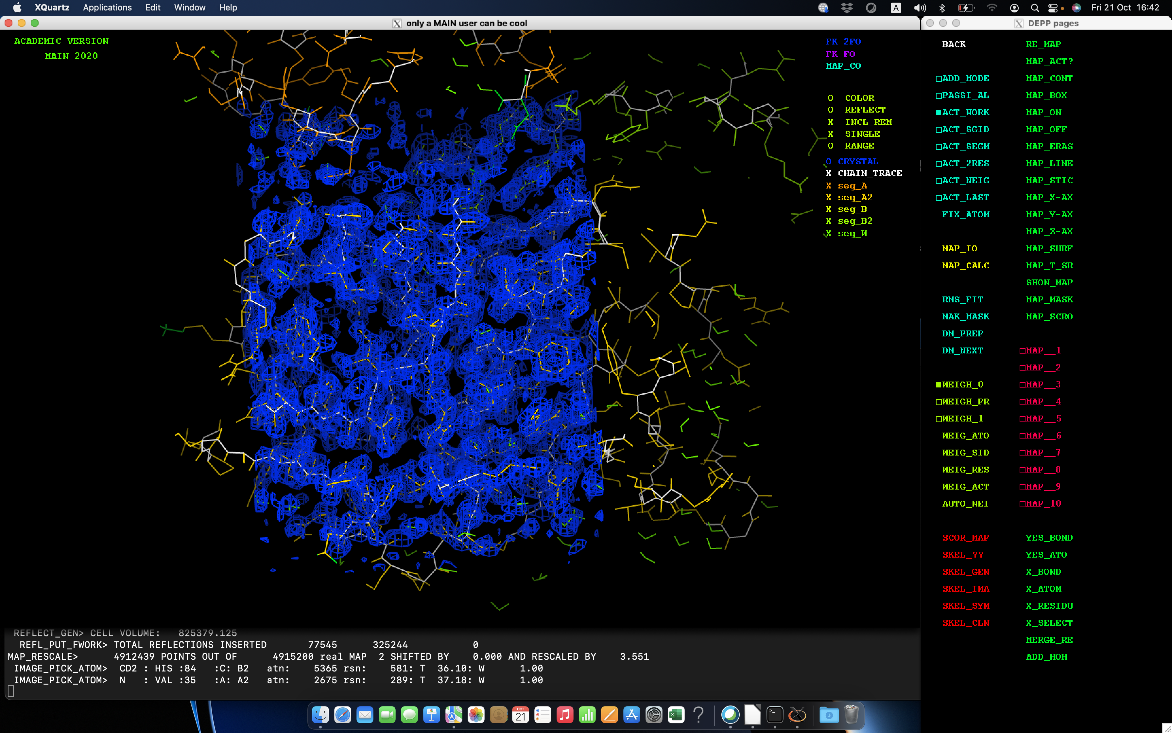
Figure 35. The calculated electron-density map.

When electron-density map is calculated (Figure 35), we start model building to adapt as much as possible the electron density to amino acid residues. During these procedure we use short commands: ”t”, “z”, “m”, “k”, ”f”, “p”, “l”... (see Apendix and Keyboard shortcuts)

Some residues not fitted well into map and they are colored green. We try to adopt them better – we start moving the residue so that finally adapted better or even worse to the belonging electron-density map. If you press on structure and select some parts of structure: ACT_LAST (selected is one residue which was clicked as the last one) or ACT_NEIG (selected are the neighboring residues to the last clicked one) or between two selected ones ACT_2RES (selected are all residues between last two clicked ones) and then “t” to get “X TETHER” in the my_image. After pressing “t” the selected part of the structure started adopting to the electron density map.

With mouse click on one residue in the structure to get text with its name and then press “c” and the calculated map will center on newly selected residue.

Click “n” to get selection ACT_NEIG and start correcting, for example, by pressing “t”.

Click “k” to kick the selected chain – it will move from its position and then you have just to wait to adapt it to electron-density map.

Click ‘f’ to do rotation of the selected atom in the residue.

Select two atoms – last two with the names, select ACT_2RES and then YES_BOND to get a bond between selected atoms or X_BOND to delete selected bond.

List of short commands is available in Appendix.

The strategy of model building is to begin with the not problematic electron densities and belonging amino acid residues and to continue to more and more not well-determined electron densities where the belonging amino acid residues are less clear (usually very flexible parts of protein structures). The amino acid residues that have to be changed, we change them one by one and checking if it adapts to the belonging electron-density map. If not, it is better to start with other “small” amino acid residues.

To change residue, use CHANGE (fill in the box before by click it with Lmouse) of my_depp command BUILD, then click on RESID ?? with Lmouse and select (the list of red written amino acids) or write the new residue in my_term.

To insert new residue between already defined sequences use ATTACH (fill in the box before by click it with Lmouse) of my_depp command BUILD which add new residue forward with regard to picked residue then click on RESID ?? with Lmouse and select (the list of red written amino acids) or write the new residue in my_term. Command INSERT add residue backward regarding to picked residue then click on RESID ?? with Lmouse and select (the list of red written amino acids) or write the new residue in my_term. To add new residues at C or N terminal you have to add always at least two residues, in other case the numbering of residues will change unpredictably. To correct the numbering of residues use UTILS of my_depp and then click on TOPO_BON or alternatively in BUILD of my_depp click SEQ_BOTH (fill in the box before by click it with Lmouse) and then click on COMP_SEQ (Figure 33).

If we see that the electron density map doesn’t suit, we have to find out first where the problem originates from or quite often insert the smallest residue, for example, GLY.

In the case that some residues have to be deleted in N- or C-terminal parts, the procedure is as follows:
- The residues are deleted by command HIS_DROP of my_depp command BUILD or HIS_CLEA which deletes the entire list of selected residues.
-To delete the last picked residue switch on the ACT_LAST and then click on X_RESIDU.

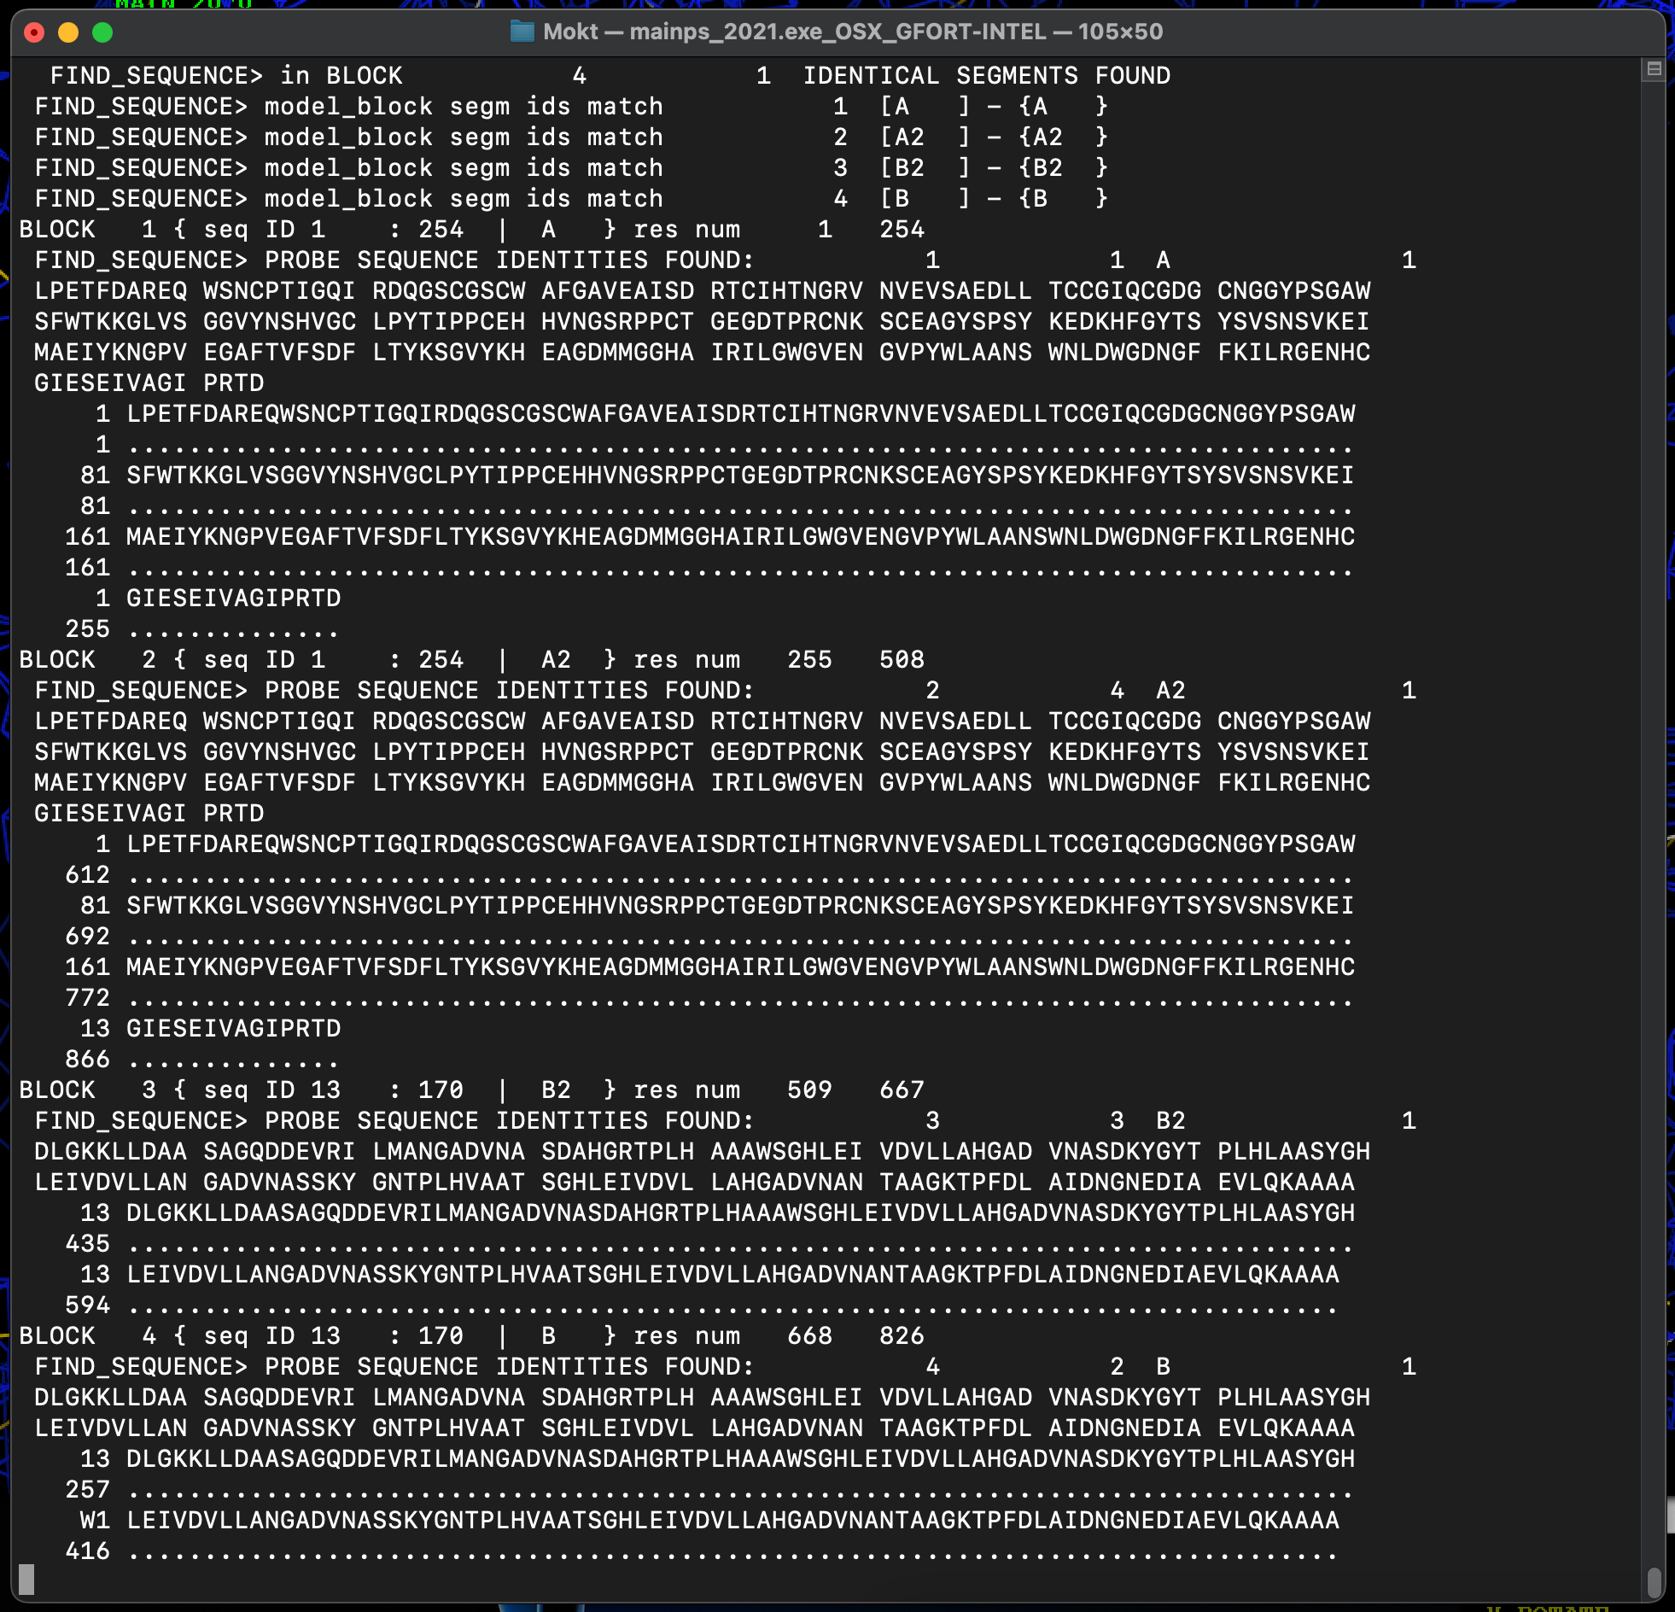

Figure 36. The output in my_term: to correct the numbering of residues use UTILS of my_depp and then click on TOPO_BON or alternatively in BUILD of my_depp click SEQ_BOTH (fill in the box before by click it with Lmouse) and then click on COMP_SEQ.

As could be seen in Figure 36 we have 4 molecules A, A2, B2, and B. Molecule A is similar to A2, and B to B2. If we adapt, for example, molecule A, we could some parts just simply copy from one molecule to another: copy A molecule into A2. We use N_MOLECU in my_depp, select ACT_WORK and WORK (fill in the box before by click it with Lmouse) and then click on SID_A and then on CRE_OTHE. The copy of one molecule into the other is useful in the first steps of model building. Later, commands PUT TO or GET FROM (of N_MOLECU in my_depp) are more useful. For example, switch on ACT_2RES (selection in A2) (we are at the segment we want to copy to the other molecule), press PUT TO and then SID_A.

The "PUT_TO" and "GET_FROM" commands will only work for topologically equivalent molecules, whereas this one simply enforces topological and geometrical equivalence. The "PUT_TO" and "GET_FROM" are commands that transfer coordinates, occupancies (weights) and temperature factors between equivalent parts of the working model and the other molecule. Equivalency is based of sequence ID matching between the key "active" selection of the working model and the other molecule. "PUT" and "GET" indicate direction of the data transfer. Coordinates are transferred on a basis of a RMS superposition between the working and the other model.

In my_term, the implementation of the commands could be checked – there should be no errors!

During the adapting of the electron-desity map, we have to use SAVE_FIL of my_depp by clicking with Lmouse. The calculation of electron-density maps have to be repeat a few times during the determination of the protein structure to check some parameters. The following commands should be used:
- REF_ALL (FREE_KICK, NCS must be ON)
- RMS_FIT
- MAK_MASK (envelope mask)
- MAP_CALC
- DM_PREP (MAP, MAP 1 is copied into MAP 2)
- DM_NEXT (repeat at least twice or even more times). Selections: 2FOFC+KICK and MAP. The command calculates average maps.

The hydrogens could be also added by using BUILD of my_depp and click with Lmouse on ADD_HOH (command in green sector). The hydrogen bonds could be added by click on HBO_SECU (command in blue sector) and optimized them by using HBON_OPT (command in the first yellow sector). In some cases also disulfide bonds have to be generated (between cysteines in two different chains).

Towards an end of refinement of a structure with sufficiently high resolution of diffraction data (beyond 2.8 A) solvent molecules are built into the peaks of difference electron density map. In my_depp, we click on REFINE and then on GEN-SOLV.

In BUILD of my_depp we click with Rmouse on GEN_LIST (the square in front of BY_VALID is fill in) and get some additional options: checking for example the cis or trans configurations of peptide bonds (Figure 37).

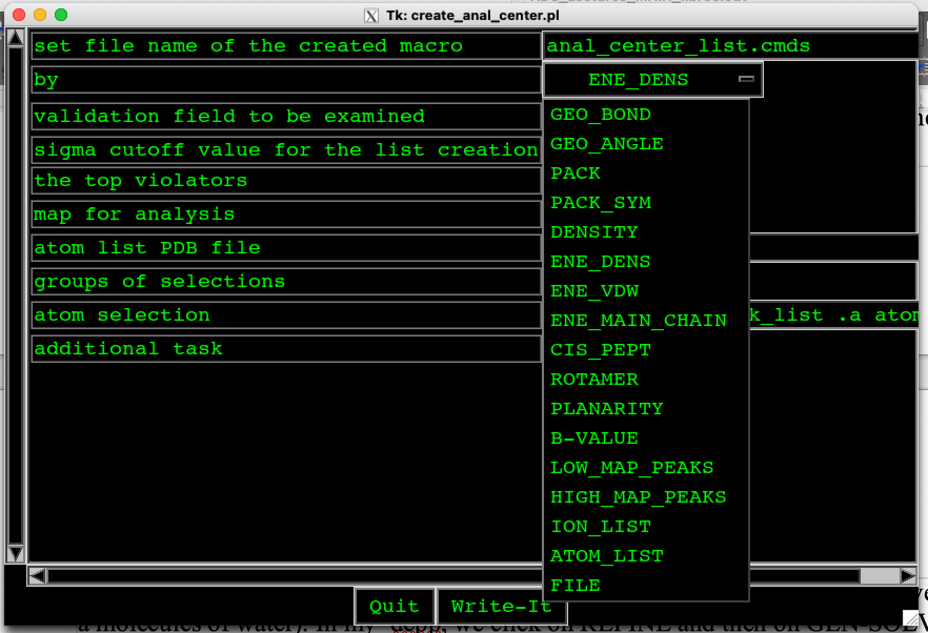
Figure 34. In BUILD of my_depp we click with Rmouse GEN_LIST and get some additional options: checking for example the cis or trans configurations of peptide bonds.

When R_val is less than 30% we start to refine the B faktor. We click with Lmouse to REFINE of my_depp and then click with Rmouse to REF_ALL to get the options presented in Figure 38. “B_factor refinement” must be turn from OFF (FLAT_B means the average B) to ON. “TARGET FUNCTION for refinement” instead of “FREE KICK” we must turn in MAP, “NCS” must be ON.

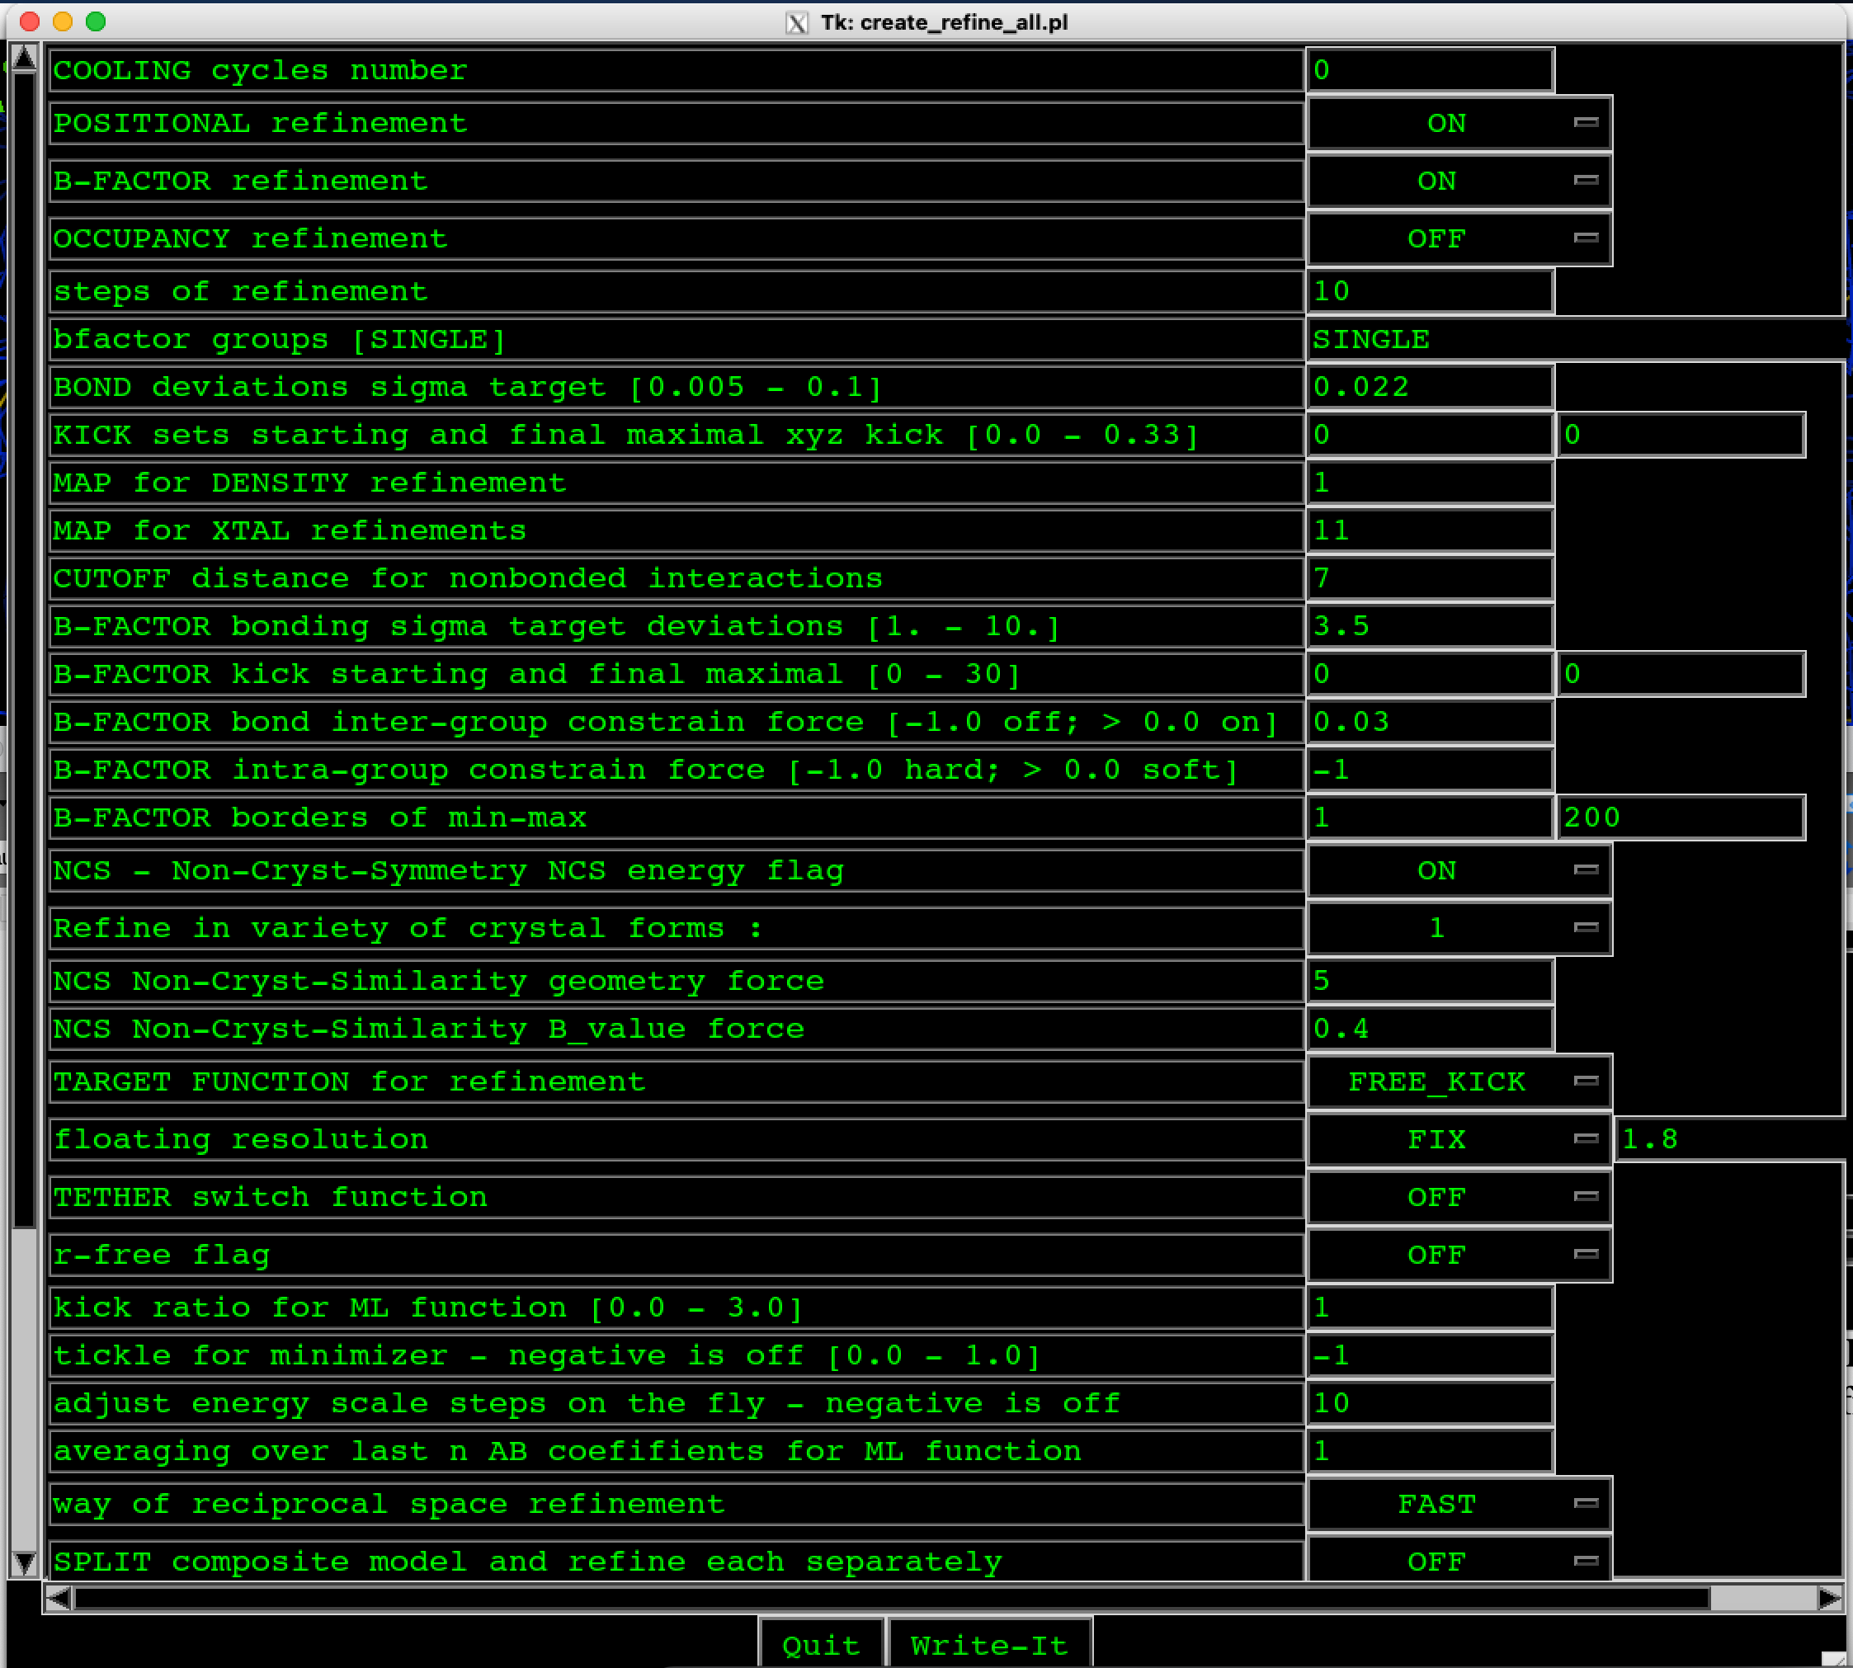
Figure 38. REFINE of my_depp and REFF_ALL options. “TARGET FUNCTION for refinement” instead of “FREE KICK” we must turn in MAP, “NCS” must be ON.
The resolution has to be turn closely to the experimental one, for example, from 2.0 to 1.8 (Lmouse klick to MAPS of my_depp and Rmouse klick to MAP_CALC to get options presented in Figure 39 where “floating resolution” has value “FIX” and value “1.8”). In the case of selections FREE_KICK, changing of NCS Non-Cryst-Similarity B_value force from 0.4 to, for example 0.1, and determine the “COOLING cycles number” from 0 to, for example, 10, then B-FACTOR will recalculate in the selected way.

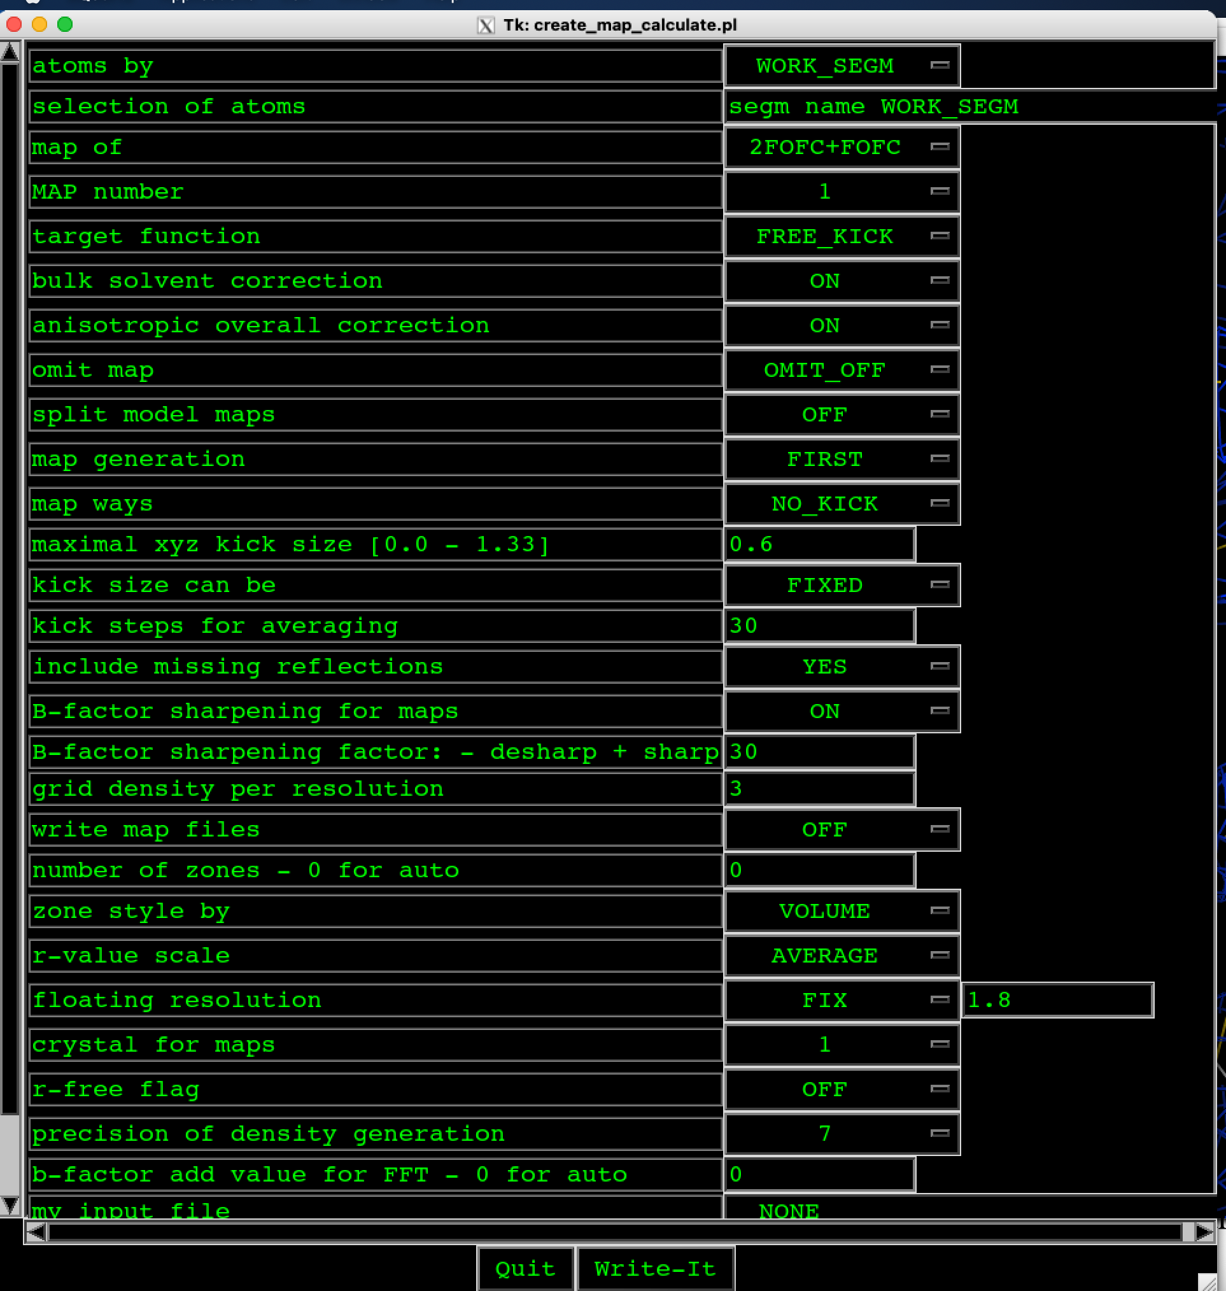

Figure 39. MAP_CALC options and refinement of the B faktor. We click with Lmouse to REFINE of my_depp and then click with Rmouse to REF_ALL to get the above options. “B_factor refinement” must be turn from OFF (FLAT_B means the average B) to ON.
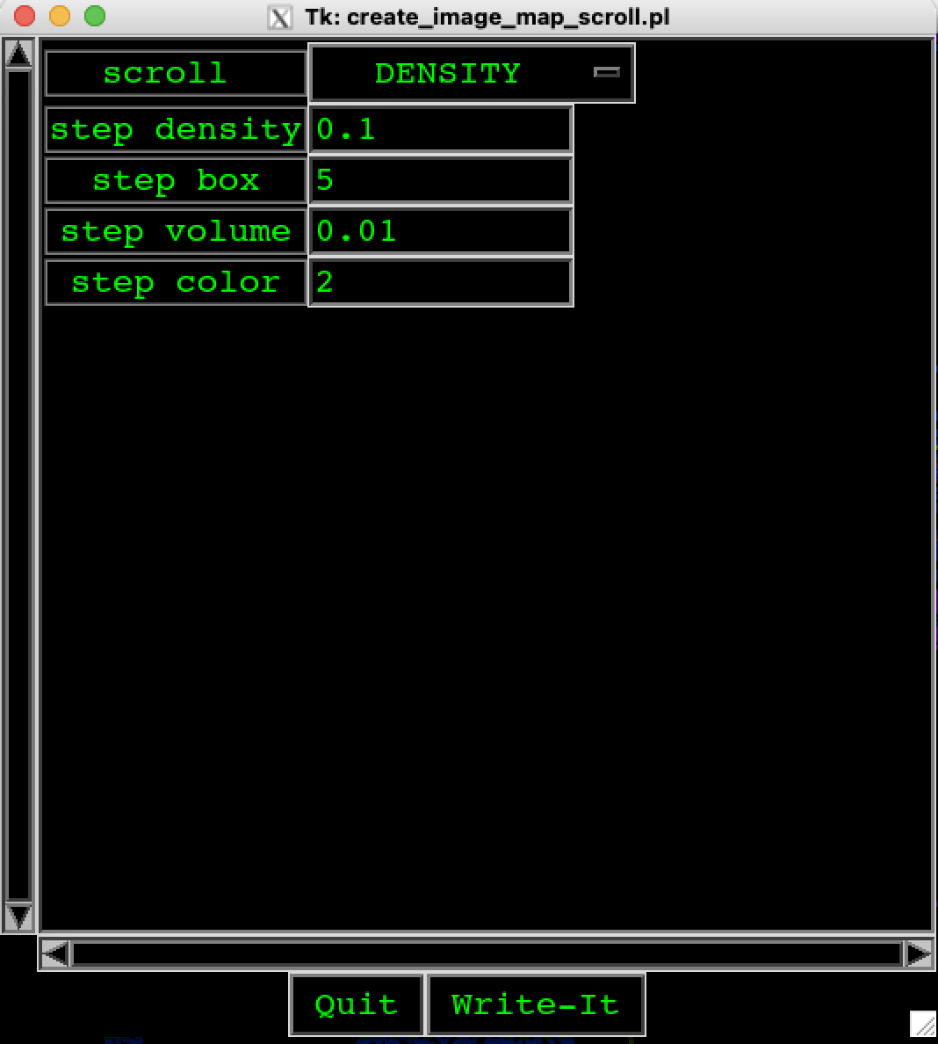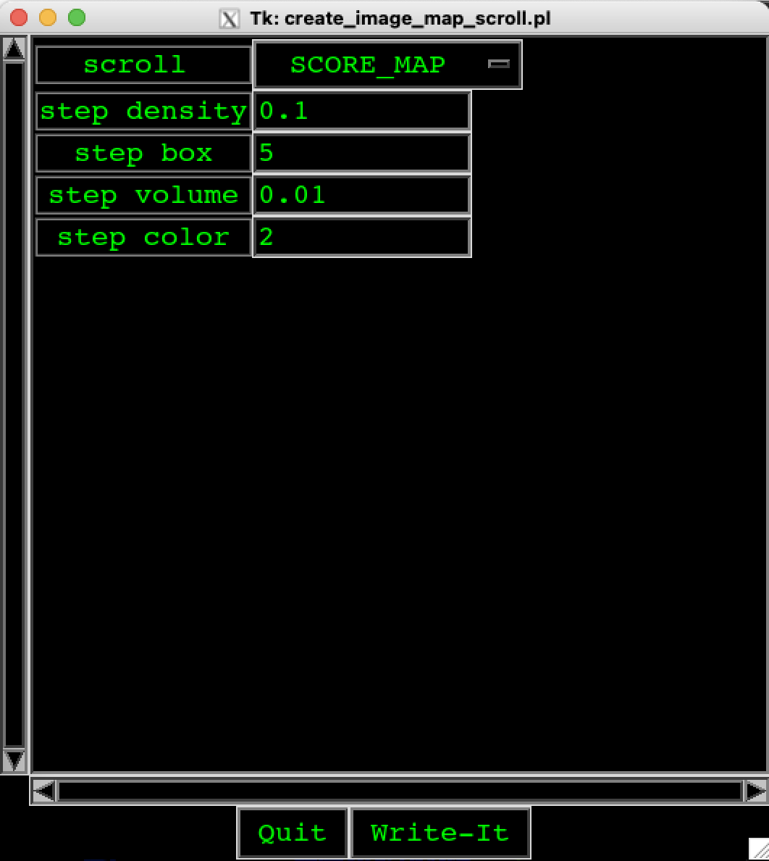
a) b)
Figure 40. To change the color of the map just change the selection in raw “scroll” from DENSITY to COLOR and press Write-it. Then with the middle mouse button (with wheel) forward and backward and select the adequate color.

- Lesson: Model validation

Ramachandran plot was used for fixing bond geometric outliers. We klick with Lmouse to VALIDATE of my_depp. First the segment of the protein structure must be selected, for example, B2. Then klick on box before RAMACHAN to fill it and the plot is presented over the protein structure as could be seen in Figure 41. Red sequential numbers of residues show the outliers. Klick on the red number moves you to this outlier. The majority of outliers have to be solved.

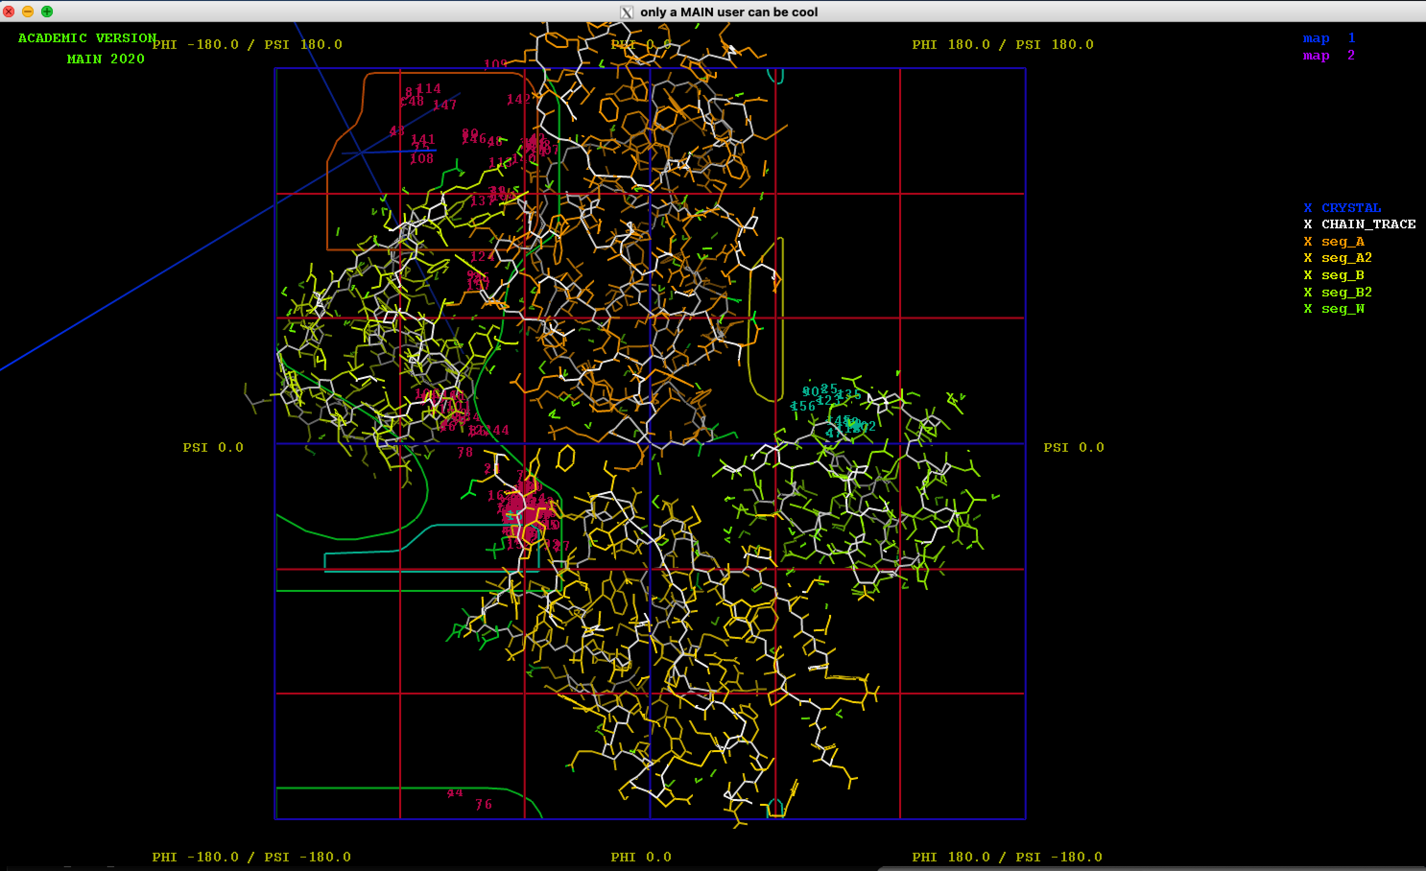
Figure 41. Ramachandran plot for selected segment of the protein structure (segment B2 was selected). With Rmouse the presented plot is decreased or increased. The outliers are presented with red letters.

During the procedure we have to save the protein structure. The structure is saved in six files and to save the whole structure all six files have to be, for example, renamed or copied to another directory:

For back-up off all new improvements, you have to safe all files starting with safe:
-rw-r--r--@ 2143 Oct 28 15:01 SAVE_FILE.CIF
-rw-r--r--@ 647492 Oct 28 15:01 SAVE_FILE.CTAB
-rw-r--r--@ 30 Oct 28 15:01 SAVE_FILE.HBOND
-rw-r--r--@ 368 Oct 28 15:01 SAVE_FILE.MAP
-rw-r--r--@ 1154269 Oct 28 15:01 SAVE_FILE.PDB
-rw-r--r--@ 312 Oct 28 15:01 SAVE_FILE.VIEW

To monitor developing of protein structure we have to check values of variables. We could list them by command in my_term window as it could be seen bellow.

MAIN>show vari
INTEGER VARIABLE 1 GLOBAL {natom } = 14707
INTEGER VARIABLE 2 GLOBAL {EXIT_STAT } = 0
INTEGER VARIABLE 3 GLOBAL {nmaps } = 30
INTEGER VARIABLE 4 GLOBAL {RAN_SEED } = 4
INTEGER VARIABLE 5 GLOBAL {FILE_OPEN } = 0
INTEGER VARIABLE 6 GLOBAL {NEXT_RESI } = 1
INTEGER VARIABLE 7 GLOBAL {CENTER_SHI} = 2
INTEGER VARIABLE 8 GLOBAL {map_boxx } = 26
INTEGER VARIABLE 9 GLOBAL {map_boxy } = 26
INTEGER VARIABLE 10 GLOBAL {map_boxz } = 26
INTEGER VARIABLE 11 GLOBAL {MAP_ACT } = 1
INTEGER VARIABLE 12 GLOBAL {MAP_COLOR } = 245
INTEGER VARIABLE 13 GLOBAL {KICK_ADDS } = 12
INTEGER VARIABLE 14 GLOBAL {SKEL_CUSHI} = 15
INTEGER VARIABLE 15 GLOBAL {NICE_SELMO} = 0
INTEGER VARIABLE 16 GLOBAL {NICE_PASSI} = 0
INTEGER VARIABLE 17 GLOBAL {MAP_LAST } = 3
INTEGER VARIABLE 18 GLOBAL {MAT_ROT } = 3
INTEGER VARIABLE 19 GLOBAL {nsegm } = 6
INTEGER VARIABLE 20 GLOBAL {IRESULT_0 } = 13172
INTEGER VARIABLE 21 GLOBAL {MAP_2FOFC } = 1
INTEGER VARIABLE 22 GLOBAL {MAP_FO } = 1
INTEGER VARIABLE 23 GLOBAL {MAP_FOFC } = 2
INTEGER VARIABLE 24 GLOBAL {MAP_WORK } = 2
INTEGER VARIABLE 25 GLOBAL {IRESULT_1 } = 14579
INTEGER VARIABLE 26 GLOBAL {IRESULT_2 } = 1226
INTEGER VARIABLE 27 GLOBAL {IRESULT_3 } = 1695
INTEGER VARIABLE 28 GLOBAL {IRESULT_4 } = 80
INTEGER VARIABLE 29 GLOBAL {npoin } = 5810
INTEGER VARIABLE 30 GLOBAL {nhistory } = 1
REAL VARIABLE 1 GLOBAL {pi } = 0.3141593E+01
REAL VARIABLE 2 GLOBAL {cut_neigh } = 0.3400000E+01
REAL VARIABLE 3 GLOBAL {force_pair} = 0.8000000E+02
REAL VARIABLE 4 GLOBAL {set_weight} = 0.0000000E+00
REAL VARIABLE 5 GLOBAL {MAP_CONT } = 0.4999999E+00
REAL VARIABLE 6 GLOBAL {MAP_SCROLL} = 0.1000000E+00
REAL VARIABLE 7 GLOBAL {KICK_VAL } = 0.4000000E+00
REAL VARIABLE 8 GLOBAL {FORCE_HBON} = 0.3000000E+02
REAL VARIABLE 9 GLOBAL {DIST_HBON } = 0.1600000E+01
REAL VARIABLE 10 GLOBAL {RESOL_MIN } = 0.4938679E+02
REAL VARIABLE 11 GLOBAL {RESOL_MAX } = 0.1690000E+01
REAL VARIABLE 12 GLOBAL {dens_scal } = 0.2500000E+02
REAL VARIABLE 13 GLOBAL {r-value } = 0.2260286E+00
REAL VARIABLE 14 GLOBAL {ML_ERROR_X} = 0.3512745E+00
REAL VARIABLE 15 GLOBAL {ML_ERROR_P} = 0.2576900E+02
REAL VARIABLE 16 GLOBAL {ener_xtarg} = -0.2165154E+06
REAL VARIABLE 17 GLOBAL {ener_encs } = 0.0000000E+00
REAL VARIABLE 18 GLOBAL {ener_total} = -0.4989498E+05
REAL VARIABLE 19 GLOBAL {ener_bond } = 0.8149788E+02
REAL VARIABLE 20 GLOBAL {ener_hbond} = 0.0000000E+00
REAL VARIABLE 21 GLOBAL {ener_angle} = 0.4503588E+01
REAL VARIABLE 22 GLOBAL {ener_dihe } = 0.0000000E+00
REAL VARIABLE 23 GLOBAL {ener_impr } = 0.0000000E+00
REAL VARIABLE 24 GLOBAL {ener_ring } = 0.0000000E+00
REAL VARIABLE 25 GLOBAL {ener_plane} = 0.0000000E+00
REAL VARIABLE 26 GLOBAL {ener_rama } = 0.0000000E+00
REAL VARIABLE 27 GLOBAL {ener_vdw } = -0.4632244E+03
REAL VARIABLE 28 GLOBAL {ener_elec } = -0.4951776E+05
REAL VARIABLE 29 GLOBAL {ener_dens } = 0.0000000E+00
REAL VARIABLE 30 GLOBAL {ener_bbord} = 0.5717079E-03
REAL VARIABLE 31 GLOBAL {RESULT_0 } = -0.1222082E+02
REAL VARIABLE 32 GLOBAL {RESULT_1 } = 0.1656771E+02
REAL VARIABLE 33 GLOBAL {RESULT_2 } = -0.8422600E+02
REAL VARIABLE 34 GLOBAL {RESULT_3 } = 0.3426100E+02
CHARACTER VARIABLE 1 GLOBAL {SEL_ACTIVE} = "SEG_ID" 6
CHARACTER VARIABLE 2 GLOBAL {AUTO_SQD } = "FORWARD" 7
CHARACTER VARIABLE 3 GLOBAL {ANAL_GRP } = "ATOM" 4
CHARACTER VARIABLE 4 GLOBAL {ANAL_KIND } = "FORCE" 5
CHARACTER VARIABLE 5 GLOBAL {MIN_TETHER} = "OFF" 3
CHARACTER VARIABLE 6 GLOBAL {CENTER_MOD} = "VALIDATE" 8
CHARACTER VARIABLE 7 GLOBAL {BULK_SOLVE} = "ON" 2
CHARACTER VARIABLE 8 GLOBAL {ANISO_CORR} = "ON" 2
CHARACTER VARIABLE 9 GLOBAL {MAP_OMIT } = "OFF" 3
CHARACTER VARIABLE 10 GLOBAL {SIGMAA_MAP} = "OFF" 3
CHARACTER VARIABLE 11 GLOBAL {MAP_KICK } = "OFF" 3
CHARACTER VARIABLE 12 GLOBAL {RAMA_PLOT } = "OFF" 3
CHARACTER VARIABLE 13 GLOBAL {IMAGE_BASE} = "CRYSTAL" 7
CHARACTER VARIABLE 14 GLOBAL {DEF_ALL } = "?MAIN_UTILS:def_top_par_prot_nuc.com" 36
CHARACTER VARIABLE 15 GLOBAL {NMOL_MODE } = "WORK" 4
CHARACTER VARIABLE 16 GLOBAL {WORK_SEGM } = "A A2 B B2 W W2 " 15
CHARACTER VARIABLE 17 GLOBAL {MY_TK_CONF} = "-bg black -fg green -fn -adobe-courier-medium-r-normal--20-240-75-75-m-150-iso10" 85
{MY_TK_CONF} = "646-1"

5. Lesson: Generation of water molecules and S-S bonds

In this lecture we will write only short commands and for the exact implementation read previous lessons.

5.1. Generation of water molecules

We will generate water molecules at Rval=0.30. The procedure will be as follows:

1. REFINE of my_depp and then REFF_ALL: resolution should be higher (the actual value, in this case, 1.6), B_fact=ON, NO_KICK;

Results: Rcum=lower than 0.30; Bf_bon sig= lower than 3.5; number of outliers=lower than 5; Rc=lower than 0.25

2. The HOH should be added: REFINE of my_depp and then GEN_SOLV – automatic adding of water (Density=2); manual adding of water: CTRL A + H.

If CTRL is hold all the time during type on A and H, the HELP menu is activated. The HELP is closed by pressing “H”.

In RE_IMAGE we add new segment for water molecules:
seg_W, segm name W

5.2. Fine tuning

Short commands used, for example, in the following order L>Z>F>T to adopt residues to the electron density map but it could be more efficient if the electron density cloud is decreased or increased. To get the right results the both possibilities had to be tried.

Click on one residue, select ACT_LAST and use one letter command Z and M (minimization) to fit the residue to electron density map.

5.3. Water packing

- REFINE>REFF_ALL: the options were already defined therefore we left them, klick on Write-It; klick with LMouse on FLAT_B and KICK_B_5 and finally also on REFF_ALL.
Or

- REFF_ALL: KICK_?? (the value should be 0.1), KICK_XYZ, KLICK_B_5.

- REFINE>GEN_SOLV and Figure 39 shows the values of distances in Å.

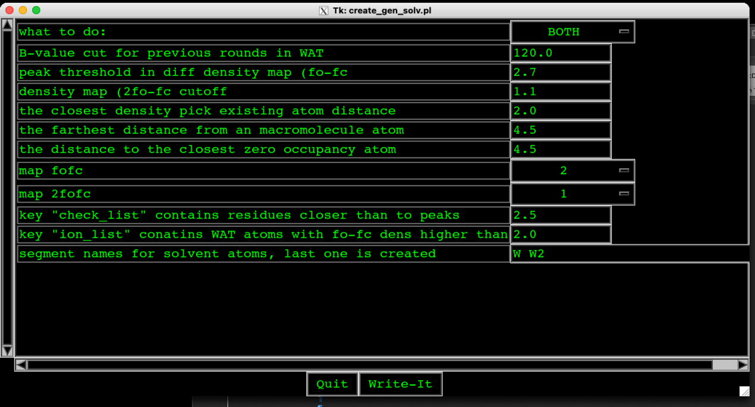Figure 42. The option for generation of water after selections REFINE>REF_ALL. The numbers present Å: 2.7 is the magenta map, 1.1 is the blue map, 2.0 are other atoms, 4.5 are other proteins

5.4. Alphabetical order of segments

In the case that in the complex the molecules were changed as in the case of cathepsins B and DARPins (Figure 31), we have to put them in the alphabetical order. We output their current order in my_term by using command:

MAIN>show segm
SEGMENT 1 <A > ATOMS: 3725 3725 RESIDUES: 254 254
SEGMENT 2 <A2 > ATOMS: 3725 7450 RESIDUES: 254 508
SEGMENT 3 <B2 > ATOMS: 2262 9712 RESIDUES: 159 667
SEGMENT 4 <B > ATOMS: 2262 11974 RESIDUES: 159 826
SEGMENT 5 <W > ATOMS: 2637 14611 RESIDUES: 879 1705
MAIN>

For the submission to PDB protein database, we need the alphabetical order of segments. The order of segments could be changed by using SAFE_FILE command (Figure 43). Rmouse klick on SAFE_FILE to open Figure 43. Change “by SEGMENTS” and klick on Write-It. Then klick with Lmouse on SAFE_FILE and QUIT the MAIN and start MAIN again. Because in our case the number of atoms is the same in B2 and B there was no need for the command UTILS>TOPO_BON in other case this command is urgently needed. Because the connection table is critically changed.

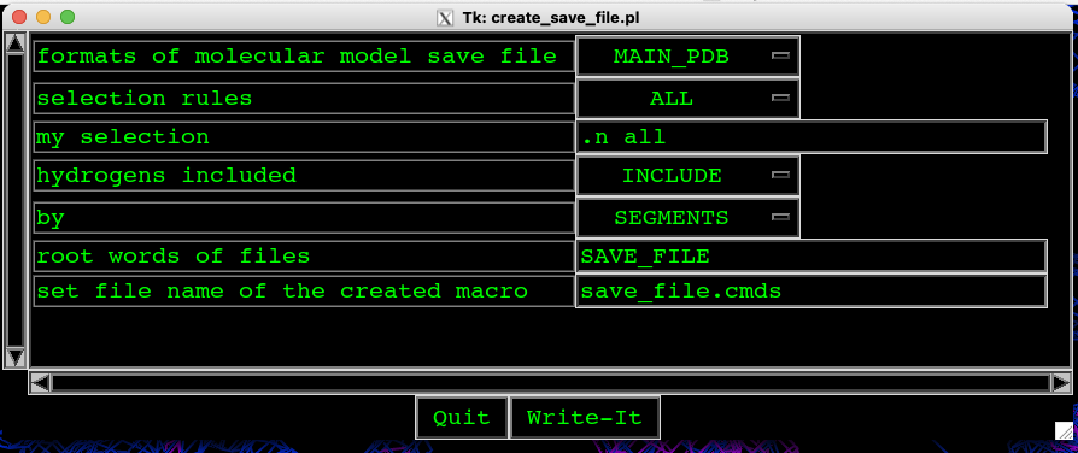
Figure 43. With command SAVE_FILE we could change the alphabetical order of segments.

If we repeat the command “show segm” the following information on segments is written out:

MAIN>show segm
SEGMENT 1 <A > ATOMS: 3725 3725 RESIDUES: 254 254
SEGMENT 2 <A2 > ATOMS: 3725 7450 RESIDUES: 254 508
SEGMENT 3 <B > ATOMS: 2262 9712 RESIDUES: 159 667
SEGMENT 4 <B2 > ATOMS: 2262 11974 RESIDUES: 159 826
SEGMENT 5 <W > ATOMS: 2637 14611 RESIDUES: 879 1705
MAIN>

5.5. Changing of KICK step in REFINE

The default value is 0.4 and this is acceptable at the beginning of the procedure of determination of protein structure. But in the final stages,, this step should be smaller, for example, 0.1. In the REFINE we klick with Rmouse on KICK_?? and get the following text in my_term.

REAL VARIABLE 7 GLOBAL {KICK_VAL } = 0.4000000E+00
NEW RADIUS FOR KICKING:: 0.1

5.6. Refinement – step further

To check the protein structure we must check the positions of water molecules, the distances between water molecules and residues, values of B factors, electron densities, … We generate first water molecules as it is presented in Figure 44.

The values of B factors we check as follows:
KICK_XYZ>FLAT_B>REF_ALL

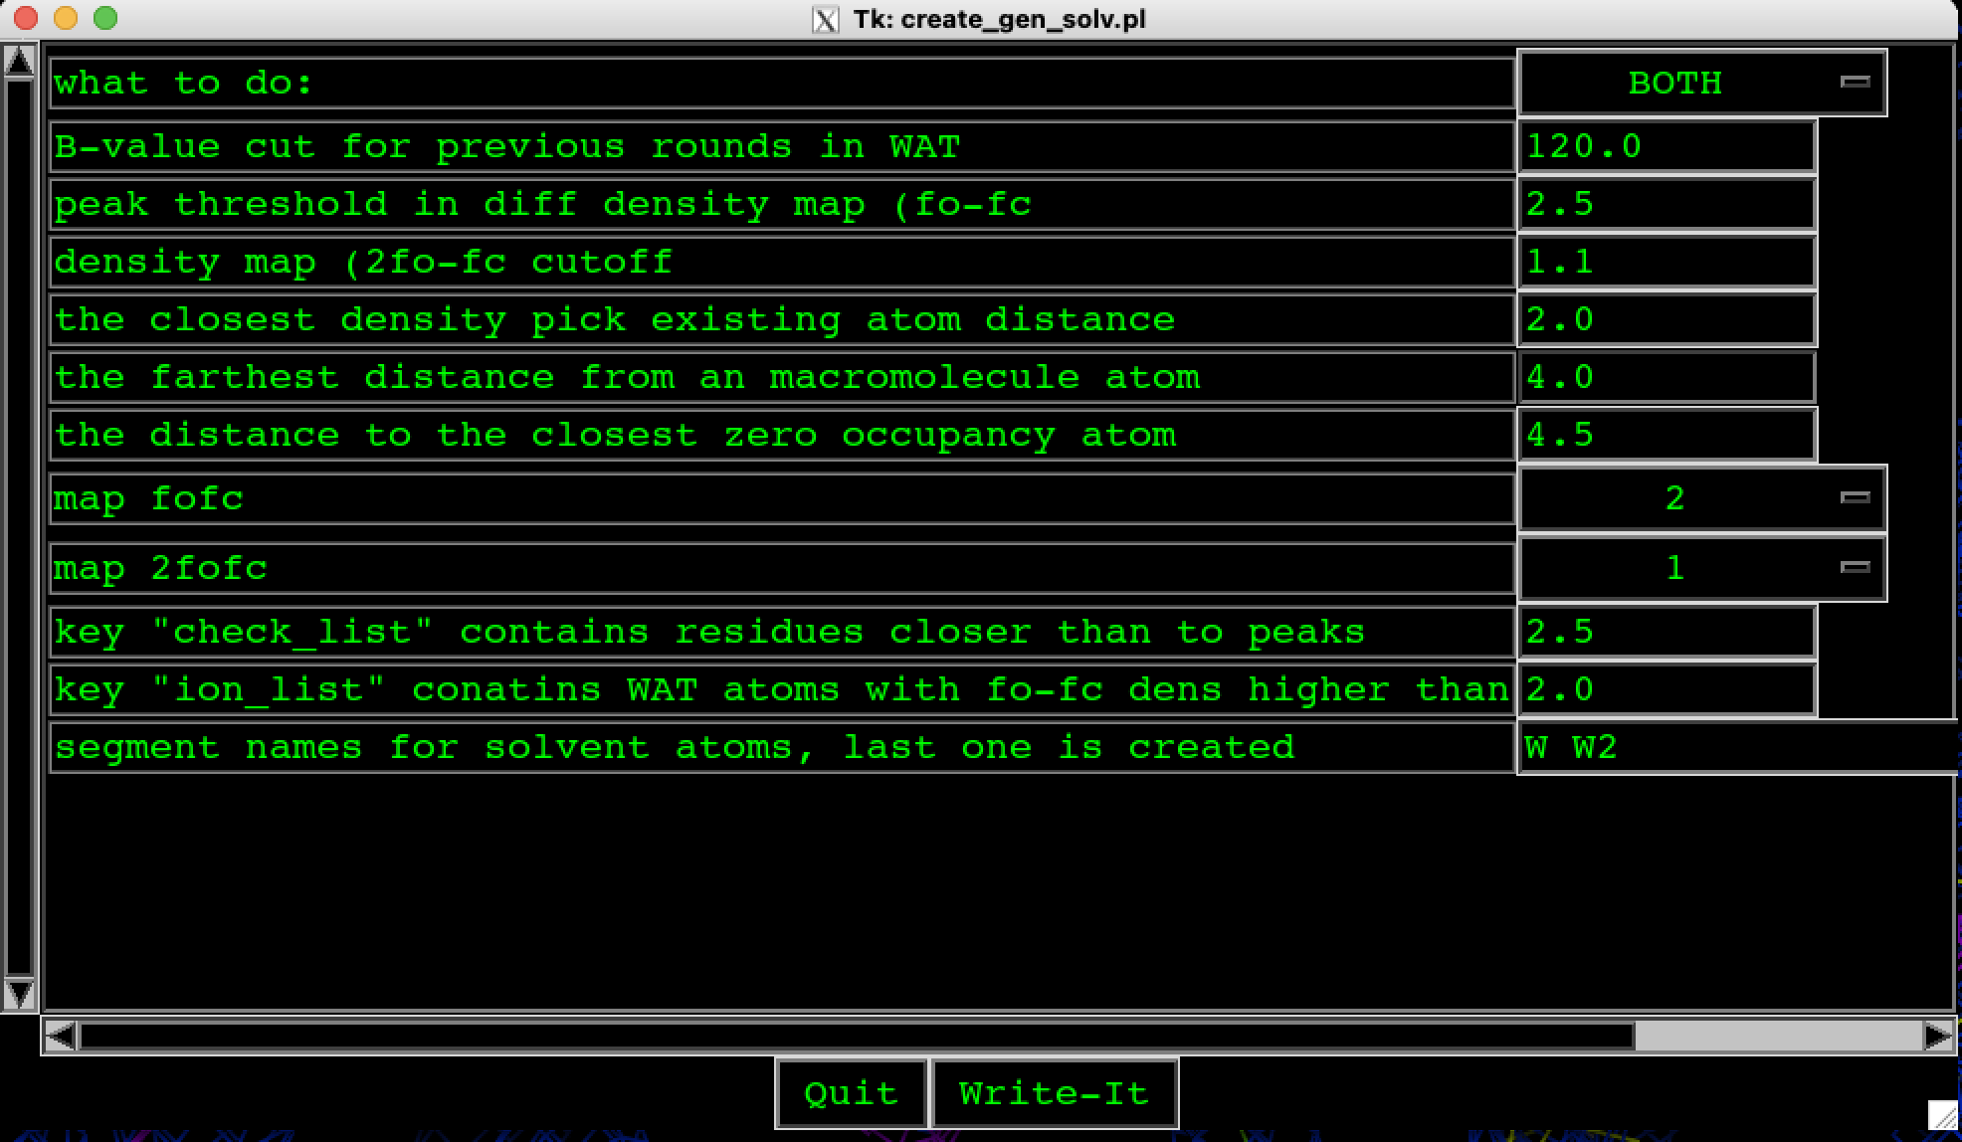
Figure 44. Select REFINE for generation of water molecules GEN_SOLV and select the parameters above.

Checking of distances of water molecules to protein by using VALIDATION in my_depp and then GEN_LIST and PACK (Figure 45). After selection of the parameters and options, klick on “Write-it”. The generated list of water molecules will move forward by one step if the following command will be used in my_term window:

set vari CENTER_SHI=1

Go again to VALIDATE and press again on GEN_LIST to run the prepared macro. During the execution of macro in my_term, the number of identified overlapping is written out – in this case closer then 2.0 Á.At the same time, the list of identified overlapping is generated. By typing “g” we are checking the list starting with the first one so that the program put the user in the problematic location in the protein structure. The user is then in the position to act – to delete or move molecules waters that are to close to each other or to protein.

Figure 46 and 48 present some validation of protein structure in the final steps.
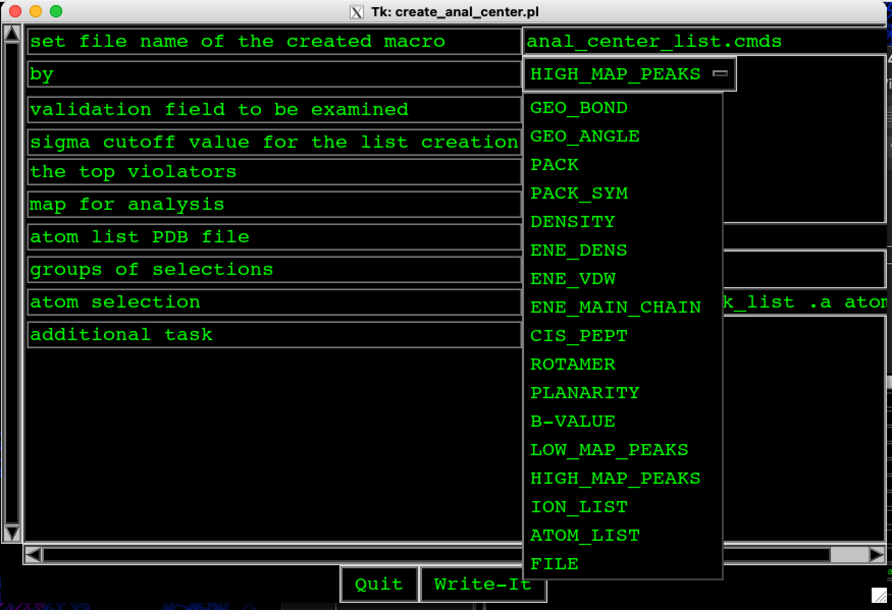
Figure 45. Select VALIDATION to check the position of water molecules to each other.

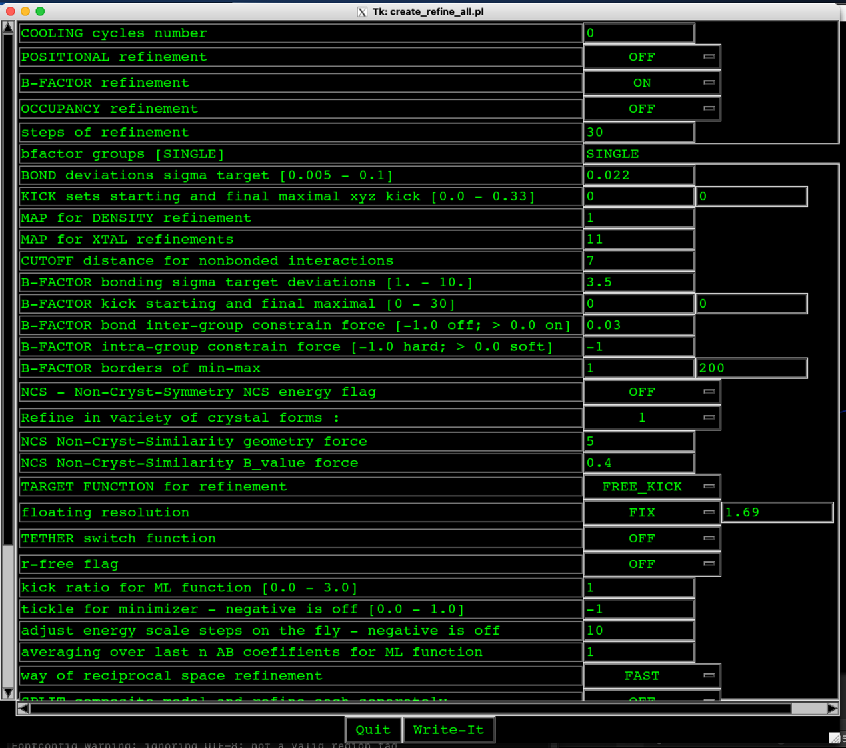
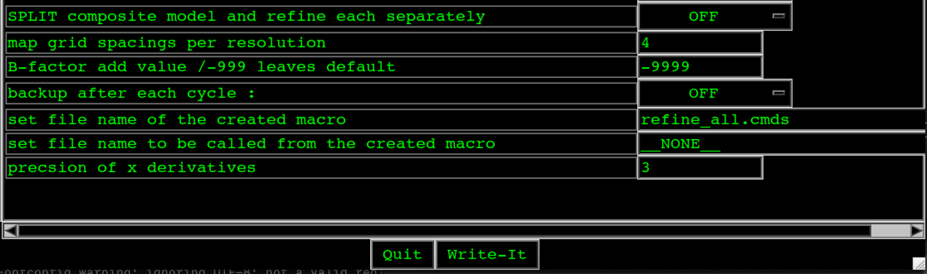
Figure 46. Selected values of parameters for refinement in final steps.

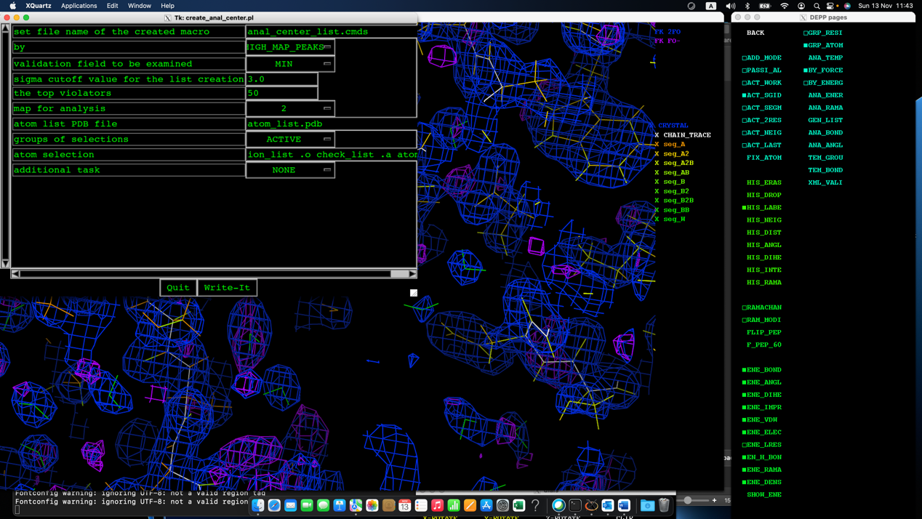
Figure 47. VALIDATION: generation of list for checking of temper. factor by using GEN_LIST.

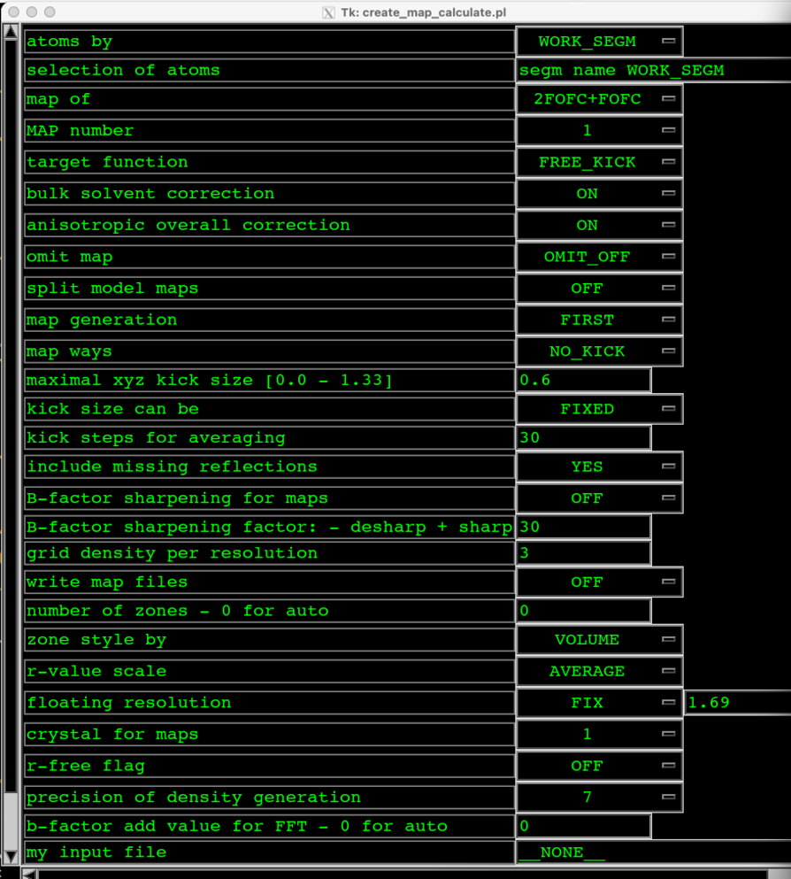
Figure 48. Parameters for map calculations during the final refinements.

- Lesson: Conformations

The procedure for generation of conformations is as follows:

- In my_depp, we select N_MOLECULE
- We select one residue in the first segment A, then ACT_SGID and ALTERN_M. To check the name of the new segment, write “show segm” in the my_term. Then we repeat this for all segments.
- In my_depp, we select MAIN_cfg (click on Lmouse) to open a window presented in Figure 46.
- The number of symmetry groups in in our case equal to five and we have to select the segments of the same group. It is important that we select COMPOSIT as could be seen in Figure 46.

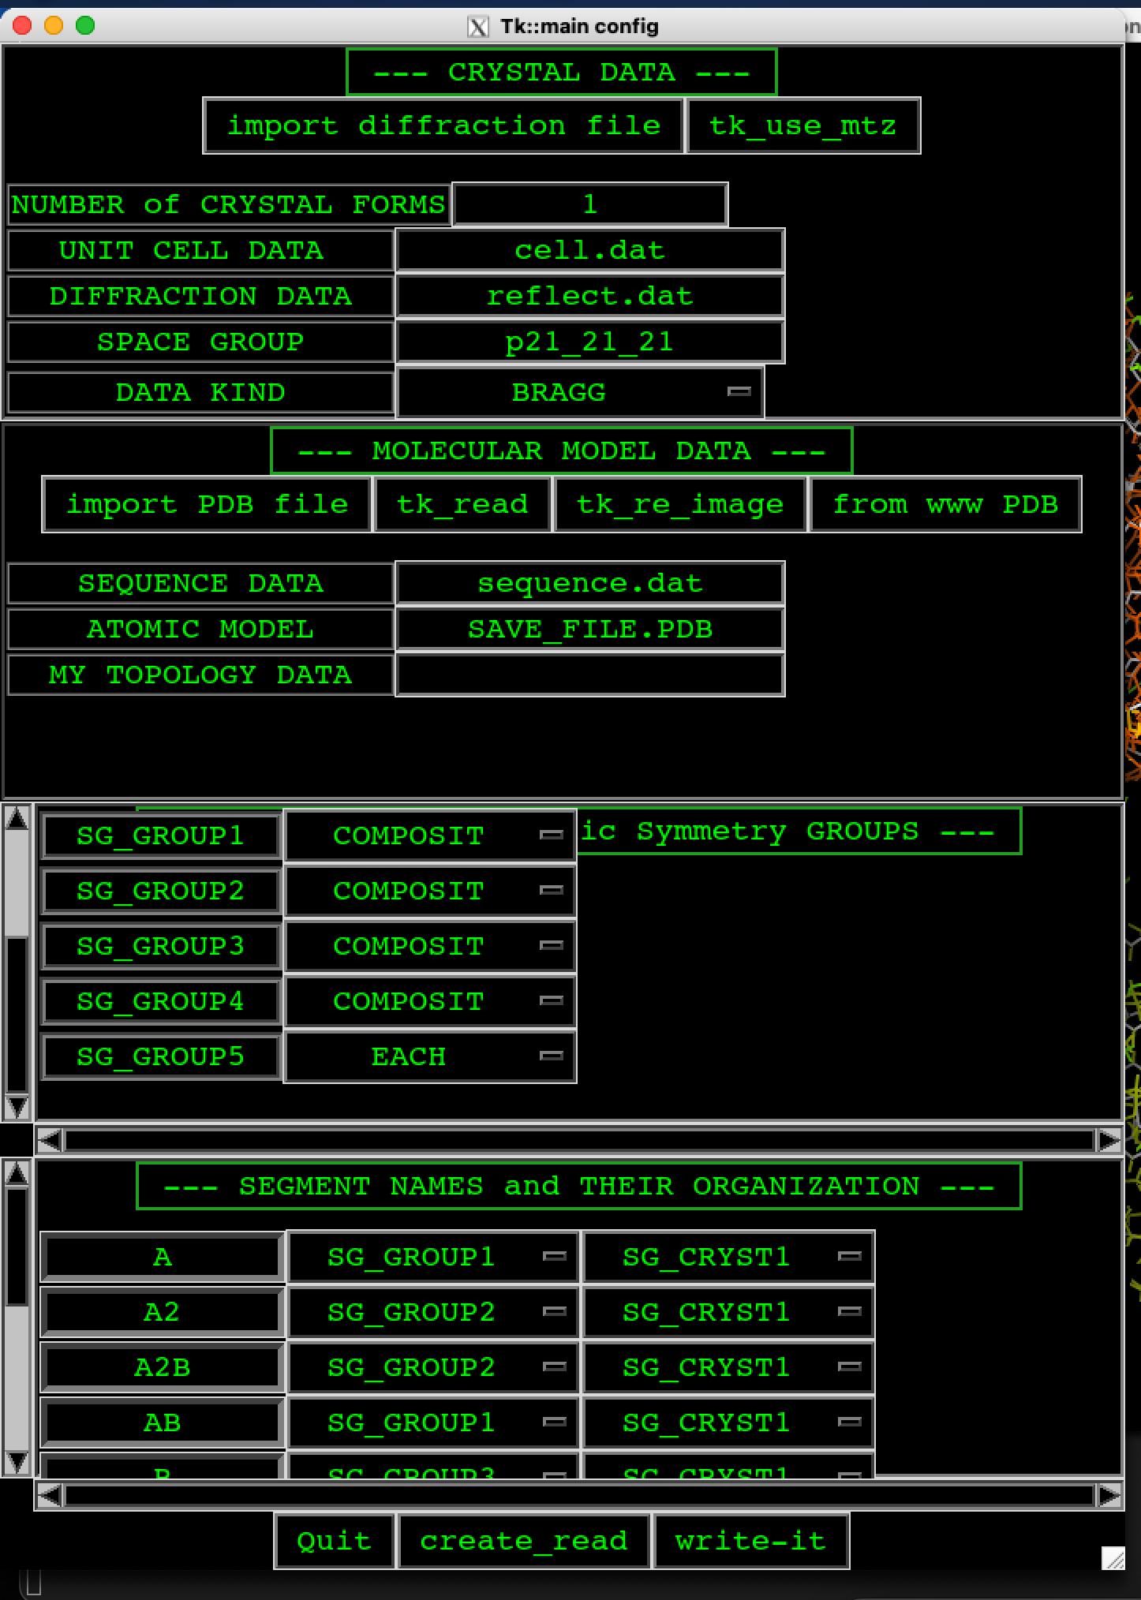
Figure 49. The input of segments for conformations in MAIN_cfg of my_depp.

Then we read new segments into RE_IMAGE of my_depp by clicking of Rmouse to get Figure 50.

To save new segments select SAVE_FIL of my_deep by clicking of Rmouse and select options presented in Figure 51.

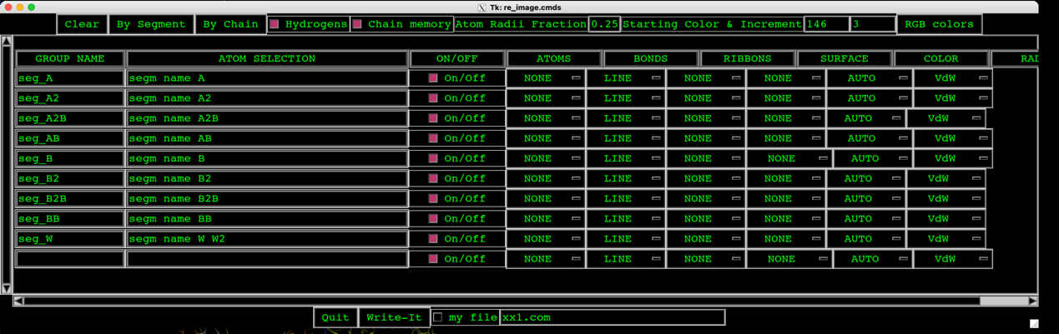
Figure 50. List of all segments. To see the differences between segments more clearly – more different colors, write 146 and 3 (top raw to write).

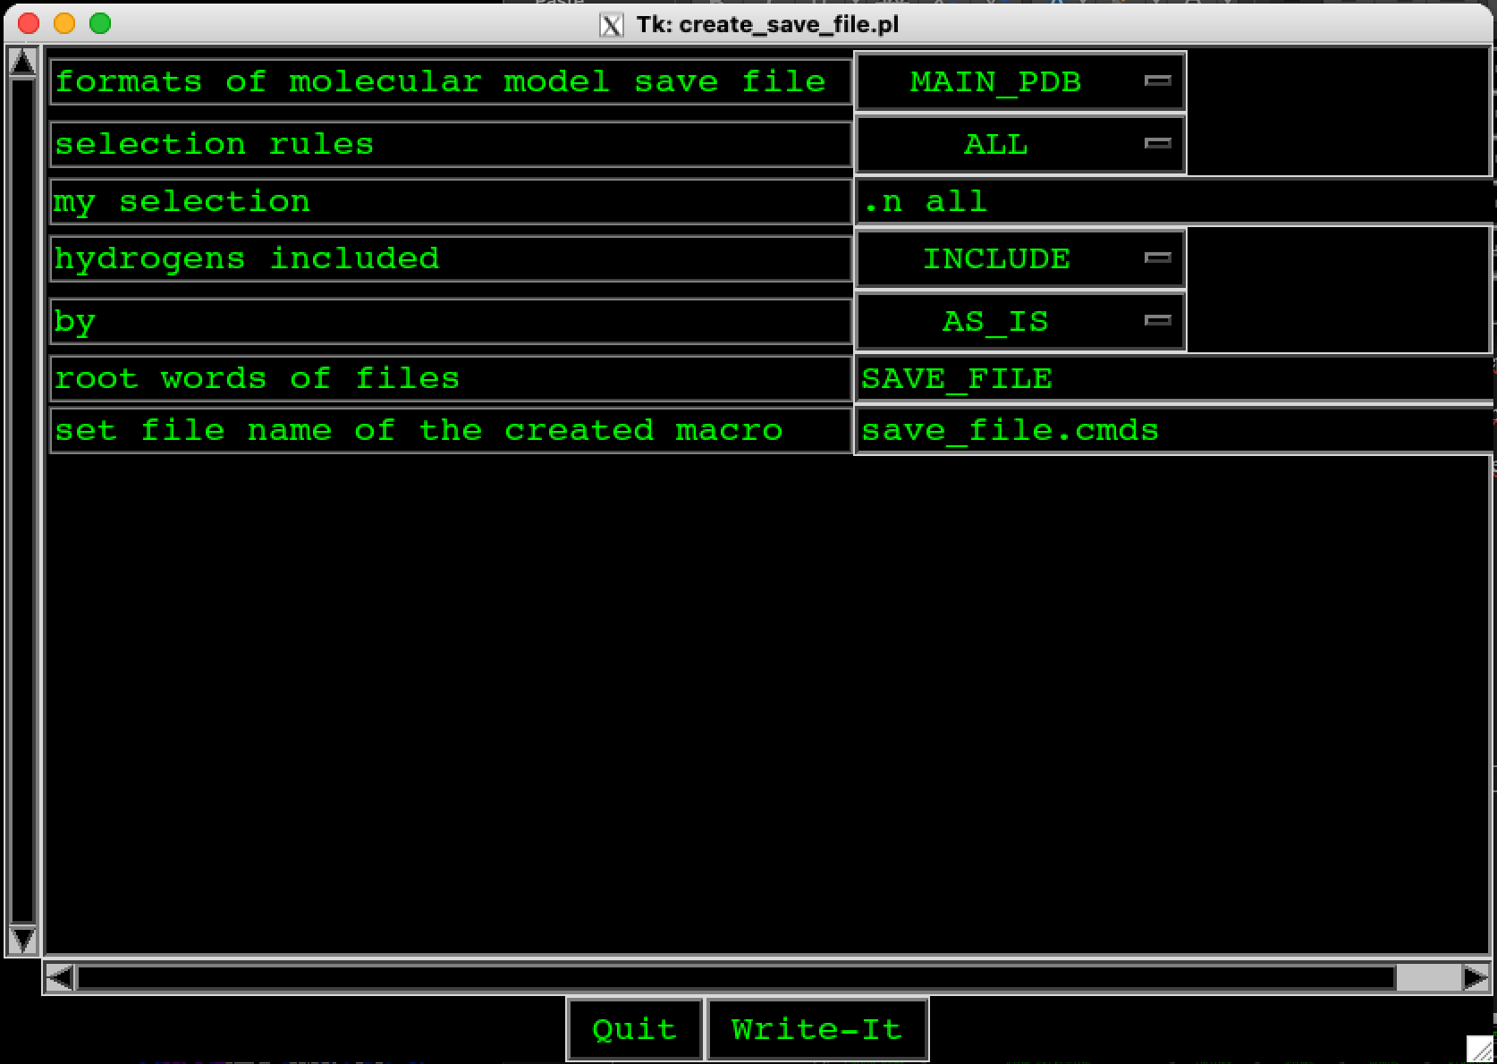
Figure 51. Saving of new segments into file.

Then we QUIT the MAIN program and start generation of conformations after map calculation. In my_depp, we select BUILD and start checking the model. When we searching for possible conformations, for example in Figure 52, the conformation of proline is presented, we have to select ACT_LAST and TETHER by press on letter “t”, then “z” to move this residue.

If we decide that this is conformation we click on the residue (for example the yellow part of the residue), click with Rmouse on WEIGH_PR and then on WEIG_SID and we repeat the same also for in our case orange part of the residue. The WEIGHTS of the two conformations of one residue became equal to 0.5.

If we found out that this is not conformation then we simply click on individual conformation (ACT_LAST should be marked) and then press by Rmouse on WEIGH_0 and then also on WEIG_RES. In this case, the residue is excluded from map calculations. If we put WEIGH_1 and WEIG_RES the residue is included into map calculation.

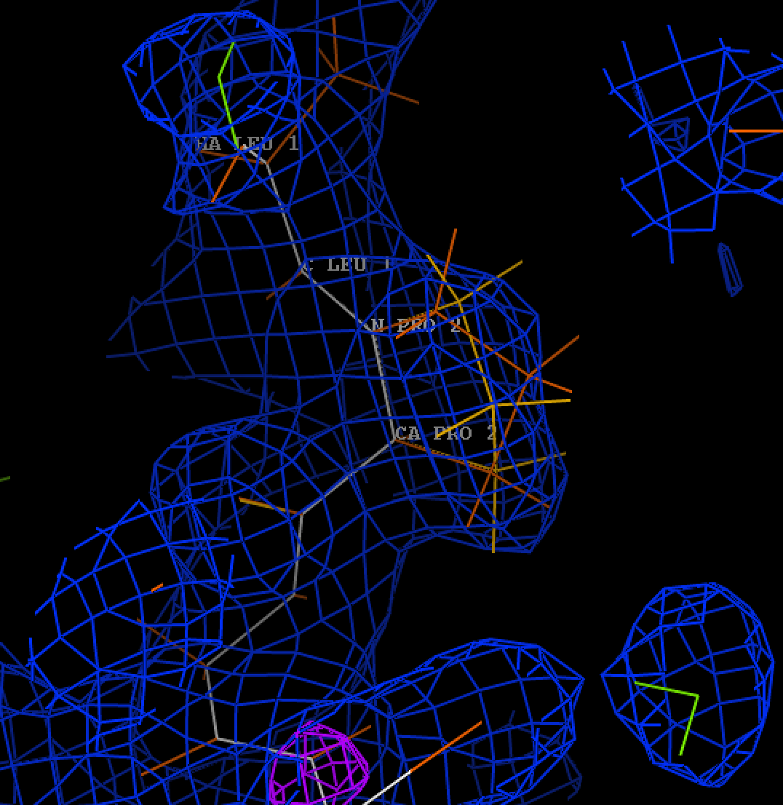
Figure 52. Possible conformation on proline.

- Lesson: Deposition of the protein structure into RCSB PDB protein data bank.

When the structure parameters achieve the target values, the protein structure is ready for the deposition into RCSB PDB protein data bank (Figure 53):
https://www.rcsb.org

First, we select “Validation API” to check if the protein structure is ready for the deposition (Figure 54). The klick on “Validation Servers” and go to
https://validate.wwpdb.org to create the validation account that allows you to use this server.

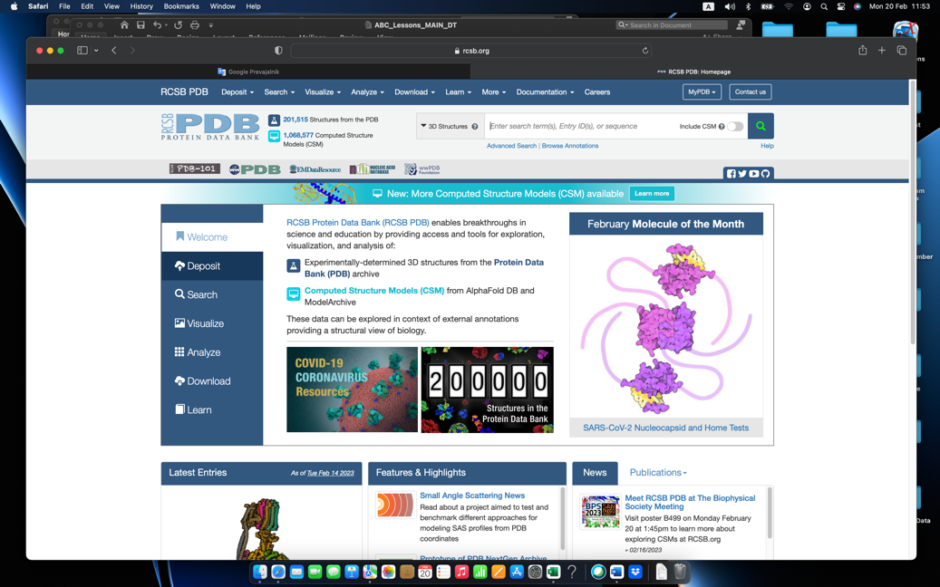
Figure 53. Deposition of the protein structure (“Deposit”).

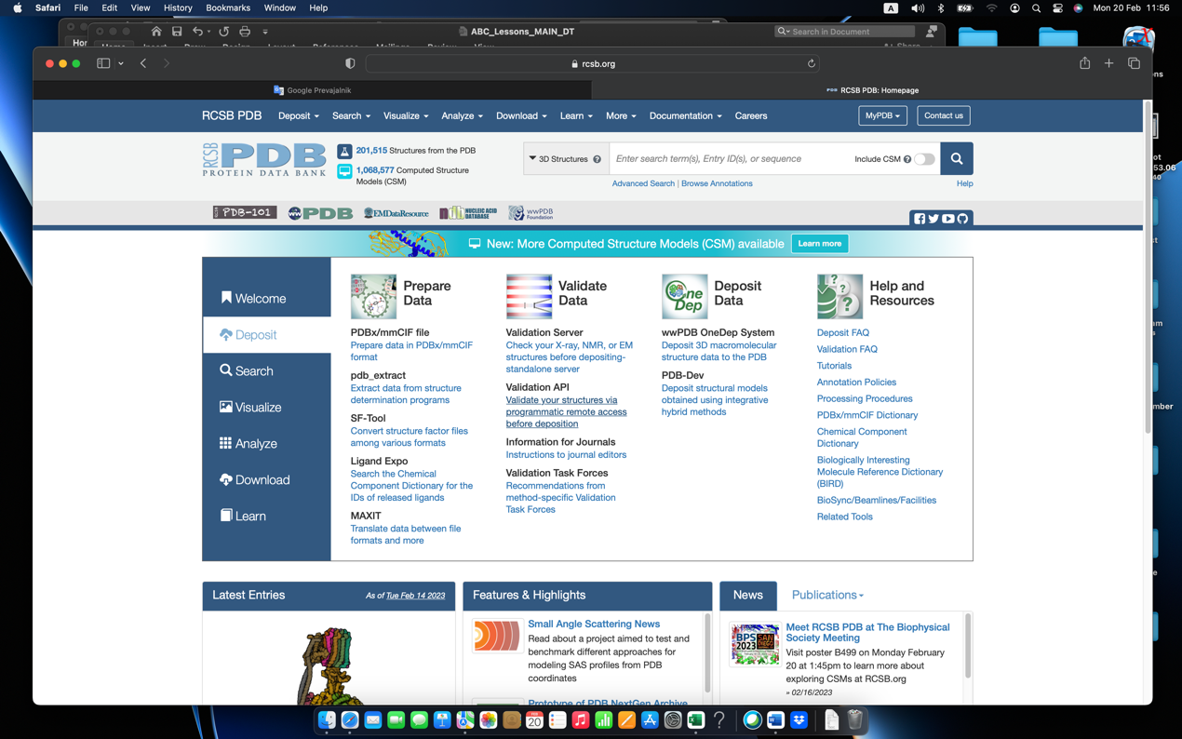
Figure 54. Deposition of the protein structure (“Deposit”). First, we select “Validation API” to check if the protein structure is ready for the deposition.
APPENDIX

Keyboard shortcuts which are case sensitive: magic of a keyboard touch

- Arrow keys
Pressing keys is usually the quickest way for an experienced user to issue commands. Keyboard single key shortcuts require no confirmation and are always at the tip of your fingers. They deal with image manipulation and serve as shortcuts for some of the most commonly applied clicks.

Currently these short commands are supported:
- '+' rotates the image for the stereo angle in the + direction,
- '-' rotates the image for the stereo angle in the - direction,
- 'M' toggles the image menu on and off,
- 'a' accepts geometry of currently defined active objects ("OB_ACCEP"),
- 'b' rigid body fit to map of groups of fragments ("RIG_SIDE"),
- 'c' or 'C' move the center of the my_image to the last picked atom ("CENTER"),
- 'd' or 'D' drops the last picked atom from the history list ("HIS_DROP"),
- 'e' or 'E' exits the dialog mode, MINIMIZation and REFINEment calculations,
- 'f' flip the last picked atom,
- 'g' go to the next residue: a shortcut to "CENT_NEX",
- 'h' toggles menu documentation mode on and off,
- 'k' kick "active" atoms: a shortcut to "KICK_ACT",
- 'l' selects the last clicked residue: a shortcut to "ACT_LAST"
- 'm' minimizes the "active" key selection of atoms: a shortcut to "MINIMIZE" Energy,
- 'n' selects the neighboring atoms: a shortcut to "ACT_NEIG",
- 'o' move the last clicked atom: a shortcut to "MOV_ATOM",
- 'p' peptide fixes: a shortcut to "FIX_PEPT" and "FIT_PEPT",
- 'r' or 'R' redraws the maps around the current center,
- 's' or 'S' toggles "STEREO" on and off,
- 'u' undo the last coordinate change: a shortcut to "UN_DO" (we pick the atom and then select UN_DO),
- 'w' calls a macro as defined by character variable "WORK_MACRO" (or write < and the name of macro file),
- 'x' move the last clicked residue: a shortcut to "MOV_RESI",
- 'z' fit residue side chains to density: a shortcut to "FIT_SIDE",
- ‘t’ tether – adopting residues to electron density map,
- Ctrl Y + H to build in the hydrogen bond.
- Ctrl X + H to delete the hydrogen bond.

TIPS

Pressing of “e” in main window: key for command PROMPT from DEPP MENU

CTRL Z: to move to terminal; “fg”: to move back to MAIN

To write the program’s output in file
./xxx.exe >my_output&
create_auto_start.pl -p 1spb.pdf -- doit >MyOutput

To get the date of the MAIN program version: mainps –nostart up

tk_config.pl -m create_map_calc.pl
-map of: 2FOFC+FOFC, 2FOFC, FOFC, PHASE_COMB, FOBS, FCALC, 3FO2FC, REFINE
-target function: UN, SIGMA, ML, FREE_KICK
Table A1. Table of colors codes for MAIN.

In the table the calculations from RGB color codes to MAIN color codes are presented which could be used in writing of MAIN macro program codes.

Procedure for model building: one-page of quick steps

The model starts building main chains followed by side chains.

MAIN starts by command “mainps”.
If you copy files from Nextcloud (linux system) on Mac then you start MAIN on Mac with command
“create_auto_start.pl --doit”

During the building process – at the start- the resolution has higher values and then it is decreasing with the decreasing of Rcum. The resolution could be decreased also in the start menu “tk_main_config.pl” or later in the program in the menu MAP_CALC and floating resolution.

Adding the missing atoms
My_depp and UTILS:
- FILL_ATO

Calculation of maps – start procedure
My_depp and MAPS:
- ACT_WORK
- RMS_FIT
- MAK_MASK
- MAP_CALC (floating resolution - for decreasing the resolution)
- DM_PREP (MAP 1 copy in MAP 2)
- DM_NEXT (repeat the command at least 2 or -times)
- 3REF_ALL (NCS must be on, NCS is off in final stages), the MAP is calculated

Adding of Hydrogen bonds
My_depp and BUILD:
- ACT_WORK
- ADD_HOH (green orders)
- HBO_SECO (blue orders)
- HBON_OPT (yellow orders)

Copy of one molecule into other
My_depp and N_MOLECU:
- ACT_SGID
- Working segm, for example, SID_A
- Create_Other

Generation of solvent
My_depp and REFINE:
- ACT_WORK
- GEN_SOLV

Calculation of maps – final step and refinement:
My_depp and REFINE:
- ACT_WORK (to check in BUILD)
- In REFF_ALL the “floating resolution” must be FIX and actual number, B_fact has to be ON
- Press in REFF_ALL at the bottom to “Write-it” (the macro in MAIN is prepared to run) and klick again on REFF_ALL (REFINE menu).
My_depp and VALIDATE
- ACT_SGID
- GEN_LIST and select PACK for checking, for example, the position of water molecules

Macro for calculation of surfaces by using van der Waals radii in MAIN program

MAIN macro procedures – the file name must be always xxx.com

W1.com (name of the file)
key my_surf sele .n ( atom name H* .o resi name HOH ) end
set rad sele my_surf end vdw
poin init sele my_surf end sele my_surf end surf ( access dens 4. probe 1.6 dots )
open unit 24 file surface.dat write
show uni 24 poin sele my_surf end resid surf
image group name my_surf
ima sele my_surf end col 220 poin surf access
clo uni 24
shell “rm BEFORE”
return

Installation of MAIN program in macOS Unix operating systems by using brew

brew update
brew upgrade gcc
brew unlink gcc
brew link gcc

use shell command sudo (you need to know the root password)
sudo rm -rf /Library/Developer/CommandLineTools
sudo xcode-select –install
exit sudo

brew link gcc
brew link –overwrite –dry-run gcc

brew Perl –install

Download Tk-804.036
generate directory Tk-804.036 in /usr/local/share/mkdir Tk-804.036
copy Tk-804.036.tar.gz to new directory Tk-804.036
go to directory “cd Tk-804.036”
tar -xvf Tk-804.036.tar.gz

use sudo shell again and input:
perl Makefile.PL
make
make install
make test
perl -MCPAN -e shell (automatically: YES / sudo o conf init)
cpan(1)>install Tk
cpan(2)>install BUNDLE::LWP
cpan(3)>install HTML::Tree
cpan(4)>install HTML::Format *
Exit from perl shell

Download the latest version of XQuartz *.dmg and install it

Download MAIN and mkdir MAIN, copy file main_distribution.tar there
tar -zkvf main_distribution.tar
chmod 755 main-ps_202*.exe_OSX_GFORT-INTEL

Download Raster3D program (http://www.bmsc.washington.edu/raster3d/) and mkdir Raster3D
copy file Raster3D_3.0-7.tar there
tar -zkvf Raster3D_3.0-7.tar.gz
make help
make linux
use sudo shell again and input:
make install

In some cases the dimensions are too small and in this case we have to change the soyes in file “parametrs.incl” as follows and repeat the installation of Rater3D:
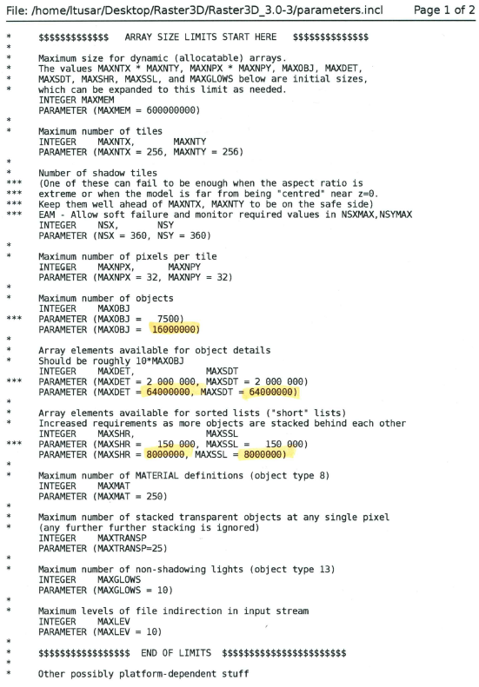

Additionally:
Libraries on my MAC for last version of MAIN
We need directory gcc@9 and there must be library “libgfortran.5.dylib”
/usr/local/opt/gcc@9/lib/gcc/9/libgfortran.5.dylib

We need two directories:
/10.2.0_4/ and /10.2.0_2/ but the content is the same. Therefore I copied:

cp /usr/local/Cellar/gcc/10.2.0_4/ v /usr/local/Cellar/gcc/10.2.0_2/

GLOSSARY and ABBREVIATIONS

Non-Crystalographic-Symmetry or Non-Crystallographic-Similarity NCS

Six numbers cell.dat represent unit cell lengths a, b, c and alpha, beta and gamma angle:
120.5 120.5 63.15 90. 90. 120.

